If you see crime occurring or suspicious activities please contact the Louisville Metro Police Department 574-2111 or 911.

Concentrated Crimes Maps for September 9- September 15

The concentrated crimes maps center on the five most reported crimes robbery, assaults, auto theft, theft from autos and burglary in the 7th Division and identify any crime trends.

Please forward this information to any family, friends, relatives and co-workers that live and work in the 7th Division.

Thefts from Vehicles 4
Thefts from unlocked vehicles 4
Burglaries 8
Thefts of Vehicle Plates 2
Robberies 4

Beat 1: Taylorsville Road, Lovers Lane, Hudson Lane, Chenoweth Run Road and Seatonville Road

Officers responded to three residential burglaries, one theft from vehicle (unlocked) and two thefts of vehicle plates in this section of the 7th Division. The residential burglaries are mainly occurring daylight hours between 0900AM- 200PM. The victims both reported that each door were forced open (kicked & pried open) to gain entry to the residences. Victims stated that the suspect(s) used a pillow case and stole jewelry and electronic equipment was the main property that was stolen. Officers have some information from witnesses that observed the subject(s) involved in these thefts. The theft from auto could have been prevented just by locking your vehicle. Please remember to properly lock and secure your home, business and vehicle. Please remember to take the time to write down the brand name, model number and serial numbers for items in your home, business, auto and garage. If you seen anything that is suspicious in the area, please contact the Louisville Metro Police Department.

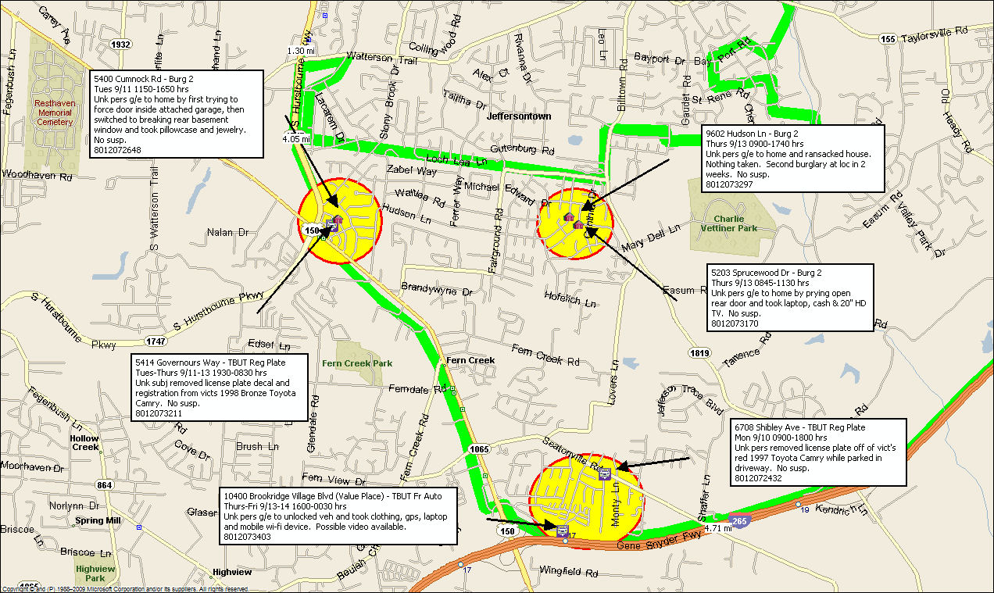

Beat 3: Highview, South Watterson Trail, Bardstown Road, Fern Creek Road, and Hurstbourne Parkway

On Beat 3 officers responded to five residential burglaries in this section of the 7th Division. Victims are reporting that the suspect(s) are mainly stealing jewelry and medication. Suspect(s) have been forcing open a rear door or window to gain entry to the residents. The time these thefts have been occurring is between 0800 AM- 500PM. Officers have little information on the identity of subject(s) that are involved in these thefts. Please remember to take the time to write down the brand name, model number, and serial number for the items in your home, business, auto and garage. Please remember to properly lock and secure your home, business and vehicle. If you see anything suspicious please contact the Louisville Metro Police.

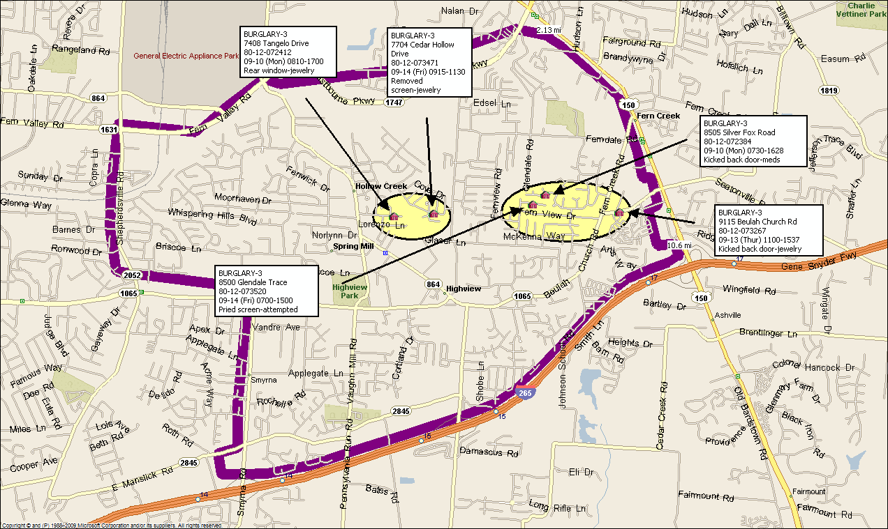
Beat 4: Copper Chapel Road, Mount Washington Road, Mudd Lane, Caven Ave, Thor Ave, Whispering Brook

Officers responded to three thefts from autos (unlocked) in this section of 7th Division. Officers have little information on suspect(s) involved in recent thefts from vehicles. Victims are reporting electronic equipment that is being stolen from their vehicles. The thefts from these autos could have been prevented just by locking your vehicle. Please remember to properly lock and secure your home, business and vehicle. Please remember to take the time to write down the brand name, model number serial numbers for items in your home, business, auto, and garage. If you see anything suspicious please contact the Louisville Metro Police.

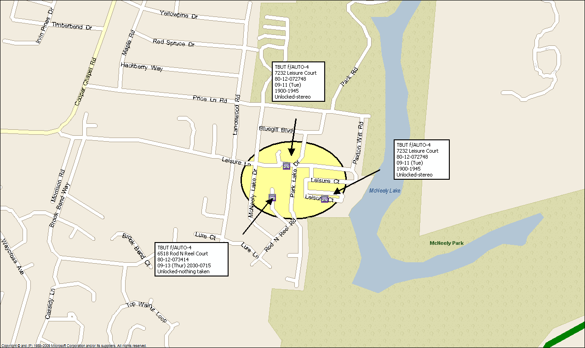

Beat 6: Preston Highway, South Park Road, Grade Lane, Fern Valley Road, Minor Lane, Blue Lick Road and Bost Lane

On beat 6 officers have responded to four different robberies from August 17-Sept 15 in this section of the 7th Division. The victims are reporting that three suspect(s) all B/M’s ages 18-20 years of age are involved in each of the robberies. Three of the robberies have occurred between 500PM-700PM. Officers have little information on possible suspect(s) in regards to these thefts. Please remember to be aware of your surroundings, just taking the time to look around before exiting from your vehicle or residents could prevent you from becoming a victim. If you see suspicious activity or crime occurring, please contact the Louisville Metro Police Department.

(August 17th to September 15th)

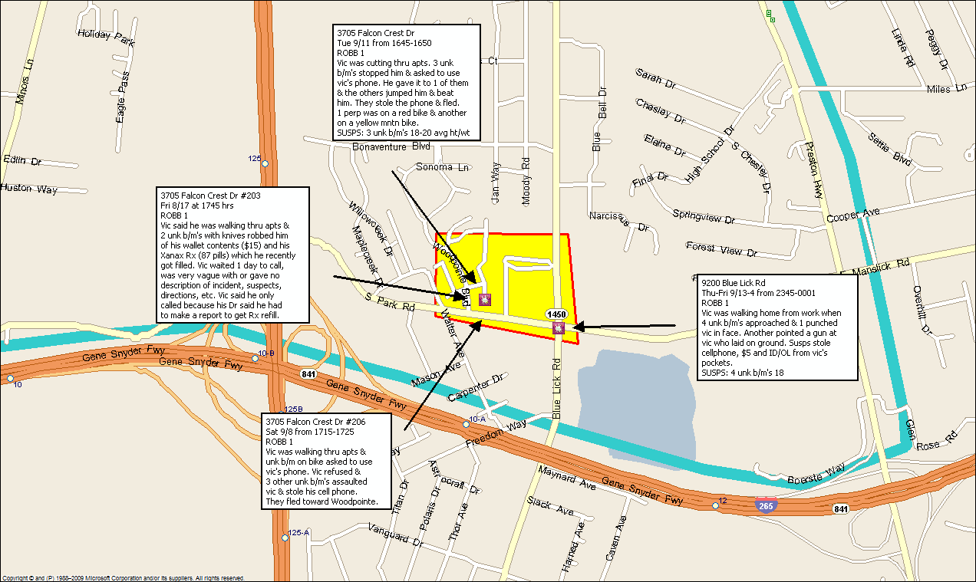

Officer Russell A Miller
7th Division Resource Officer
7201 Outer Loop
Louisville, KY 40228
Office 502-574-2133
Cell 502-376-0534
Email russell.miller@louisvilleky.gov

