Youth Leaders
Meet Cobe Williams from the Award Winning Documentary:
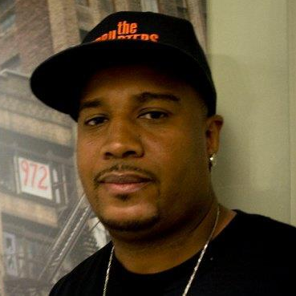 The Interrupters
www.pbs.org/wgbh/pages/frontline/interrupters
Friday July 27, 2012
From 8pm till 10pm @
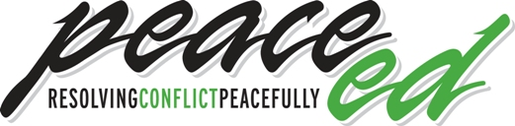
318 West Kentucky St., Louisville, KY 40203
RSVP to Janene@peaceeducationprogram.org
For more information call 502-589-6583
Sponsored by: The No More Red Dots Campaign
Councilman David James, Councilwoman Cheri Bryant Hamilton, The Board 4 Change, The LIFE Hope Center, & The Peace Education Program

Youth Leaders
Meet Cobe Williams from the Award Winning Documentary:
The Interrupters
www.pbs.org/wgbh/pages/frontline/interrupters
Friday July 27, 2012
From 8pm till 10pm @
318 West Kentucky St., Louisville, KY 40203
RSVP to Janene@peaceeducationprogram.org
For more information call 502-589-6583
Sponsored by: The No More Red Dots Campaign
Councilman David James, Councilwoman Cheri Bryant Hamilton, The Board 4 Change, The LIFE Hope Center, & The Peace Education Program

