No More Red Dots Campaign
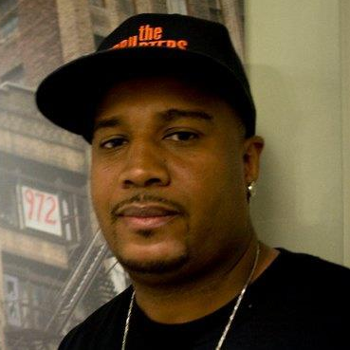
Presents Mr. Cobe Williams From the Award Winning Documentary The Interrupters
www.pbs.org/wgbh/pages/frontline/interrupters
Neighborhood Leadership
Orientation
Saturday July 28, 2012
From 10 am till 1pm
Lunch Included

Learn Non-Violent conflict resolution skills to help end the violence in Louisville
Location 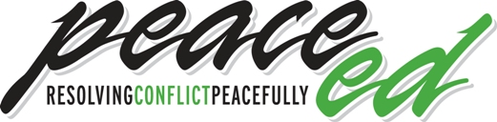
318 West Kentucky St., Louisville, KY 40203
RSVP to Janene@peaceeducationprogram.org
For more information call 502-589-6583
Sponsored by: The No More Red Dots Campaign
Councilman David James, Councilwoman Cheri Bryant Hamilton,
The Board 4 Change, The LIFE Hope Center, & The Peace Education Program

