MSU Extension Kent County: Introducing Adriana Sierra Ramirez

Adriana Sierra Ramirez named as the new Kent County

urban bilingual (Spanish) 4-H Program Coordinator
MSU Extension’s Kent County office welcomes Adriana Sierra Ramirez as the new county urban bilingual (Spanish) 4-H Program Coordinator. Adriana’s focus is on engaging youth and volunteers from traditionally underrepresented communities.

Adriana holds a Bachelor of Psychology with an emphasis on community engagement from Corporación Universitaire Minuto de Dios in Bogota, Colombia, and a Master of Public Health with a specialty in health promotion from Grand Valley State University. At GVSU, Adriana participated in initiatives that supported the community, engaged in various projects, and actively volunteered with community-focused organizations.
Prior to joining MSU Extension, Adriana worked with communities with diverse cultural backgrounds, including refugees, Black, and Latinx communities, and communities with socioeconomic disadvantages, both in her home country of Colombia and in the United States. Additionally, she served as a panelist in the 2023 Teaching for Equity: Inclusion, Accessibility, and Belonging program promoting diversity and inclusion.
Adriana enjoys reading, spending quality time with family and friends, and outdoor activities in her free time.

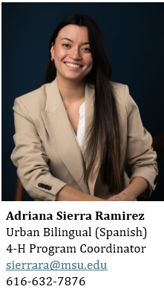
Adriana is currently working in the community sharing education and resources with students and families across Kent County.
- Dia del Niño at the Hispanic Center of West Michigan April 26, 3:00-6:00 pm
- Kent School Service Network - Sibley Elementary Resource Fair May 14, 3:30-6:00 pm
- Exploration Days with Kent County Delegation June 19-21

Adriana is a great resource for any community events and programming to reach this population.
For a complete listing of all MSU Extension & 4-H events, visit our website at: https://www.canr.msu.edu/kent/events.

