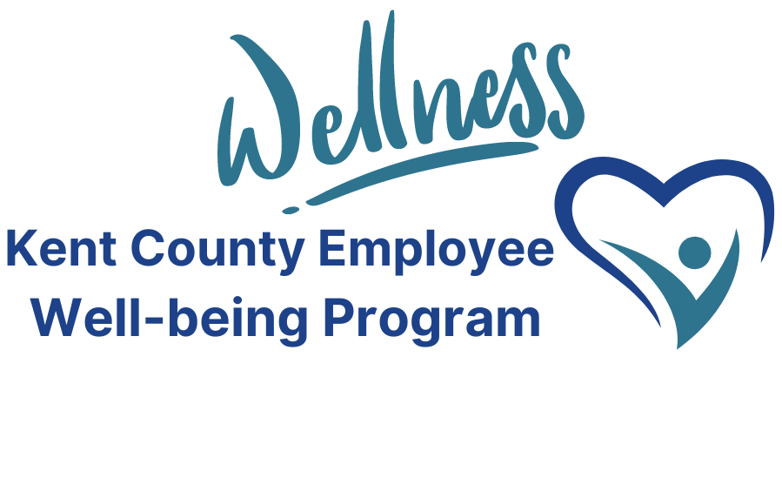
Happy Harvest!
With every changing season, we look forward to a change in local produce. Fall is an abundant food season. Let’s look at some of these foods – what to do with them, and their benefits to our health.
SQUASH – There are dozens of types of squash, many of which are grown locally. Some popular varieties include acorn, butternut, spaghetti, and pumpkin. Squash is high in antioxidants, which can protect your body from certain cancers and heart diseases. This vegetable is high in vitamins A & C, which benefit healthy skin and immunity. The high fiber content promotes good digestion and may improve cholesterol. Squash is relatively low in calories; one cup of butternut squash is just 82 calories.
Squash is most commonly prepared by baking or roasting, but you can also enjoy it as a soup (butternut variety) or a substitute for pasta (spaghetti squash). Some types can be tricky to cut, so find a sharp knife and be careful!
Recipe: ROASTED BUTTERNUT SQUASH
- 1 butternut squash peeled, seeded, and cut into cubes
- 1 ½ Tbsp olive oil
- 1 ½ Tbsp maple syrup or brown sugar
- 1 tsp salt
- 1 tsp cinnamon
- ½ tsp black pepper
- Fresh rosemary
Preheat oven to 400 degrees. Spray baking sheet with nonstick spray.
Place cubed squash in large bowl. Drizzle with olive oil and maple syrup. Add salt, cinnamon, and pepper, toss to coat. Spread cubes in a single layer on baking sheet.
Bake for 15 minutes. Remove pans from over, turn squash with spatula. Continue baking 10-15 minutes or until squash is tender.
Sprinkle with rosemary.

BRUSSELS SPROUTS – Brussels sprouts have gained popularity over the last few years as people have realized you can make them taste good. Brussels is another veggie that is low-calorie and high-nutrient. They have lots of fiber, can help reduce inflammation, and are rich in vitamins K & C. You can boil them, but we’d recommend tastier methods such as baking or air-frying. Also, if you’ve never seen a Brussels sprout in the wild, look it up! The way they grow is pretty neat.
Recipe: CRISPY PARMESAN BRUSSELS SPROUTS
- 1 pound brussels sprouts, washed and cut in half
- 1-2 Tbsp olive oil
- Salt & pepper
- Garlic powder
- ½ cup shredded parmesan cheese
Preheat air fryer to 375 degrees.
Place brussels sprouts in bowl, drizzle with olive oil. Sprinkle with salt, pepper, and garlic powder to taste.
Air fry for 10 minutes. Halfway through, shake fryer basket and add parmesan cheese.
PEARS – apples usually are the stars when it comes to fall fruit. But pears offer their own health benefits and unique taste. Pears are also high in fiber and vitamins, including C and K, as well as potassium and antioxidants. Its high-water content helps with hydration. This fruit can be prepared in a couple of ways- eating on its own, adding to a salad, grilling, or poaching. Considering 1 medium pair is only ~100kcal that’s a great low-calorie option to add to a dish well packing 6 grams of fiber (~21% of what is needed in a day.)
Recipe: BROCCOLI PEAR SALAD SLAW
- 1 large chopped pear
- 2 cups chopped broccoli
- ½ cup dried cranberries
- ½ cup pistachios
- ¼ cup feta cheese
- Vinegarette dressing of choice (suggested: apple or raspberry)
Combine all ingredients. Toss in dressing. Top with feta cheese.

Do you have any fall or winter recipes you love and would like to share? We love to hear from you!
Email the Kent County Employee Program at kcwellness@kentcountymi.gov

