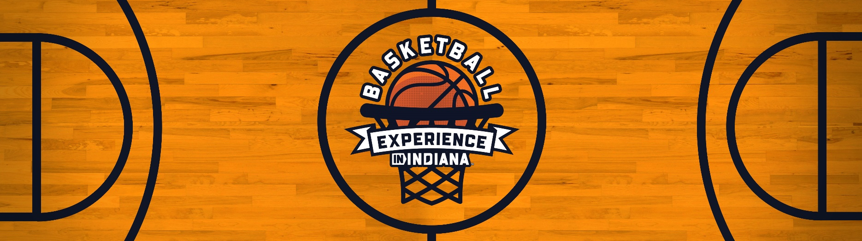

Indiana Basketball Experience - Media Toolkit
Official Launch: August 6
Announcement: August 3rd

Release Link: [Link]

Blog Links:
7 Places to Experience the Hysteria of Basketball in Indiana
20+ Places in Indiana For a True Fan's Basketball Bucket List
These Basketball Cathedrals Are the 10 Best High School Gyms in Indiana

Find @VisitIndiana on Instagram, Twitter, Facebook

Sample Copy
- In 49 states, basketball is just a game, but in Indiana, it just means more. The Indiana Basketball Experience is an online resource created to highlight the best of Hoosier Hysteria. #HoosierHysteria #InIndiana
Get in the game: [Link]
- With the Indiana Basketball Experience, you will never be caught without a gameplan. #HoosierHysteria #InIndiana
Learn more: [Link]
- Don’t miss your shot to dive into the rich history of Hoosier basketball with the Indiana Basketball Experience! 🏀 Discover legendary locations that shaped the Hoosier Hysteria story across the state. #HoosierHysteria #InIndiana
For more info: [Link]
- Don’t get caught without a gameplan! 📣 Uncover the legacy of Indiana's basketball roots with the Indiana Basketball Experience. 🏆 Explore historical locations that fueled the passion for the game in the Hoosier state. #HoosierHysteria #InIndiana
Learn More: [Link]
- Discover the heart and soul of basketball in Indiana with the Indiana Basketball Experience! 🏟️ Immerse yourself in the stories of iconic locations that changed the game forever. #HoosierHysteria #InIndiana
Get in the game: [Link]
- Experience the passion, the glory, and the essence of Indiana basketball with the Indiana Basketball Experience! 🏆 Journey through historic locations that define Hoosier Hysteria. #HoosierHysteria #InIndiana
Learn More: [Link]
- Don't miss the chance to relive the magic that shaped #HoosierHysteria! Check out the Indiana Basketball Experience, a comprehensive list of historic gyms and larger than life installations of some of the best to have ever played the game. #HoosierHysteria #InIndiana
Get in the game: [Link]

Interested in growing your audience with us? Collaborator posts are a great way to share your message across multiple audiences. Contact Hailey Reynolds at hreynolds@visitindiana.com to discuss scheduling your post with Visit Indiana.

