Highlighted New Features of vFire 9.10.2
Talking Points for Managers/Supervisors
After receiving feedback from surveys sent out to vFire users, the Service Management Department worked with Alemba (vFire’s vendor) to have a number of new features incorporated into this upcoming new release. With this upgrade, vFire has the overall same functionality and design it had, but with a variety of new features to enhance its abilities and user experience.

Summary of new features (Details are on the follow pages.)
- Add Objects and send Emails without Taking Ownership
- IOT Customer Feedback Request Process (IOT-Specific Feature)
- Default Suspension Time of a Call
- Propagate Emails Added to Parent Calls to Their Children (Linked) Calls
- Propagate Objects Added to Parent Calls to Their Children (Linked) Calls
- Return Forwarded Call to Sender’s Queue
- Search Inside Attachments for Knowledge Bank and Calls, Tasks, Request
- New Modernized Look to the Menus (but the same Workflows/overall functionality)

How will I be prepared if my role/job changes through these efficiencies?
No roles/jobs should change due to this upgrade.

How difficult will it be to learn the new system?
Since most of you have already been using vFire, learning how to use the new features will be simple. Documentation (below) and videos have been prepared to help you use the new features.

What does the future state look like?
vFire functionality will continue to improve and increase. The Service Management Department will continue to work with vFire’s vendor (Alemba) to make the transition of any future enhancements into our current vFire system as smooth as possible. The Service Management Department will also work with Alemba on any special features IOT might need added to vFire.

What are SMEs?
SMEs are subject matter experts. These are users of the system that have more knowledge of vFire’s capabilities than the average user has and are good “go to people” if someone has a question about vFire. There are users in various departments that have a better understanding of the system than others. When in doubt, contact someone on the Service Management Department with any questions you may have. This department reports to John Toole.

How will I receive information regarding vFire upgrades/enhancements?
The Service Management Department will put together a summary sheet like this one and communicate it to the various departments prior to changes.

Details - New Highlighted Features of vFire 9.10.2

- Add Objects and Send Emails without Taking Ownership
If you belong to the same organization as the customer of a call and have the ability to view a call, then you can add objects, such as an attachment, send an email from a vFire call, and view the call without having to take ownership of the call.
- IOT Customer Feedback Request Process (IOT-Specific Feature)
With this new feature, whoever is working a call can request additional information, and if no additional information is received by a determined timeframe, the system will close the call. This feature will help to make sure Analysts always have the needed information to properly resolve an issue.
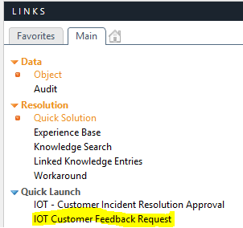

Below is an example of the Feedback message the customer will receive when an Analyst selects the “IOT Customer Feedback Request”
Dear Jason Garrett,
Ticket #: 2037453
Description of Incident: Jason test
We need more information to process your request. If a response is not received within 60 hours, it will be assumed that the incident has been resolved and the call will be closed. Please click this link to respond.
If you were unable to respond within the 60 hours, and the incident has not been resolved, please contact the IOT Helpdesk to open a new ticket.
Thank you for helping us serve you better!
If the customer does not respond within the given time frame, the call will be closed with the below message as the reason:
[Closed]
[Reason: Closed Per Automated Process]
[One Liner: IOT believes this ticket is resolved and the customer did not respond to our requests for information within 60 hours. If the issue is not fixed, please open a new ticket as this ticket is now closed.]
- Default Suspension Time of a Call
In the past, if you suspended a call, it defaulted to the current time and date. However, if you weren’t paying attention and clicked the suspend box and then clicked “OK,” the call would come out of suspension--right after you told the system to suspend the call. Now when you suspend a call, it defaults to 5 days in the future. You can change this value to a different point in time. This value is set on the same screen you set the call status after clicking the defer button.
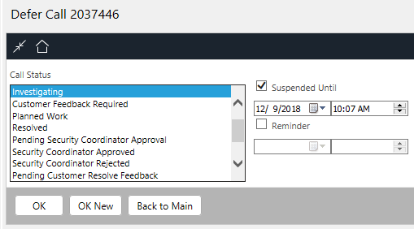

- Propagate Emails Added to Parent Calls to Their Children (Linked) Calls
This feature allows you to send emails to any linked child calls. The email will be added to the call’s history and emailed to the individual you select. From the parent call you would click on “Email” and then click on “To Recipients”.
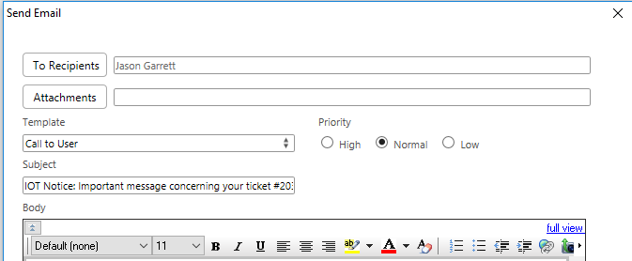
- Select “Linked calls” and then search by any of the following:
- Name
- Organization
- Group
- A “%” sign in one of those fields to search child calls.
The “%” is a wildcard and will search the child calls for anything in that field. For example searching based on the Name field with the “%” will search all child calls for any email addresses in the customer field or alternate contact.
- Click on “Find” and this will bring up any emails associated with the child call.
- Click on “Add” to the email(s) that you want to include and then that email will be added to the parent call history as well as the child call(s) history.

The example on the following page shows the link, find, and add described above.

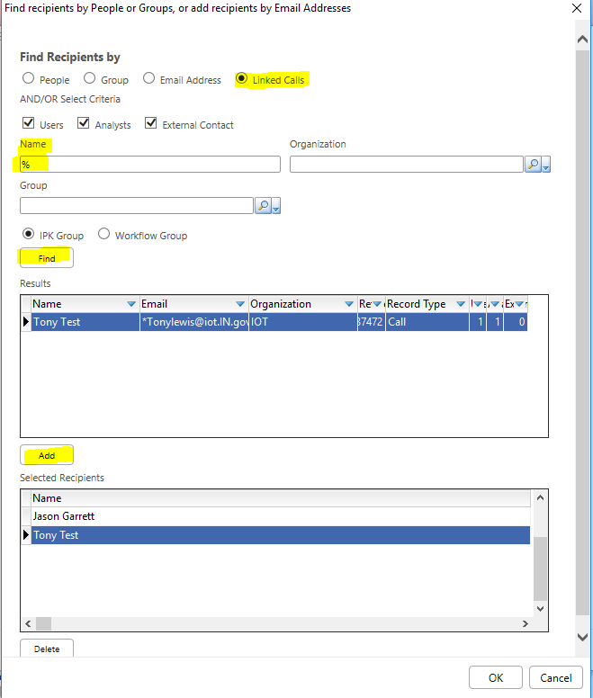

- Propagate Objects Added to Parent Calls to Their Children (Linked) Calls
This feature allows you to add an attachment to a call that has been linked as the parent and the attachment(s) are also uploaded to the child call. After you click on the upload object icon you will see the below window which allows you to select “Propagate attachment(s) to Linked Child Calls”
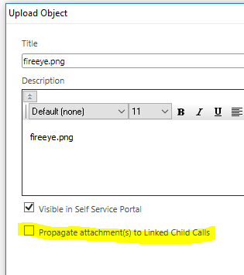

- Return Forwarded Call to Sender’s Queue
This feature allows an Analyst to request the call come back to them if no action is taken on the call for X number of days (determined by the Analyst). This helps ensure calls don’t get lost in the shuffle and thereby get overlooked. This value is set on the same screen you pick who or what group you want to assign the call to.
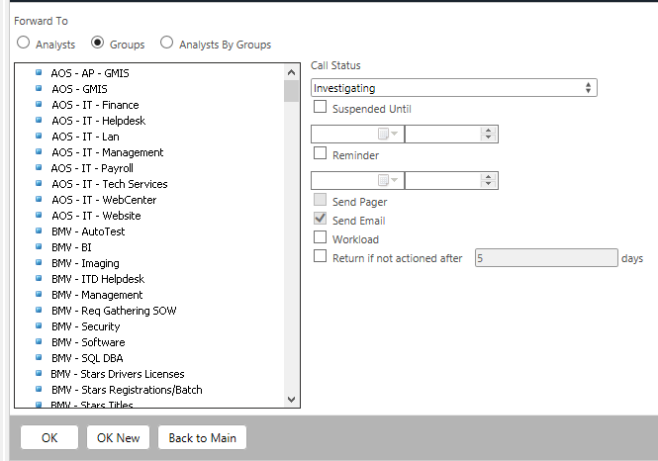
Reassign “Return if not actioned after X number of days”

- Search Inside Attachments for Knowledge Bank and Calls, Tasks, Requests
vFire now has the ability to search the contents of attachments that are attached to knowledge bank items, calls, tasks, and requests. In your “Configure Search Criteria” just select the “Search Attached Objects”
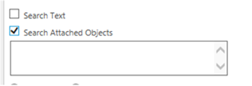

- New Modernized Look to the Menus (but the same Workflows/Overall Functionality)
The menu icons have changed some in order to simply give vFire a new look, but the new release has the very same functionality and design, with a variety of new features to enhance its abilities.
