PUM47 - SCM DocuSign & Other updates
Refresh Document – allows Wizard information to be updated
Compare Document – uses Word to create a document compare

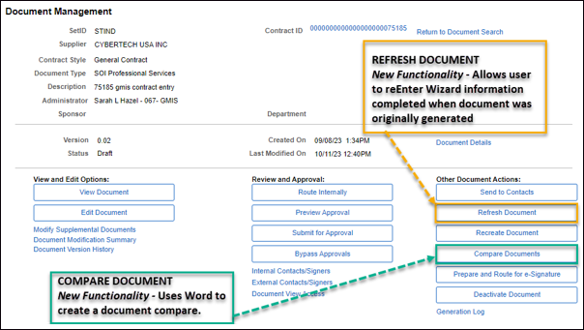

DocuSign Edit Recipients – allows changes to Signature information originally entered. This functionality can be used for email corrections, inserting a new Signer, or deleting a Signer. Once a Signer has completed their step, no further edits are allowed.
