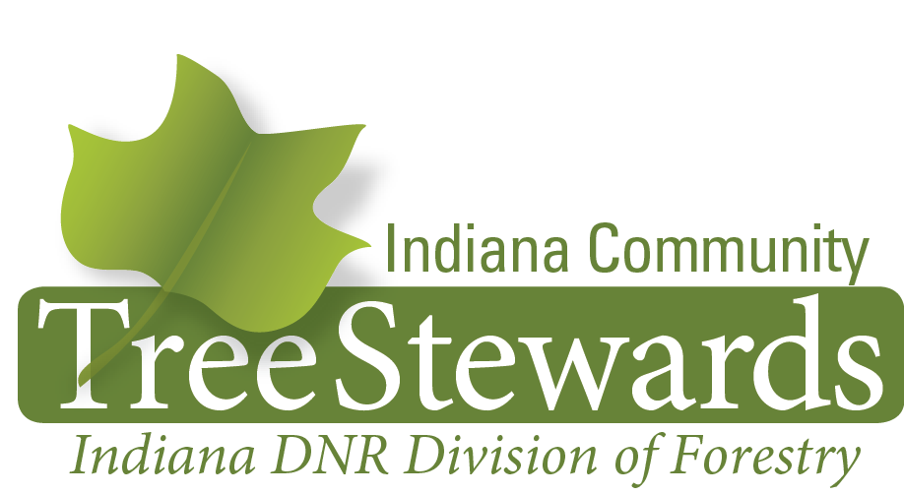

Training Program

The Tree Steward program focuses on a broad range of topics related to the urban forestry discipline. Courses are generally held every three months in all regions of the state.

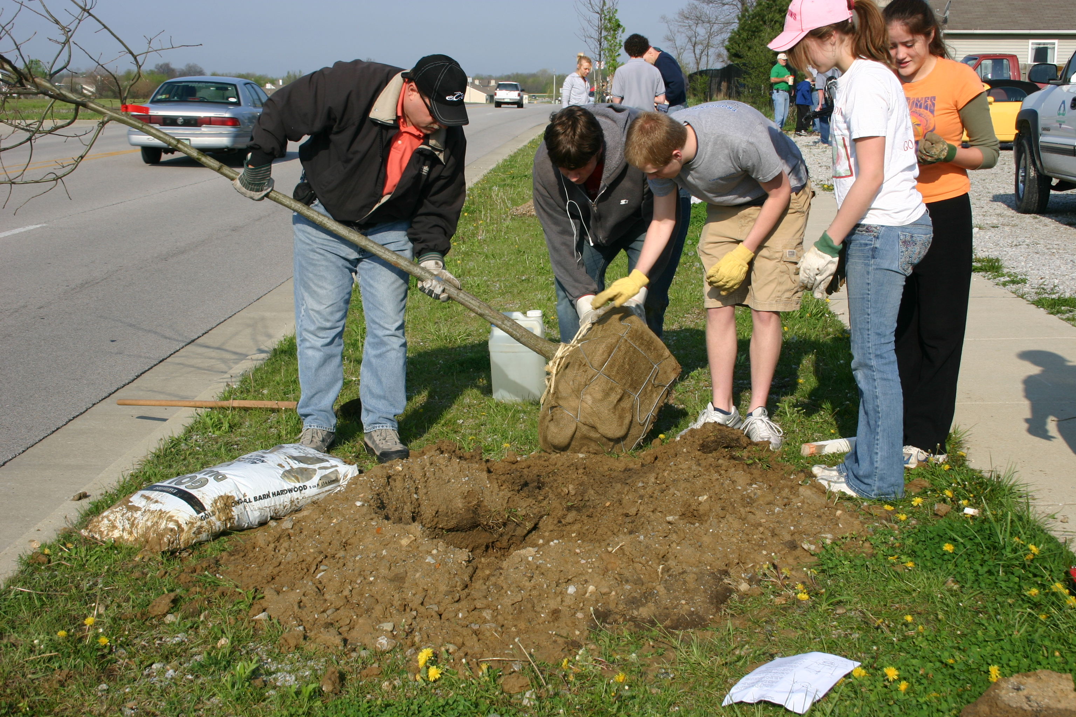
The course was developed in 1995 by Pam Louks, DNR Forestry, with assistance from Dick Crum and Jim Barbour, Marion Co. Extension. It was developed in order to actively engage Hoosiers in various aspects of urban forestry and to begin to generate a base of urban forestry advocates. Indiana has over 1,000 tree stewards throughout the state.

Participants who complete the course are asked to donate 15 hours of volunteer service to their community or state urban forestry programs. These hours can include tree planting, maintenance and care, advocacy for the urban forest, presentations on tree planting, care, or engaging and involving citizens in urban forestry.

The course is approximately 18 hours in length, includes lecture and hands on learning opportunities both indoors and out of doors, and includes a test at the end.

Participants receive the Indiana Community Tree Steward Manual filled with information from each topic in the course. Those who complete the course take the required exam, and complete their 15 hours of service, will receive a certificate signed by the State Forester, a lapel pin, and a copy of 101 Trees of Indiana.

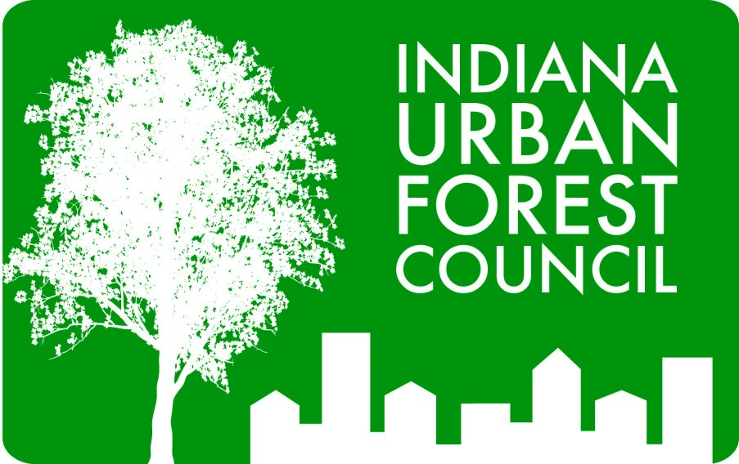
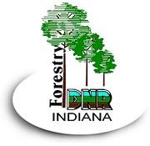


Proud Co-sponsors of the Tree Stewards Program
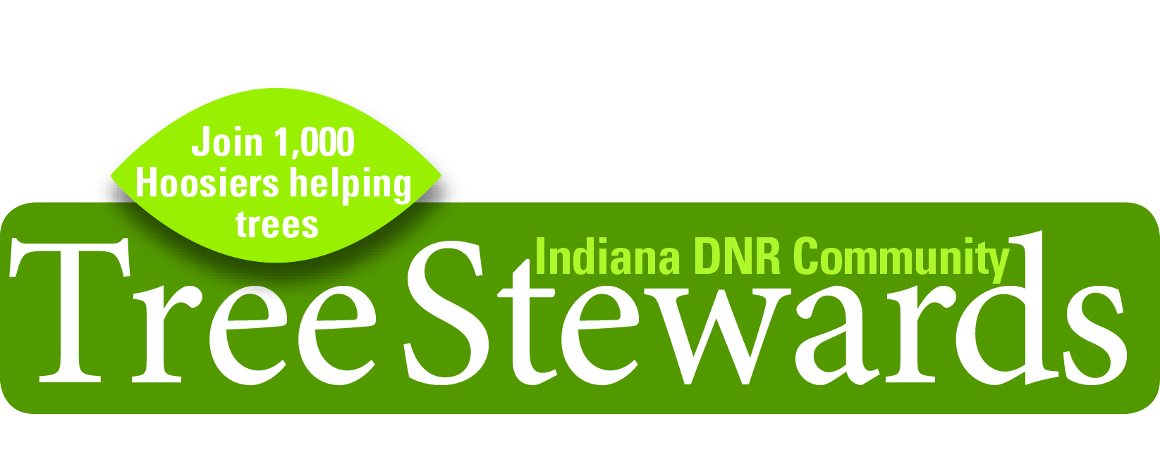

Curriculum for Urban Forestry Study

The Scoop on Soils
Participants will gain a working knowledge of the different soil types and learn how urban soils differ from soils in the woods or forest. Instructors focus on key soils features that will affect tree growth, and discuss how and when to spend time, dollars, and energy attempting to fix soil problems.

How Does a Tree Grow?
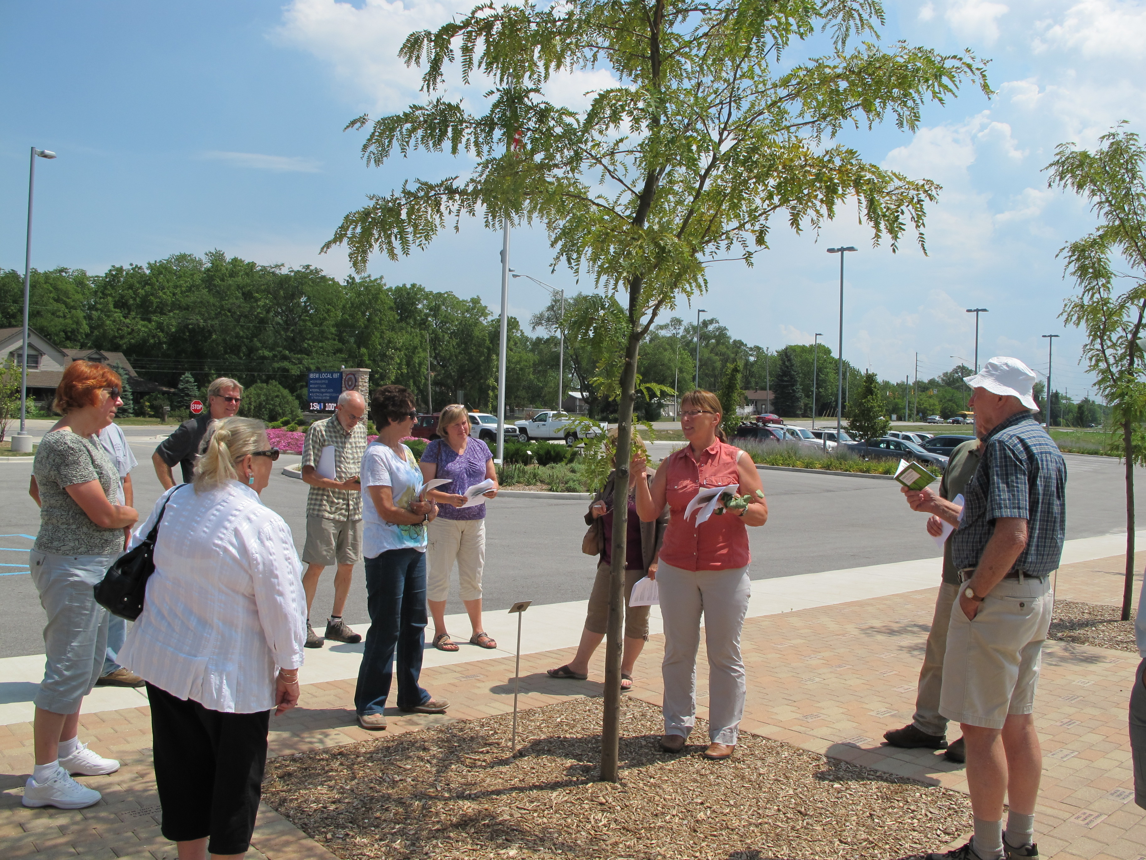
This is Tree Biology 101-condensed. Instructors explain the anatomy of trees focusing on the function of the stem, twigs, leaves, and roots, physiology i.e. photosynthesis, respiration, and compartmentalization, growth patterns and what they mean. Participants will leave this lecture with a general idea of the structures and functions of all parts of the tree.

Tree Identification
This is one of the favorites! Instructors for this topic include Indiana’s
District Foresters who focus on the parts of the tree that will help aid in identification, leaf shapes, fall color, leaf types, what type of trees might be present in wet or dry areas helping to aid in identification, and different tree shapes. Weather permitting, the second half of this two hour long topic is spent out of doors using a tree key to aid in identification. Participants will be able to use these learned tools of observation to help them begin to identify trees.

Selecting the Right Tree for the Right Place
Many problems in the urban forest could be alleviated if trees are planted in the right place. Participants will learn why it is important to select the right tree for the right place, determine the reasons for planting a tree, discuss trees that can handle specific site conditions, and view some species for tough sites. Participants will conclude this course topic knowing how to determine what tree species will fit in a particular environment.


The Indiana Community Steward Program is paid for by a grant from the
USDA Forest Service, Northeastern Area.

Diagnosing Tree Problems
Knowing how to identify characteristics of disease and pest damage can help tree enthusiasts begin their search for the correct diagnosis. The instructor helps participants key in on specific characteristics to determine types of problems and where to go from there. There is also a discussion on the status of Emerald Ash Borer which is a threat to the urban forest as it destroys Indiana ash tree population.

Proper Tree Planting and Maintenance Techniques
Planting and caring for a tree is not simple if you want it to survive and thrive into maturity. Instructors focus on different types of planting stock, choosing good stock at the nursery, and then describe or demonstrate how to dig the hole and then plant balled and burlapped, containerized and bare root trees. Participants will also learn how much water it takes for a new tree, types of mulch, how to mulch, fertilization dos and don’ts, and even a bit about lightning protection. Participants will know the right way to plant at the end of this lecture.

Pruning Do’s and Don’ts
After instruction on pruning, participants will be a bit more cautious when cutting branches off trees. Instructors describe different types of pruning, reasons to prune, bad pruning versus good pruning, tree response to pruning, and demonstrate how to actually prune, and demonstrate proper pruning tools. This lecture will help participants visually identify a good pruning job, how to prune young trees, and how to insure that pruning work they hire will be done professionally.

Identifying Tree Defects and Risk Awareness
This session will send participants home and looking up at trees to better understand why trees and tree parts fail. Instruction will include what tree defects to look for, defining a risk tree, what constitutes a target, and how to correct a tree that has risk issues. Weather permitting; there will be time to go outdoors to look at and discuss actual tree defects.

Benefits of the Urban Forest
This is a crash course that explains the science behind the benefits of trees in the urban forest, urban woodlands, and the urban forest as a whole. Discussion will focus on key environmental, economic, and psychological benefits; determine why the urban forest is in decline, and what is being done to enhance the health of this crucial urban natural resource. Participants will be able to articulate the key benefits of trees after this lecture.

Tree Steward Opportunities
The Volunteer Coordinator for urban forestry shares what volunteer activities are eligible to be counted toward tree steward hours, how to count those hours, and how to turn them in. Community non profits and tree board members are also sometimes on hand to share plans they have for local urban forestry initiatives and opportunities for Tree Stewards in their area. Participants will leave this session with ideas and opportunities on how to complete their 15 hours of volunteer service.

Indiana Community Tree Steward Written Exam
The exam is at the end of the last class, takes about an hour, and is multiple choice and short answer. The Volunteer Coordinator grades them and sends the grades to each participant. The exam is simply a way for participants to gauge their new found knowledge of trees in the urban forest. Each instructor insures that their presentation includes specific topic points that will be covered in the exam.

Workday
The Tree Steward workday is up to the host community or non profit to plan with suggestions from the CUF Volunteer Coordinator. It is usually three to four hours long and can consist of pruning young trees or working on a planting project.

Proud Co-sponsors of the Tree Stewards Program

