https://www.capitalpress.com/ag_sectors/livestock/idaho-mulls-change-to-post-exchange-grazing-permits/article_123d8a8a-c5e0-11ee-91c4-db0859d1739d.html

Capital Press

Idaho mulls change to post-exchange grazing permits
- By BRAD CARLSON Capital Press
- Feb 8, 2024

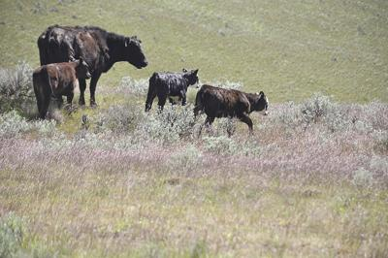
A bill in the Idaho Legislature would protect ranchers' grazing rights when there is a land exchange between the state and federal governments.
Capital Press File

Idaho ranchers will be able to keep key features of a federal grazing lease after the state assumes ownership in a land exchange under a bill before the state legislature.
The Senate Resources and Environment Committee on Feb. 5 voted to send Senate Bill 1243 to the full Senate with a do-pass recommendation.
The bill would apply to “a very narrow set of qualified lands,” according to its purpose statement.
Wilderness designations, wildfire management needs, and improved connection are among reasons that the Idaho Department of Lands and a federal agency may exchange parcels. In the West, a patchwork of ownerships and jurisdictions may prompt exchanges.
“It doesn’t happen very often,” Sen. Mark Harris, R-Soda Springs, one of the bill’s sponsors, said in an interview. “It’s a slow, drawn-out process — and rightfully so, to get everybody’s input.”
An exchange several years ago in Owyhee County left some ranchers feeling slighted, said Harris, a rancher. The bill would be retroactive to 2019 if passed.
Ranchers had opportunities to opt out of that exchange, Jonathan Oppenheimer, Idaho Conservation League government relations director, told the committee.
Following an exchange, a rancher faces a different set of costs and rules.
Federal grazing permits typically are renewed automatically if the holder stays in compliance. IDL permits cost more, and the land to which they apply may be auctioned after a period — recently 10 years. But state-level decision making may offer an advantage.
“By and large our members are willing to accept state management,” said Idaho Farm Bureau CEO Zak Miller. “The primary concern that comes with state management is the potential fracturing of a rancher’s continuity of decision making and grazing management.”
Parcels that the state acquires through an exchange would not be subject to auction requirements under SB 1243. The auction requirement only applies to original trust lands acquired from the federal government following statehood, according to the bill text, which cites the Idaho Constitution and state Supreme Court precedent.
Properties to which a federal grazing permit is attached are more valuable and bankable, Weiser-area rancher Cody Chandler told the committee. Banks use the permits as collateral.
“At the current time, I owe a fair amount of money to banks,” he said.
Chandler started on private land in 2000 and expanded as federal permits became available, he said. He also has state leases, with which he has had “really good luck.”
But a change from federal to state leases means the rancher loses a property right, he said. He supports the bill.
Idaho Code recognizes federal grazing-preference rights as property rights protected under the state Regulatory Takings Act, so the state “cannot lawfully extinguish these preexisting and legally recognized rights through an exchange," according to the bill text.
Compared to congressionally granted lands, lands that Idaho subsequently acquired through exchanges with the federal government — completed on an appraised, dollar-for-dollar basis — often come with preexisting encumbrances and property rights attached, according to the text.
If the bill passes, ranchers impacted by an exchange-prompted shift to state ownership would be issued a state permit instead of a lease, significant because leases are associated with congressionally granted lands, he said.

