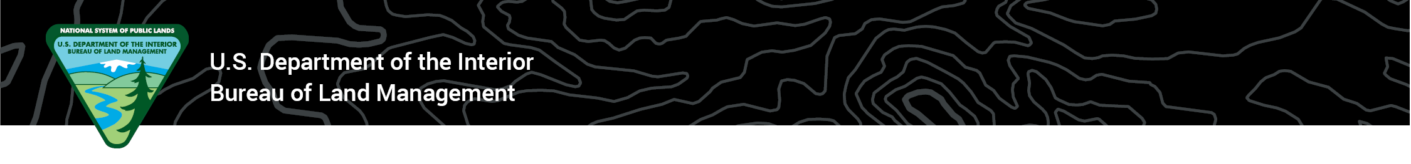News Release
BLM Office
Media Contact: BLM_Press@blm.gov or Jennifer Jones, jenniferjones@blm.gov, 208-373-4016
February 17, 2022

BLM Announces Karen Kelleher to Idaho State Director Position
Veteran land manager to oversee nearly 12 million surface acres and 37 million acres of subsurface mineral acres

BOISE -- Bureau of Land Management (BLM) Director Tracy Stone-Manning announced today that veteran land manager Karen Kelleher has been selected as the BLM’s Idaho State Director, based in Boise, Idaho.

In making the announcement, Director Stone-Manning said, “Karen Kelleher is a true professional with decades of experience contributing to the BLM’s multiple-use mission on behalf of the American people. We’re excited to have Karen leading our agency forward in Idaho, strengthening and expanding our partnerships with state and community leaders and being a good neighbor.”

As BLM Idaho State Director, Kelleher will oversee approximately 12 million acres of public lands, representing nearly one-fourth of the state's total land area, for multiple uses including livestock grazing, mining, conservation and recreation.

Kelleher’s career in federal service began more than two decades ago with the BLM, serving as planner, environmental coordinator, district manager, field manager and monument manager. She has held several key leadership positions in recent years including Senior Advisor to Assistant Secretary-Land and Minerals Management, Deputy Assistant Director for Resources and Planning in Washington, DC, and most recently served as the Associate State Director for BLM’s Arizona State Office since 2018.

Kelleher earned a bachelor’s degree in computer science from Union College in Schenectady, N.Y. and a master’s degree in environmental management from Duke University in Durham, N.C.

Kelleher will assume her new role in March, and acting director Peter Ditton will return to his permanent role as BLM Idaho Associate State Director.

-BLM-

The BLM manages more than 245 million acres of public land located primarily in 12 western states, including Alaska, on behalf of the American people. The BLM also administers 700 million acres of sub-surface mineral estate throughout the nation. Our mission is to sustain the health, diversity, and productivity of America’s public lands for the use and enjoyment of present and future generations.

