Email Signature Template
Please copy this template into Outlook and customize it with your professional contact information.
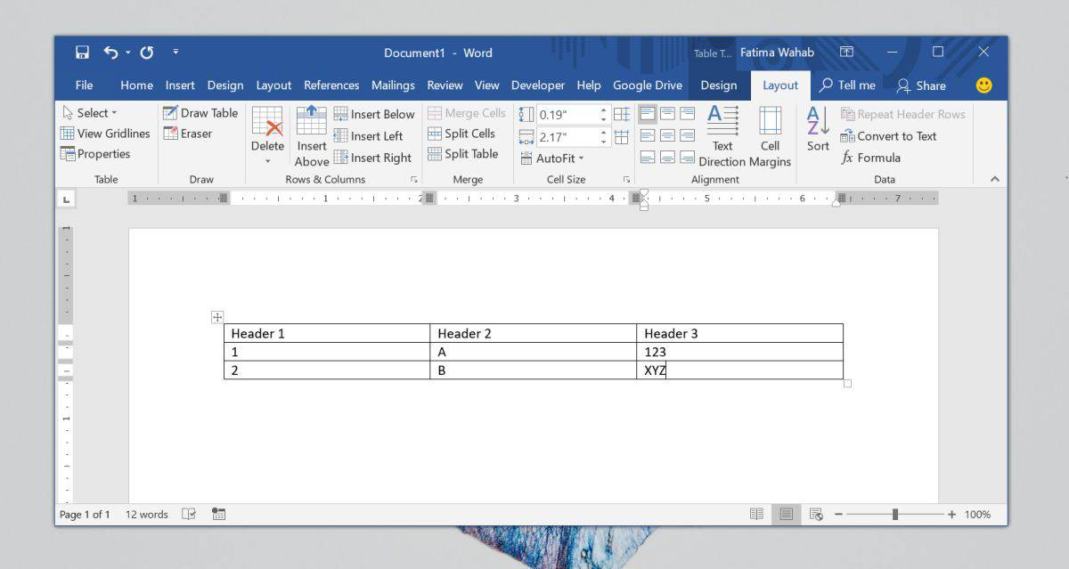
(See below: How to Create an Email Signature in Outlook.)
- Standard Template:
 | First and Last Name  Position/Title  Idaho Department of Lands  Address  Office: (208) xxx-xxxx  Email:  https://www.idl.idaho.gov

- Optional Template with Fire Logo:
 | First and Last Name  Position/Title  Idaho Department of Lands  Address  Office: (208) xxx-xxxx  Email:  https://www.idl.idaho.gov

- Mobile Devices Template (mobile Outlook App does not support image in email signature):
First and Last Name
Position/Title
Idaho Department of Lands
Address
Office: (208) xxx-xxxx
Email:
https://www.idl.idaho.gov

Signature Standards
Required—You should include the following information (text is Calibri, 10 pt):
- IDL logo
- Your first and last name
- Your position or title
- Agency name
- Address (as listed on the IDL website)
- Office phone number (and cell phone number if state-reimbursed)
- Your email address
- IDL website
Optional—Your email signature may include the following information:
- Mobile phone number
- Fax number
- OGCC website
- Certifications, credentials (example: “Archie Gray, Certified Forester”)
- Regular hours (include time zone)
Not Allowed—Do not include personal quotes in your signature. This will present a professional image and avoid having others assume a particular statement represents the agency.

Creating an Email Signature
Instructions are on the next page. Except:
- Outlook on Mobile Devices—When setting up a signature on your mobile device, the IDL logo may be omitted from the signature block. (In Microsoft Outlook for mobile devices, one cannot include an image in signatures generated by the mobile app.)
- Outlook on the Web (Office 365)—Find instructions at support.microsoft.com.

How to Create an Email Signature in Outlook
- In Outlook, click New Email.
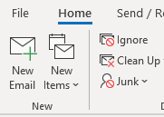
- Click Signature, and then select Signatures.
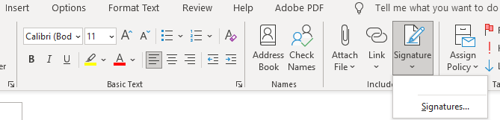
- Select New.
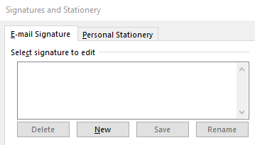
- In the popup window, type a name for your new signature (such as your name), and then click OK.
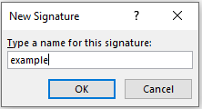
- Copy and paste the IDL signature template into the Edit signature box.
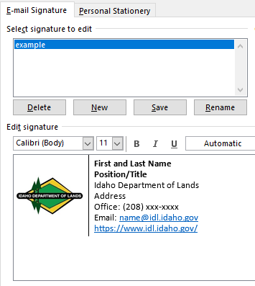
(Make sure your newly created signature is selected under “Select signature to edit.”)

- Add your contact information. Choose the default signature for New messages, and click OK.
