Social media posts for LPH and IDPH (launch)

The COVID-19 vaccines currently in use do not contain either live or dead virus. You may develop “flu-like” symptoms such as tiredness, fevers or headaches after receiving one or both doses of the vaccine but these usually resolve within three days. | 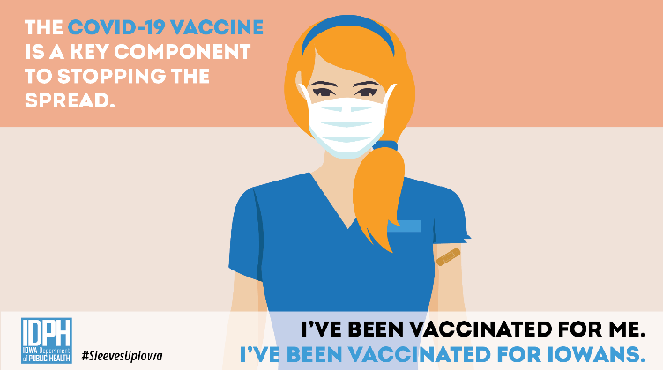
Right now, health care personnel, long-term care residents and staff are receiving the vaccine. As the supply increases, more populations will be prioritized to receive the vaccine. By mid-2021, there will be enough vaccines for anyone who wants to receive one. | 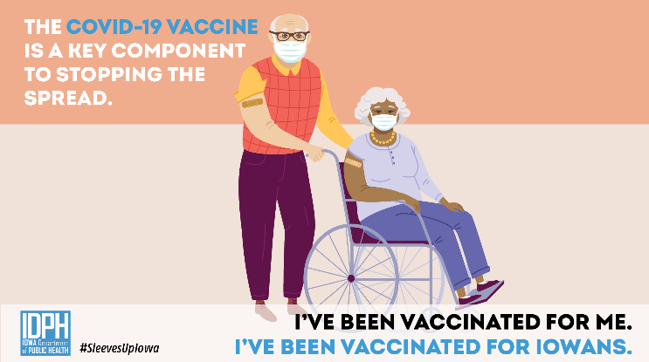
COVID-19 vaccines were tested in large clinical trials to ensure they meet safety standards. Many people were recruited to participate to see how the vaccines offer protection to people of different ages, races, and ethnicities, as well as those with different medical conditions. | 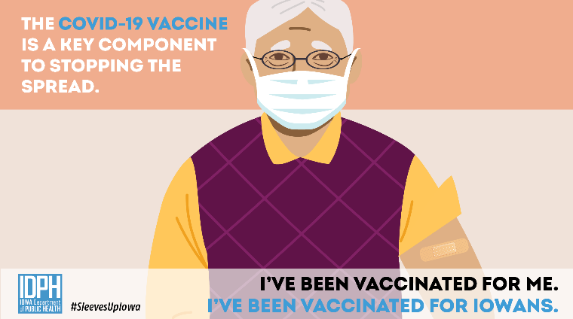
Vaccines work with your immune system so your body will be ready to fight the virus if you are exposed. Other steps, like covering your mouth and nose with a mask and staying at least 6 feet away from others, help reduce your chance of being exposed to the virus or spreading it. | 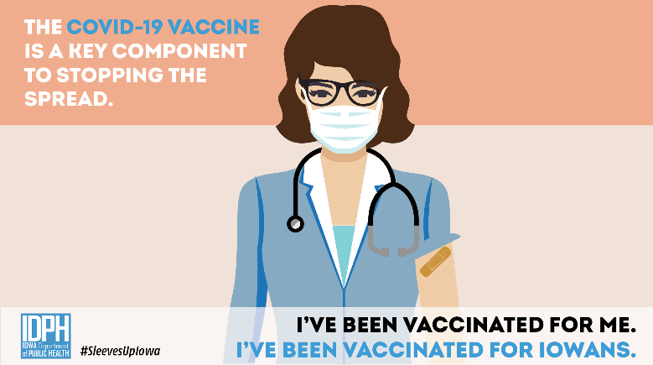
V-SAFE is a new smartphone-based, after vaccination health checker that will use text messaging and web surveys from CDC to check in with vaccine recipients for health problems following COVID-19 vaccination.

