Coast Guard wants your feedback!
Help improve the Nation’s shallow draft waterways ATON system

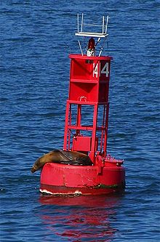
The U.S. Coast Guard is conducting a 5 minute on-line survey to assess the East Coast Shallow Draft Waterway Systems. The study will help the Coast Guard to determine the Aids to Navigation (ATON) requirements in the Shallow Draft Waterway Systems which includes all navigable waterways of the United States less than 12 feet. Surveys have already taken place on the West and Gulf Coasts, now it’s time for the East Coasters to weigh-in.

The Coast Guard wants your feedback if you operate in navigable along the east coast in waters less than 12 ft. in depth.

Take the survey NOW at https://www.surveymonkey.com/r/ShallowWaterWAMS
Who should take the survey?
The survey is geared toward boaters who operate on the east coast of the US in waters where the depth is 12 feet or less.
- All recreational boaters
- Commercial operators (construction/cargo/fishing)
- Local and state agency boat operators

Questions include years of experience, waters where you operate and how often, what navigation tools you use (radar, electronic charting systems, etc.), your concerns and more!

Take the survey TODAY at https://www.surveymonkey.com/r/ShallowWaterWAMS.

This link will remain available only until November 1, 2020.

Further questions or comments may be emailed to CGNAV@uscg.mil using the subject line: “Shallow Draft WAMS”.

