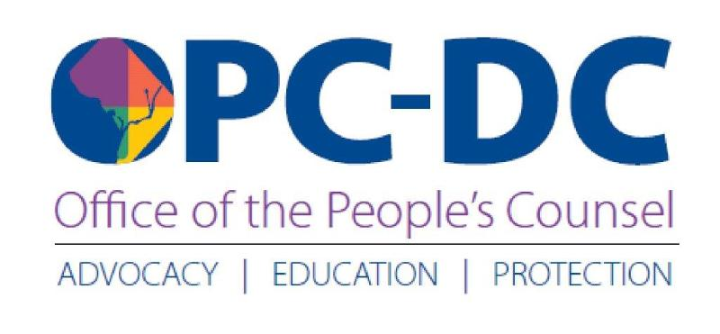

CONSUMER ALERT

OPC Commends DC Council Passage of Additional Protections for Utility Consumers During COVID-19 Health Emergency

April 8, 2020

Sandra Mattavous-Frye, People's Counsel for the District of Columbia, wants DC consumers to know about new relief for utility company customers that the DC Council approved yesterday. OPC staff worked with the Council to develop language in the COVID-19 Response Supplemental Emergency Amendment Act of 2020 that prohibits Verizon from disconnecting the service of local phone customers for non-payment during the public health emergency. Among other things, the act also bars shutoffs by all cable and internet service providers.

OPC also consulted with the Council prior to the passage of its first emergency legislation on March 17. That act prohibits the electric, natural gas and water utilities from disconnecting customers for non-payment during the coronavirus pandemic.

However, telecommunications companies were excluded. As the statutory advocate for all District utility consumers, OPC recommended to Ward 5 Councilmember Kenyan McDuffie, Chairman of the Committee on Business and Economic Development with oversight of utilities, that Verizon customers should be afforded the same relief.

"We applaud Councilmember McDuffie for his leadership and the rest of Council for taking extra steps in their second emergency bill to protect our constituents," says People's Counsel Mattavous-Frye. "Staying in touch with health professionals and loved ones is critical during these unprecedented times. It could mean the difference between life and death. We thank all Councilmembers and Mayor Muriel Bowser for their comprehensive response to the COVID-19 pandemic."

This second emergency bill also allows low-income DC Water residential customers who have outstanding water bill balances to apply for financial assistance from the Clean Rivers Impervious Area Charge (CRIAC) Assistance Fund. OPC became the advocate for DC Water consumers on April 11, 2019.

During the Mayor's telework stay-at-home order, OPC staff has continued to respond to consumer complaints related to their water, electric, natural gas and local phone utilities. Consumers should contact (202) 727-3071 for help with a service or billing issue, or file a complaint online @ opc-dc.gov.

Media Contact:
Doxie McCoy
Public Information Officer
(202) 261-1180
dmccoy@opc-dc.gov

