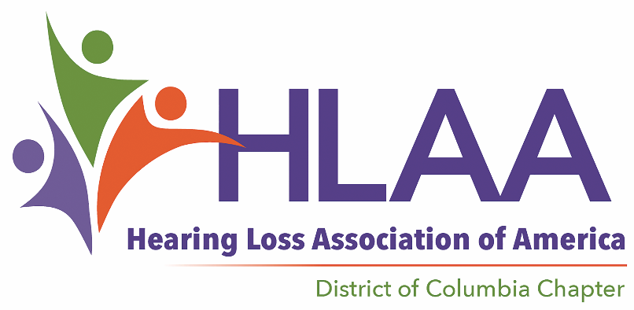
Best Audiological Practices
Date and Time: Sunday, May 6 at 2:00pm
Place: DC Public Library at Tenleytown
4450 Wisconsin Ave NW
Washington, DC 20016

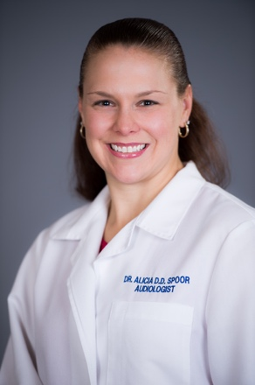
There is a general misperception that we need to visit an audiologist when there is a need to determine hearing aid and/or cochlear implant status. While correct, this is only a part of a larger story. To determine if hearing aids are right for you, and which features are beneficial, your audiologist needs a good understanding of the situations you find challenging and the type, degree, and causes of your hearing loss. This evaluation entails a “getting to know you” interview and a variety of tests. You should receive expert advice on hearing technologies to supplement hearing aids, communication strategies, hearing aid fine tuning, and a referral to another specialist if testing indicates a medical issue.
Alicia D.D. Spoor, Au.D., will discuss best audiological practice and will answer your questions. Dr. Spoor received her doctorate from Gallaudet University and is President of the Academy of Doctors of Audiology, an organization dedicated to practitioner excellence, high ethical standards, sound business practices, and quality audiologic care. She started her own practice, Designer Audiology, born out of her passion for delivering quality, person-focused audiological care.

Our meeting room in the Tenleytown library facility is looped, and real-time captioning will be provided so that everyone can participate in the program comfortably. There is no charge. All are welcome.

