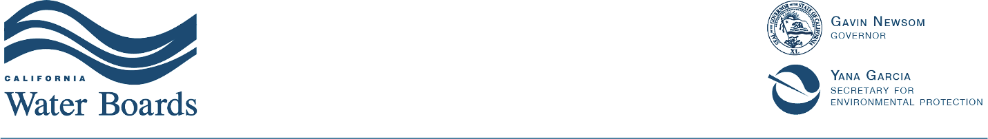
Central Valley Regional Water Quality Control Board
Irrigated Lands Regulatory Program

Stakeholder Meeting
26 July 2023
10:00 AM – 1:00 PM
Hybrid Meeting – Stanislaus Farm Bureau or Zoom
1201 L St, Modesto
(email Keri.Yee@waterboards.ca.gov to request Zoom link)

Agenda
Goal: Provide open forum for communication between water board staff, agricultural coalitions, environmental justice groups, and other interested parties in the Central Valley
- Introductions and Agenda Review
- Concise (< 5 minute) Updates (10:15 to 11:35 AM)
- Central Valley Water Board
- State Water Board
- California Department of Food and Agriculture, FREP
- Central Valley Agricultural Water Quality Coalitions
- Environmental Justice Representative(s)
- CVSALTS Updates
- Pyrethroid Research Plan (11:35 to 11:45 AM)
- No-host lunch (15 minute break to obtain reserved lunch – please RSVP and be prepared to pay $15 to Stanislaus Farm Bureau)
- Lunch time discussion (start no later than noon):
Groundwater Protection Targets & Groundwater Quality Management Plan Updates
This will include an update on the Management Practice Evaluation Program.
Link to a YouTube video of April CV Water Board information item on the Targets:
www.youtube.com/watch?v=d_rrFdFbDmg&t=4720s
- Next Meeting (25 October 2023)

