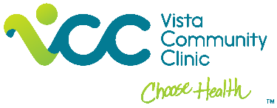

Empowering Local Communities to End the Tobacco Epidemic
Community Engagement Partnership

Vista Community Clinic is working to build momentum toward ending California’s tobacco epidemic through policy, systems, and environmental change strategies by increasing community engagement in these initiatives within populations that have been disproportionally targeted by the tobacco industry. VCC is looking to fund $2,500 to local groups or agencies serving low-income Latinos, youth or young adults, environmental and social justice groups.
The 2022 Policy Platform published by the Latino Coordinating Center for a Tobacco-Free California lists many reasons that messaging and policies in the Latino community must support tobacco-free living: (1) the tobacco industry has a history of targeting Latinos; (2) e-cigarettes have been marketed with flavors specifically designed to appeal to Latinos; (3) Latinos are less protected by smoke-free workplace laws; (4) Latinos are more susceptible to secondhand smoke where they live because they are more likely to live in multi-unit housing; (5) Latino neighborhoods have more tobacco retailers; and (6) tobacco is a major driver of death among Latinos.

Desired Health Outcome: Reduce and prevent exposure to secondhand smoke and create equitable living spaces for multi-family housing residents.

Goal: Smoke-free multi-family housing and outdoor public areas.

Project Locations: City of Vista and City of Escondido

Project Timeline: One year

Partner Groups would be invited to support one or more of the following activities. Activities to complete will be mutually agreed upon between VCC and the partner agency based on the partner agencies ability and desire. Activities could include, but are limited to the following:
- Attend trainings (i.e. Community Organizing; Tobacco Use and Health Equity; Advocacy)
- Recruit volunteers or advocates
- Promote and attend tobacco advocacy events in the community
- Share social media posts
- Review and provide feedback on educational materials
- Collect public opinion surveys
- Other mutually agreed upon activities

For questions, please reach out to Jennifer Gill, Vista Community Clinic Tobacco Program Manager, Jennifer.Gill@vcc.org

