Search page
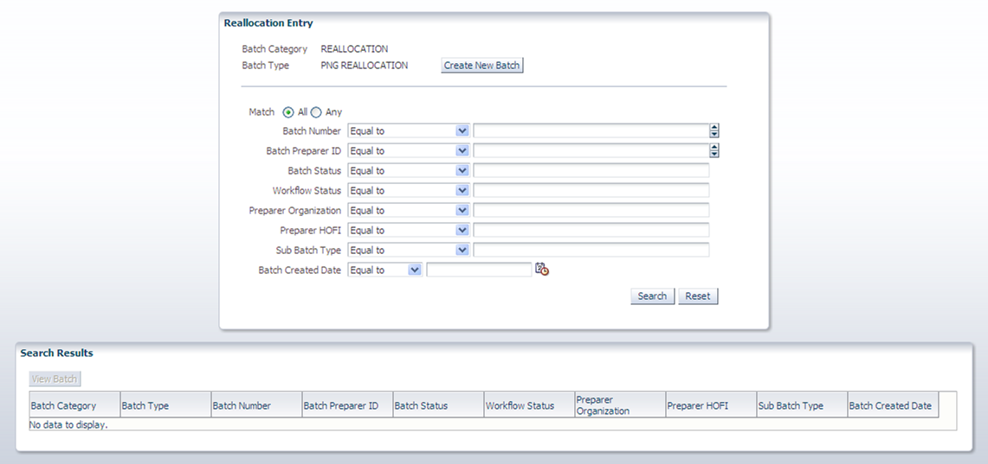

Search page with results
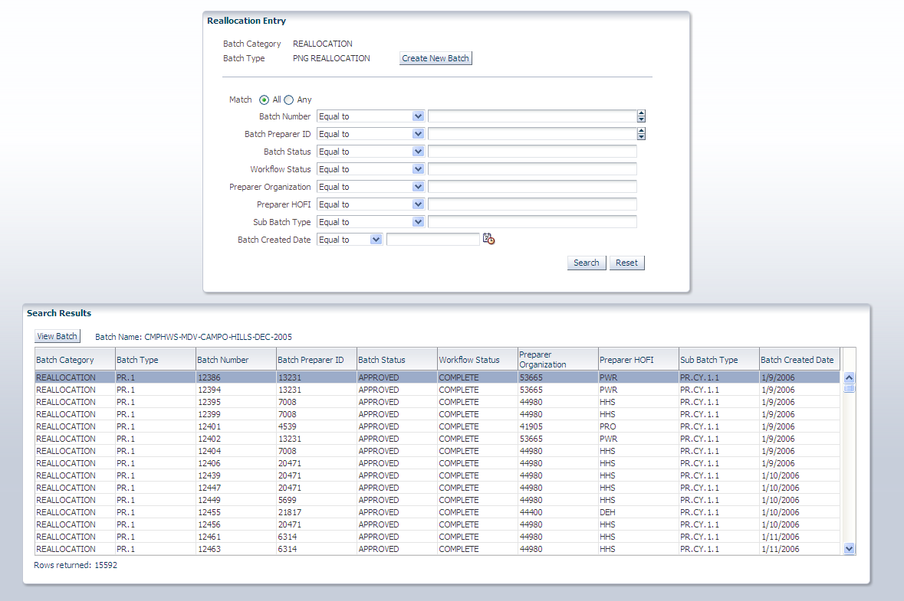

Reallocation main page
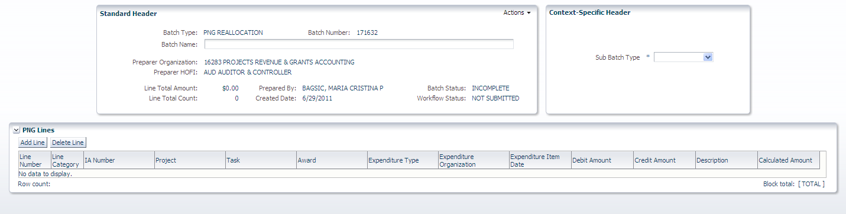

Reallocation main page with line entry
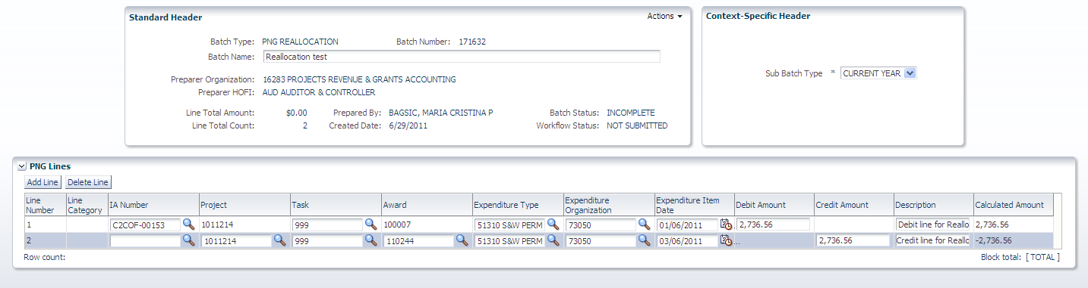

Reallocation main page with action menu
