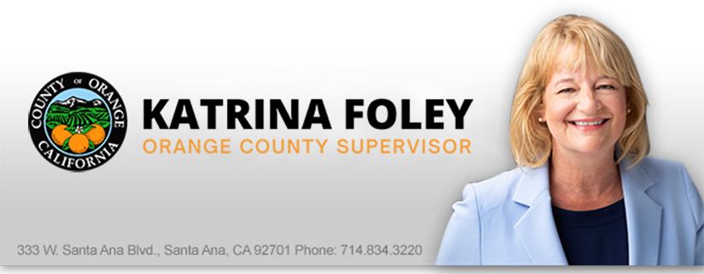
FEDERAL BIPARTISAN INFRASTRUCTURE BILL PASSES & BENEFITS ORANGE COUNTY
This month, President Biden signed the $1.2 trillion Infrastructure Investment and Jobs Act (IIJA). This massive infrastructure bill provides reliable transportation funding for the next five years, including $115.8 billion in new spending for highways, $42.1 billion for transit and $86.7 billion for rail programs.
The bill also provides funding for new programs, to battle the effects of climate change and $7.5 billion to speed up the conversion to electric vehicles, leading to cleaner air for all.
There are so many worthy projects that will benefit Orange County. We are organized with designed and shovel ready projects at both the County and OCTA to take advantage of this funding opportunity. I’ll be working with our local city leaders to identify projects we can partner on to capture funds and move long standing projects forward. Send us your wish list so we can prepare: Katrina.Foley@OCGov.com
South County Congressman Levin supported the bipartisan bill and he’s already working with local officials in San Clemente to identify projects. Check out his video: Here

LISTENING TO SOUTH COUNTY RESIDENTS
During the last 2 months I twice voted to support the efforts of South County local officials’ requests to Supervisor Bartlett for a cooperative agreement related to the future of transportation projects that protect the quality of life and the beaches of South Orange County. Many local officials reached out to my office for support. At the County Board the vote was 3-2 in favor, but fortunately a stronger super majority of OCTA directors supported the plans. “For decades, residents in San Clemente have spoken loud and clear about the importance of preserving our open space and protecting the character of our community,” said San Clemente Mayor Kathy Ward. “Thanks to this agreement, we can finally focus on common-sense traffic solutions to ensure our City and our neighboring cities remain desirable places to live, work and visit.”
You can read more about the plan: Here
I-405 Update
I’ve participated in the construction of the I-405 Construction Project at so many levels. As a former City Council Member and Mayor, I advocated for greater access to the express lane and to protect adjacent residents and businesses from construction impacts. Now, as your County Supervisor and OCTA Director, I continue to monitor the impacts, including trash and increased graffiti, and progress toward a better transportation system. Construction on the I-405 Improvement Project, which is improving a 16-mile stretch of the freeway between Costa Mesa and the Orange County border with Los Angeles County, continues to move forward with an anticipated completion date of 2023.
The project is adding one regular lane in each direction between Euclid Street to I-605, and a second lane in each direction in the center of the freeway from SR-73 to I-605 that will combine with the existing carpool lanes to form the 405 Express Lanes. The project is nearly 70% completed.
You can learn more about the project status: Here

I-5 UPDATE
Supervisor Bartlett and I both serve on the Orange County Transportation Authority (OCTA). She recently shared a good recap of what’s happening and in store at various interchanges related to the I-5 Widening Project.
Approved by nearly 70% of Orange County voters, the $580 million project spans 6.5 miles and is being constructed in three segments. The overall project is more than one-third finished, with Segment 1 from SR-73 to Oso Parkway and Segment 2 from Oso Parkway to Alicia Parkway each 50% complete. When completed, these improvements will increase freeway capacity and enhance ramp, roadway and interchange operations from Mission Viejo to Laguna Woods. You can read a detailed update: Here
Sign up to receive alerts here:
- Sign up for Weekly Construction Alerts at https://bit.ly/3oGFNAO
- Get construction notices on FB and Instagram feed @oci5southcounty
- Contact the I-5 team with specific questions at (949) 614.0202 or via email: i5southcounty@octa.net
For our active transportation friends, don’t worry, we are also focused on helping improve our protected multipurpose trail systems to help more residents leave their cars at home for short trips to the store, school, a friend’s house, or in many areas even to work. You can read more about our active transportation projects: Here
As we continue to improve physical mobility alternatives, we need your input. Send us an email with ideas for improvements here: Katrina.Foley@OCGov.com
OCTA SURVEY
In an effort to learn from residents, riders, and local businesses, OCTA recently conducted a survey. Not surprising, homelessness is the top concern. Our efforts to reduce homelessness and improve the system of care remain a top priority. See the survey results: Here

