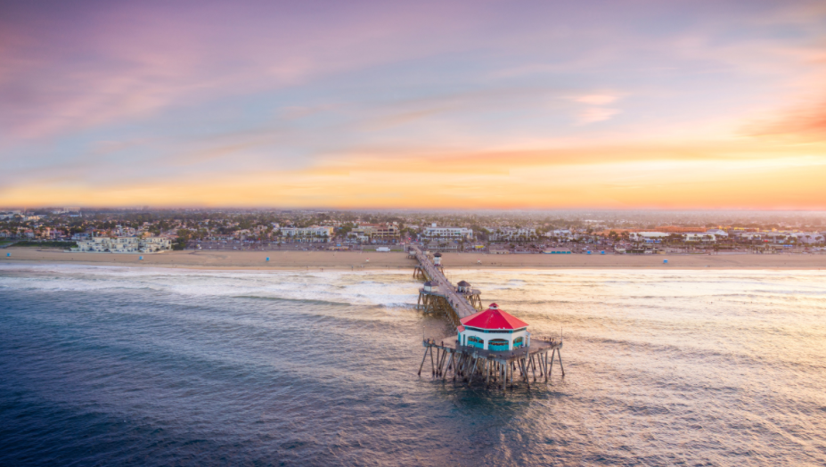
Orange County Oil Spill Update
Current Status:
All public beaches and harbors are open to the public.
All booms have been removed.
Fisheries remain closed and are set to open in late November.
Vessel decontamination sites are still operational in Huntington Beach, Newport Beach and Long Beach-- of 248 claims submitted; 216 vessels completed; 32 vessels in progress
Resources:
For Business Impact Recovery Claims, Call (866) 985-8366
Fill out the Economic Injury Worksheet and return to EOCLiaison@ocsheriff.gov
History of the Oil Spill:
On October 1, an oil slick was reported off the coast of Huntington Beach.
While (estimated) 24,696 gallons of oil was released during the spill, 5,544 gallons of oil was recovered on the water, along with 13.6 barrels of tar balls (571.2 gallons), and 532,522 pounds of oily debris and sand collected. Later, boiled oil was discovered and cleaned up.
Wildlife Update
The toll of an oil spill impacts many of our natural resources and the animal population. 99 birds were found during the oil spill (34 live – 22 released; 82 dead), along with 7 mammals, and 1 reptile.

