
CCI BioEnergy Awarded Equipment Supply Contract for Toronto's Disco Road Organics Processing Facility Expansion
Published Jul 27, 2026
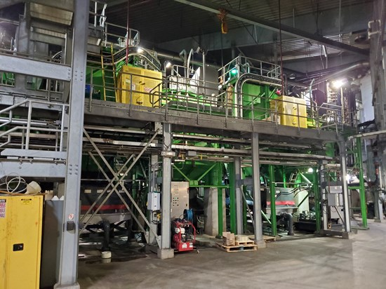
Toronto, Ontario–(Newsfile Corp. – July 27, 2026) – CCI BioEnergy is pleased to announce that it has been awarded the contract to supply key process equipment for the expansion of the City of Toronto’s Disco Road Organics Processing Facility. The project will significantly increase the facility’s organics processing capacity while supporting the City’s continued investment in sustainable waste management infrastructure.
The agreement follows the preliminary and detailed design work previously announced by CCI BioEnergy for the pre-treatment and part of the anaerobic digestion (AD) process for the facility expansion. Upon completion, the project will increase the facility’s processing capacity from 75,000 tonnes per year (tpy) to 125,000 tpy, with a peak capacity of 140,000 tpy.
Under the agreement, CCI BioEnergy will supply a BTA® Waste Pulper, BTA® Grit Removal System, two anaerobic digester equipment packages, and associated ancillary equipment required for the facility expansion. The supplied equipment will form the core of the facility’s organics pre-treatment and anaerobic digestion process, removing contaminants from collected Green Bin material while ensuring the highest organic materials capture rates and as a result maximized conversion into biogas. In addition to equipment supply, the agreement includes installation support, on-site supervision, acceptance testing, training, and project documentation required to support full implementation of the expanded facility.

The Disco Road Organics Processing Facility processes source-separated organics collected through Toronto’s Green Bin Program. The facility accepts a wide range of residential organic materials, including food waste, diapers, incontinence products, pet waste, kitty litter, and other organic materials collected in both plastic and compostable bags. After removal of the contaminants these materials are fed into the digesters and converted into biogas and high-quality Class A compost quality.
“We are proud to continue supporting the City of Toronto on one of North America’s leading municipal organics processing facilities” said Ward Janssens, President of CCI BioEnergy. “Having worked alongside the City through the design phase, we look forward to delivering the equipment and supporting the successful implementation of this important expansion project.”
The Disco Road expansion project builds on more than two decades of organics processing experience at City of Toronto facilities utilizing the BTA® Process. Additional project milestones and construction activities will be announced as the project progresses.

