Weekly Vaccine Digest 12/8/23
Los Angeles County Department of Public Health
Dear Colleagues and Partners,
Below are the LACDPH weekly vaccine administration and order updates, upcoming webinars, and newsworthy events. Attached to this email you will find a pdf version of this digest and the links shared during the CDPH Office Hours. To view the CDPH recording and slides please visit https://eziz.org/. We have received additional doses for the Bridge Access Program (BAP). Please submit your vaccine order by Monday at 5:00 pm to receive your vaccine order the following week. Orders submitted after Monday at 5:00 pm may take an additional week to deliver. Please order a 1–2-week supply of COVID-19 vaccine through myCAvax and re-order as necessary as you assess patient demand.

Attached to this email you will find a pdf version of this digest and the links and slides shared during the LA DPH and CDPH Office Hours.

If you received this email and would like to be added to our listserv, please contact our COVID-19 Provider Vaccine Call Center at covidvaccinereq@ph.lacounty.gov
Table of Contents
- Page 1-3: Order and Administration Reminders
- Page 3: CDPH Information and Education
- Page 3-5: COVID-19 Vaccine Administration Data
- Page 6: RSV Update: RSV Vaccine Special Ordering Now Open
- Page 6-8: COVID-19 Testing Updates
- Page 8-9: Clinical Information
- Page 9-10: COVID-19 Vaccine Storage & Handling
- Page 10-11: Vaccine Insurance Coverage
- Page 12-13: Vaccine for Children (VFC)
- Page 14: Holiday Shipping Cadence
- Page 15: Upcoming Webinars, LACDPH & CDPH Provider Office Hours Link

Order and Administration Reminders
- Holiday Note: The CDPH Immunization Updates for LHDs and Providers are cancelled on the following dates:
  - Friday, December 22, 2023
  - Tuesday, December 26, 2023
  - Friday, December 29, 2023
  - Tuesday, January 2, 2024
- REMINDER: For delivery before the holidays, please place ALL vaccine orders by Monday, December 11th.
  - There will be NO BAP or VFC deliveries from December 20th through December 29th.
- Vaccine delivered from the DPH warehouse will be delivered 3-7 business days after the order is place in myCAvax. Please present a photo ID (work badge, school ID, driver’s license, etc.) and sign for the delivery when received.
- REMINDER: If a Shipment Incident results in a Temperature Excursion, providers should always report the Shipment Incident first. CDPH will determine if the vaccine should be reported as waste and then they will inform the provider
  - VFC providers should report temperature excursions and waste events in myVFCvaccines
  - BAP and SGF providers should report temperature excursions and waste events in myCAvax
  - Outbreak (mpox/Jynneos) providers should NOT report temperature excursions in myCAvax, but all waste events should be recorded in myCAvax in vials NOT doses.
    - Note: Expired or spoiled Jynneos vaccine does NOT need to be returned to LAC DPH or the manufacturer. Ignore the “Return Shipping Method” section when reporting a waste event and leave it as the default. That section is only for providers in counties besides LA County.
- REMINDER: Pfizer, Moderna, and Novavax are all available for ordering through myCAvax for Bridge Access Program (BAP) providers and through myVFCvaccines for Vaccines for Children (VFC) providers VFC providers may only report through myVFCvaccines.
  - VFC providers that report in the wrong system (myCAvax) should contact the Provider Call Center at ProviderCallCenter@cdph.ca.gov or call (833) 502-1245 for guidance on removing or updating the incorrect report BAP providers may only report through myCAvax.
  - BAP providers that report in the wrong system (myVFCvaccines) should contact the VFC Call Center at myVFCvaccines@cdph.ca.gov or call (877) 243-8832 for guidance on removing or updating the incorrect report
- REMINDER: Job aid for Vaccine and Clinic Eligibility by Funding Source can be found here.
- UPDATED: Bap Eligibility Resource can be found here
- CA BAP Program Requirements can be found here.
- Additional BAP Resources can be found here.
- NOTE: CAIR/RIDE Registry ID's - Under AB 1797, vaccine providers are required to enter immunization information into the California Immunization Registry (CAIR) OR Healthy Futures/RIDE.
  - 119 VFC Providers have no IIS Org Code.
  - Reminder to Providers: Please join CAIR/RIDE.
  - CAIR webinar slides and recordings will be available after next week at http://publichealth.lacounty.gov/ip/trainingsconferences.htm
- NOTE: V-safe for RSV Vaccines in Older Adults Now Available
  - V-safe now available for adults 60 years and older who received RSV vaccine
    - Will be available soon to pregnant people who received RSV vaccine
  - V-safe is a safety monitoring system that lets you share with CDC how you, or your dependent, feel after getting an RSV vaccine.
  - Using V-safe after RSV vaccination requires a new registration.
  - Please encourage your patients to participate.
  - CDC V-safe
  - V-safe print materials
- Covid-19 Vaccine Fact Sheets can be found here.
- Novavax COVID-19 Vaccine Resources:
  - Novavax at a Glance (CDC, 10/31/23)
  - Storage & BUD Tracking Labels (CDC, 10/18/23)
  - Standing Orders (CDC, 10/31/23)
  - Expiry Checker (Novavax)
  - Temperature Excursion Checker (Novavax)
  - CDC Resources by Product
______________________________________________________________________________
CDPH Information and Education
COVID-19 Treatments – Resources and Toolkits
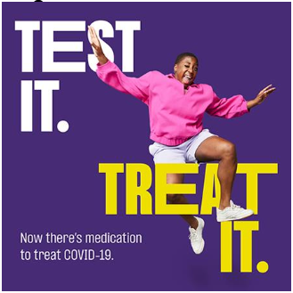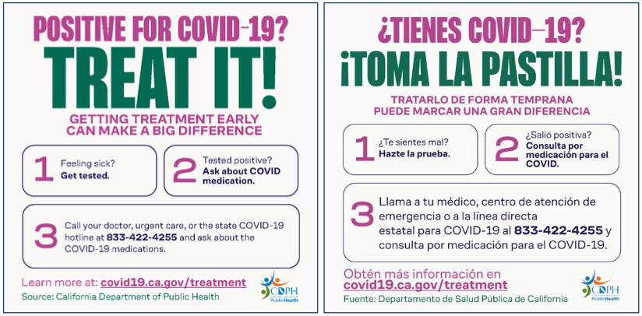
- You can access additional shared resources on treatment by accessing the CDPH COVID-19 Treatments Toolkit.
- For questions, please contact OTCTesting@cdph.ca.gov
_____________________________________________________________________________
COVID-19 Vaccine Administration Data
- COVID-19 Vaccine Administration Summary (as of Nov. 27, 2023)
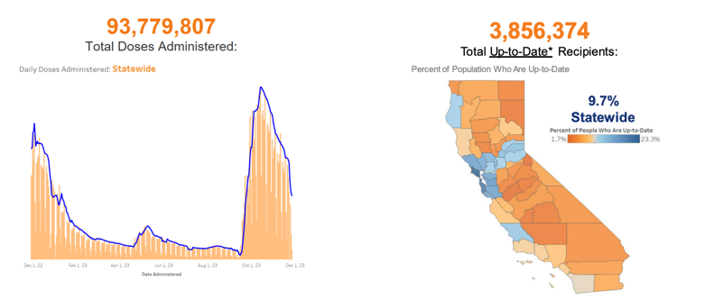
  - State-wide Vaccine Data (see here)

- Bivalent vs Up-to-Date Uptake: COVID-19 Vaccine
  - Over time:
    - In 84 days since EUA, Bivalent Booster uptake was 12.8% vs 10.3% with Updated 2023-2024 doses
  - Divide in Bivalent Booster vs. Updated 2023-2024 dose increasing over time
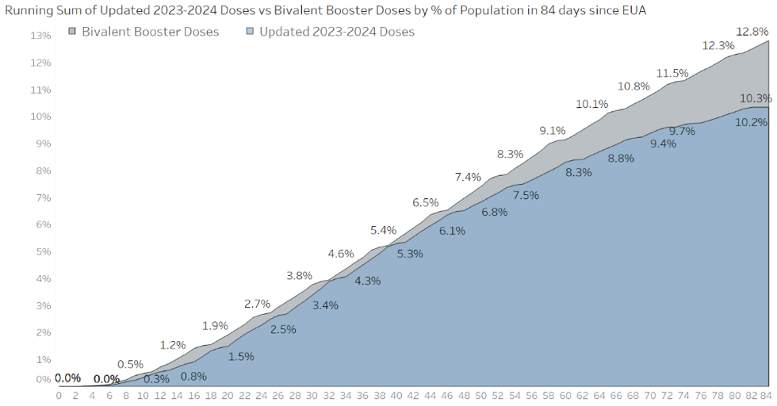
- Trends in COVID-19 Vaccine Administration
  - Most Recent Eligibility Groups
  - Updated 2023-2024 vaccine for 6 months and older
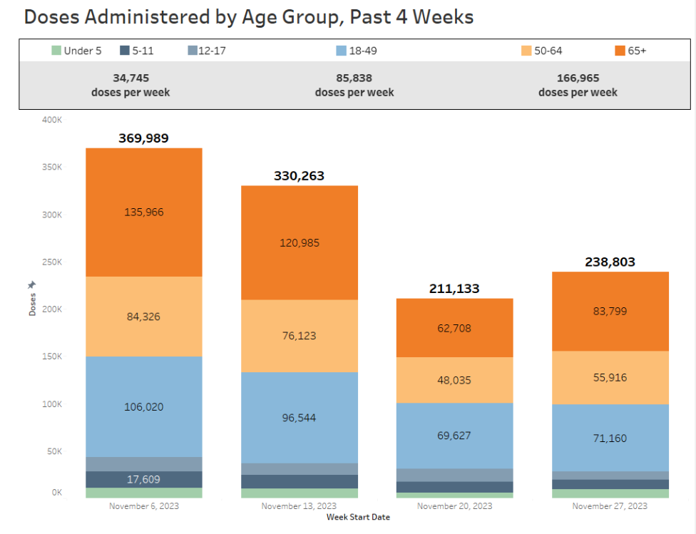
- Up-to-Date COVID-19 Vaccination Status by Race* and Age
  - By race and age:
    - Highest uptake among NHPI, White, and Asian
    - Uptake above state average in all 65+ race/ethnicity groups
  - * - Vaccination rate estimates for some groups, such as NHPI, may be affected by differences in how demographic data is collected by the Census and at the time of vaccination
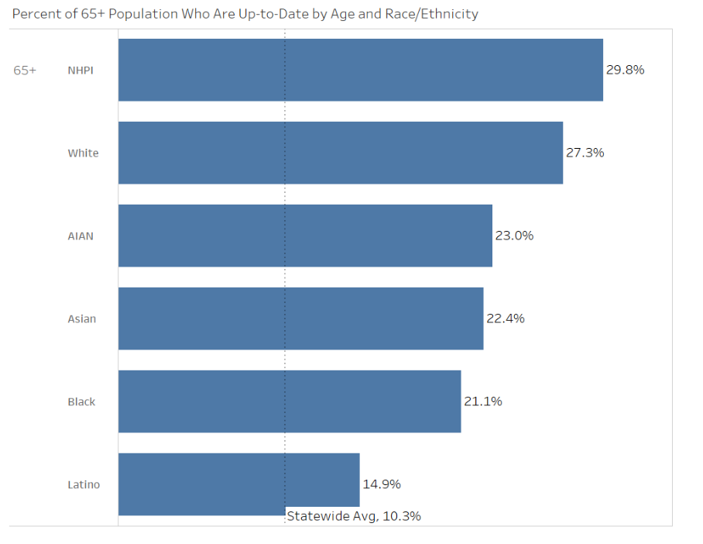
- Providers Administering Updated 2023-2024 COVID-19 Vaccine
  - 5,013 Total Updated 2023-2024 Vaccine Providers Reported
  - 74% of previous Bivalent vaccine Providers
  - +2% pt increase from last week
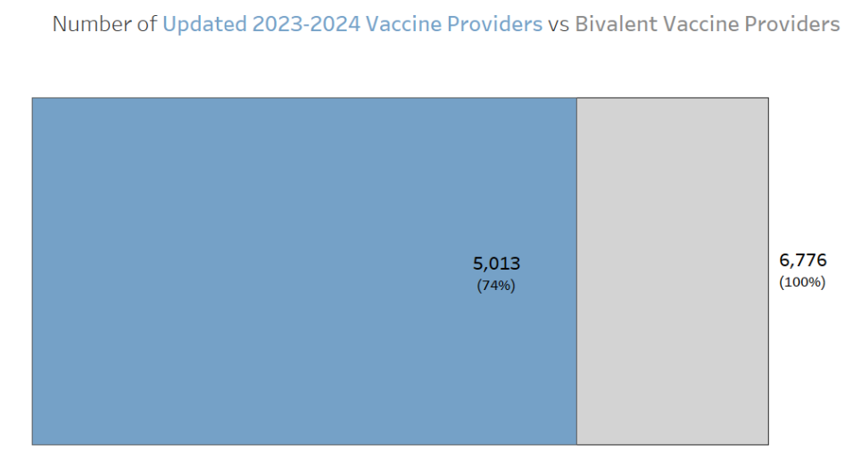
- COVID-19 Vaccine Data Summary
  - Key Metrics
94.0 million doses administered | +239K doses administered
10.3% Statewide who are Up-to-Date | 4.1 million Up-to-Date recipients
27.1% 65+ who are Up-to-Date | 1.8 million 65+ Up-to-date recipients
  - System Notes
    - Public dashboard Up-to-Date status now includes the Updated 2023-2024 guidelines
    - Email cdphvaccinedatateam@cdph.ca.gov for questions and comments

_____________________________________________________________________________________
RSV Update: RSV Vaccine Special Ordering Now Open

The Vaccines for Adults (VFA) and 317-LHD Program has now opened special ordering for RSV vaccine and will be closing this ordering period on December 12, 2023. CDC has allocations in place to facilitate equity across jurisdictions. Due to the limited quantities available, 317-LHD providers can order up to 20 doses of either Abrysvo or Arexvy vaccine. Clinics can only select one brand of RSV vaccine to order. Vaccine requests will be approved based on available supply and ordering will close once our current allocation has been depleted. RSV vaccine will be available again for ordering once additional allocations are received.

If your practice would like to request doses beyond the caps, please include the amount and justification in the comment section of the order form. These requests will be reviewed and approved on a case-by-case basis.

The only vaccine available to order during this period is RSV. All other vaccines will be available to order when you place your next monthly order.

After placing your RSV order, review the VFA RSV Clinical Letter, which includes information regarding:
- Adult RSV Immunization Recommendations
- Prenatal RSV Vaccine Guidance
- RSV Educational Resources
- VFA Program Resources
Steps to Order Vaccine:
- Log-in to your MyVFCVaccines account.
- Enter your VFC PIN and ZIP Code.
- After you have logged in, click on the "Order 317 Vaccines" button.
- Confirm that your Practice Delivery Information is correct.
- For your order, select the vaccine from the drop-down and enter the number of doses you would like to request.
- You will be required to enter 317 doses administered and 317 doses on hand.
- Click Preview to review the order and make any corrections if necessary.
- Click Submit to place your order.
For any questions, providers can reach out to: my317vaccines@cdph.ca.gov.
_____________________________________________________________________________________
COVID-19 Testing Updates
- End of the CDPH COVID-19 Testing Programs
  - The test distribution programs that were under the Testing Task Force are now part of the Medical Countermeasure Unit in CID
  - CDPH is currently providing direct distribution of:
  - OTC tests through Feb 29, 2024*
    - *while supplies last
  - Professional tests to facilities with their own CLIA-waiver through June 30, 2024
    - Order professional CLIA-waived tests here: https://labsupport.powerappsportals.us/ordercovidprofessionaluse/
  - Thanks to you, CDPH has distributed 107 million at-home tests over the past 3 years!
- Eligible Orgnization
  - Federally Qualified Health Centers (patients, communities)
  - All CA Health Centers and Clinics (priority populations)
  - CA Pharmacies (priority populations)
  - Skilled Nursing Facilities and Long-Term Care Facilities (residents, staff and visitors)
  - A focus on priority populations
    - Uninsured/underinsured
    - SNFs/LTCF
    - Medicare part B, people >65
    - Those disproportionately affected by COVID-19
- Ordering Deadlines, Expiration Dates and Storage
  - Last day to order is February 29, 2024
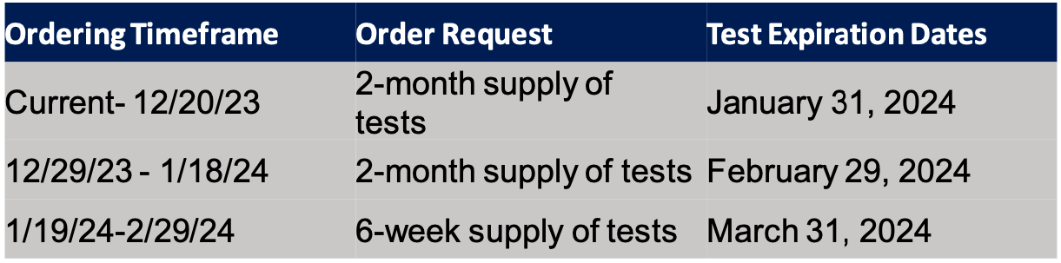
  - 2 tests per box
  - Store between 36-86°F
  - Order here: https://labsupport.powerappsportals.us/ordercovidotc/
  - For more information on the end of the at-home testing program, including ordering eligibility and deadlines, please visit: End of CDPH's At-Home Testing Program
- Additional ways to obtain COVID-19 tests
  - Insured? You may be eligible for free or low-cost tests. Read more here: https://covid19.ca.gov/get-tested/
  - Fall 2023, U.S. households can order free COVID-19 tests mailed to their home: https://www.covid.gov/tests
  - Home Test to Treat offers free tests and free treatment (if eligible) for
  - COVID-19 at home www.test2treat.org. * As of December 8, 2023, eligible individuals that sign up for Home Test to Treat will be sent COVID/Flu tests to use and home treatment options available will include COVID and Flu treatment (depending on the test result).
- Update on COVID/Flu A&B Multiplex Tests
  - Skilled Nursing Facilities, Long-Term Care Facilities, Federally Qualified Health Centers, and Community Clinics with their own CLIA and state licensing can request COVID/Flu A&B Multiplex Tests.
  - Printed expiration dates on these tests are January 31, 2024, and they have been extended! Extended expiration dates on the COVID/Flu Multiplex tests is October 31, 2024!
  - If you are an eligible facility with your own CLIA and you are interested in ordering COVID/Flu A&B Multiplex tests, please email OTCTesting@cdph.ca.gov for information on how to order.
_____________________________________________________________________________________
Clinical Information
- RSV Activity in California, 2023-2024 Season—Limited Opportunities Remain To Prevent Severe RSV
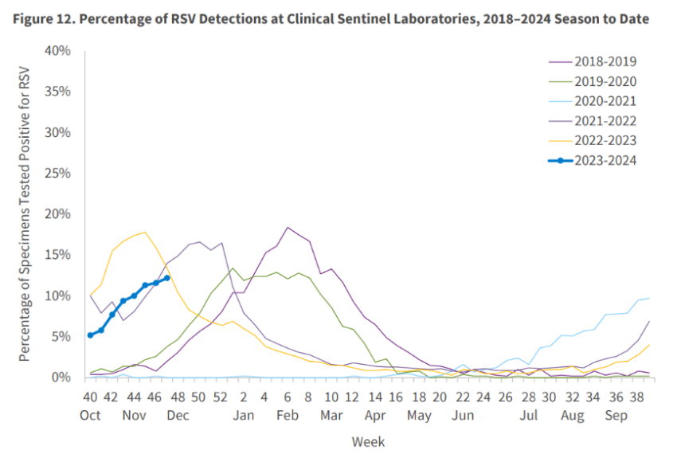
  - Week of Nov 17-Nov 25: RSV positivity 12.2%
- Options to Prevent Severe RSV in Early Life
  - New options for 2023-2024
    - Prenatal RSV vaccine (Abrysvo) at 32 – 36 weeks gestational age
    - Postnatal immunization (nirsevimab)
      - Birth hospitals
      - Outpatient visits
  - Ongoing options
    - Seasonal monthly palivizumab
      - For high-risk children
    - Breastfeeding
    - Hand and respiratory hygiene, distancing, etc.
- Prevent Vaccine Administration Errors
  - Ensure the right product is being given
  - Abrysvo: RSV PreF vaccine indications
    - Adults 60 years of age and older, under shared clinical decision making
    - Pregnant persons between 32-36 weeks pregnancy between September-January
  - Arexvy: RSV PreF3 vaccine indications
    - Adults 60 years of age and older, under shared clinical decision making
  - Nirsevimab (Beyfortus): monoclonal antibody indications
    - Infants and toddlers
  - SEE JOB AID PDF HERE
- Reporting Nirsevimab Adverse Reactions
  - If Nirsevimab is given alone:
  - These reactions may be reported to MedWatch online (https://www.fda.gov/medwatch), by fax, by mail, or by contacting FDA at 1-800-FDA-1088
  - If adverse reaction occurs after coadministration of nirsevimab with a vaccine
    - Report to Vaccine Adverse Event Reporting System (VAERS)
    - Reports should specify that the patient received nirsevimab on the VAERS form specifically, in Section 9: “Prescriptions, over-the-counter medications, dietary supplements, or herbal remedies being taken at the time of vaccination.”
    - When adverse reactions that occur after the coadministration of nirsevimab with a vaccine are reported to VAERS, additional reporting of the same adverse reactions to MedWatch is not necessary.
- V-safe Expands to Include Maternal RSV Vaccine
  - Earlier this fall, V-safe added functionality to allow people aged 60 and older who received an RSV vaccine to register for V-safe using their smartphone, tablet, or computer to tell CDC vaccine safety experts how they feel following vaccination.
  - CDC’s V-safe is expanding to include the maternal respiratory syncytial virus (RSV) vaccine.
  - Now, people between 32-36 weeks pregnant who receive an RSV vaccine can register for a V-safe account to begin receiving and completing health check-ins.
  - Vaccine safety monitoring is a top priority at CDC. V-safe is one of several systems CDC uses to closely monitor the safety of vaccines in the United States.
- V-safe Resources
  - Ask patients to sign up for V-safe at vsafe.cdc.gov.
  - Share V-safe factsheets with instructions on how to register and complete health check-ins.
  - Hang a V-safe poster near vaccination areas.
_____________________________________________________________________________________
COVID-19 Vaccine Storage & Handling
- COVID-19 Storage & Handling
  - VFC Providers are not required to purchase Ultra-low Temperature freezers to store Pfizer COVID-19 Vaccines
  - Refrigerators & freezers that are set up to meet VFC requirements are all that is required to properly store COVID Vaccines
  - Ordering smaller quantities of vaccine more frequently can help reduce waste and increase opportunities to vaccinate!
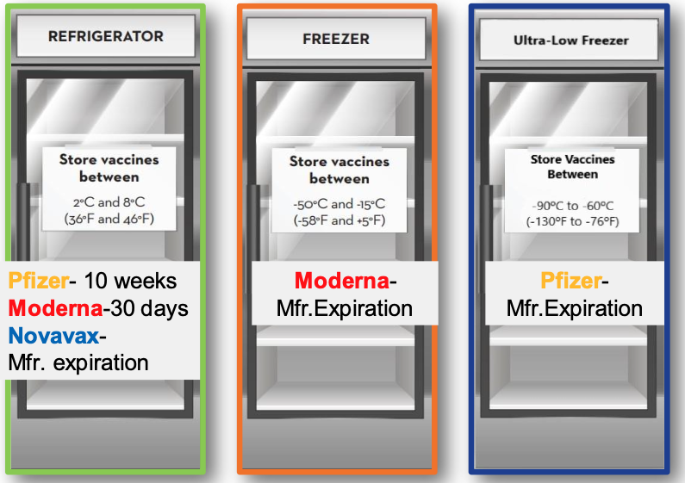
- COVID-19 Beyond Use Date/Beyond Use Time
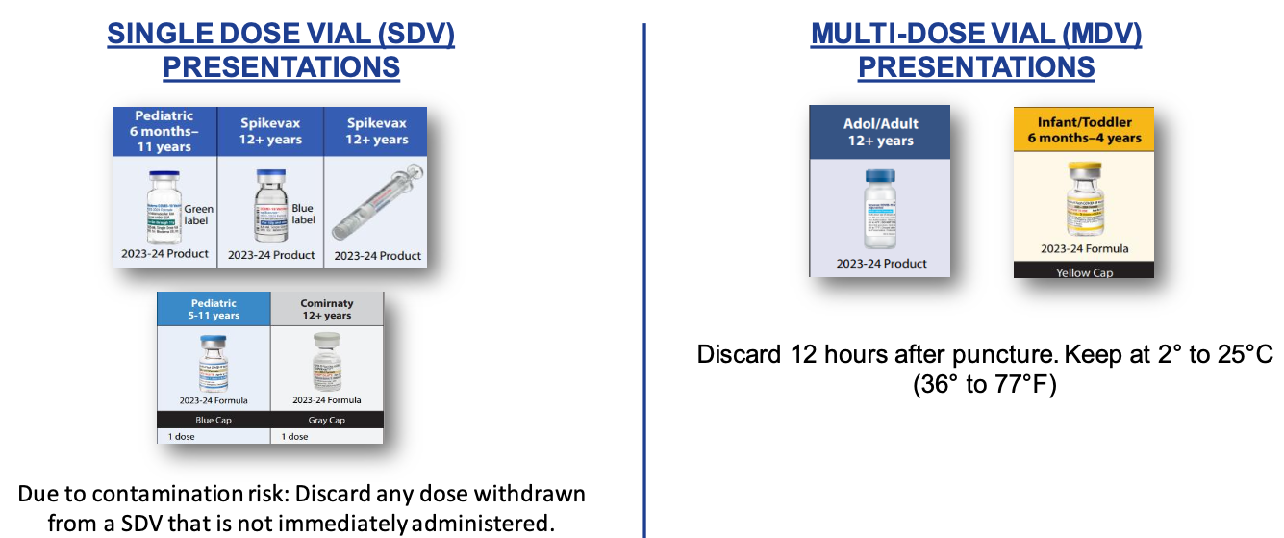
_____________________________________________________________________________________
Vaccine Insurance Coverage
- Commercial COVID-19 Vaccine Coverage for Children
  - Medi-Cal beneficiaries, children 3 years and older may now receive their COVID-19 vaccine at pharmacies as a pharmacy benefit.
  - For members 6 months of age up to 3 years of age, COVID-19 vaccine will be available at a VFC provider.
  - Pharmacies that service Medi-Cal patients must use commercial supply.
- COVID-19 Medical Coverage Changes (Following End of Federal Public Health Emergency)
- Respiratory Virus Vaccine Coverage Quick Guide
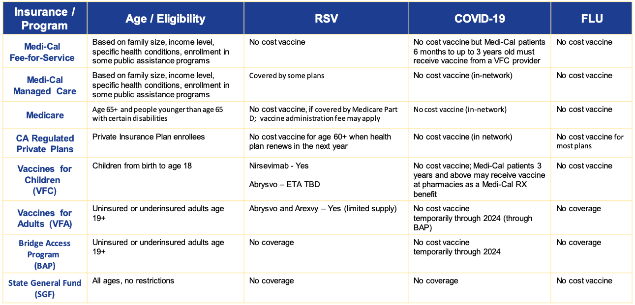
- Vaccines By Funding Source
- Who Providers Can Contact For More Inf;ormation?
  - Medi-Cal Fee-for-service—Email contactus@dhcs.ca.gov
  - Medi-Cal RX—Phone: 1-800-977-2273, which is available 24 hours a day, 7 days a week, 365 days per year.
Email: MediCalRxEducationOutreach@magellanhealth.com
  - Medicare—Phone: 1-800-MEDICARE (1-800-633-4227)
  - California Regulated Private Plans—Call Insurance Company First, Phone: Call DMHC at 1-888-466-2219 or visit https://www.dmhc.ca.gov/
  - Uninsured—For all non-COVID-19 vaccines, please contact your local health department.
    - For COVID-19 Vaccines visit:
      - https://eziz.org/vfa-317/bap/
      - www.vaccines.gov
      - www.covidaccess.com (independent pharmacies)
    - For COVID-19 Therapeutics visit:
      - Merck Programs to Help Those in Need - Product(merckhelps.com)
      - PAXCESS™ | PAXLOVID™ (nirmatrelvir tablets; ritonavir tablets)

_____________________________________________________________________________________
Vaccine for Children (VFC)
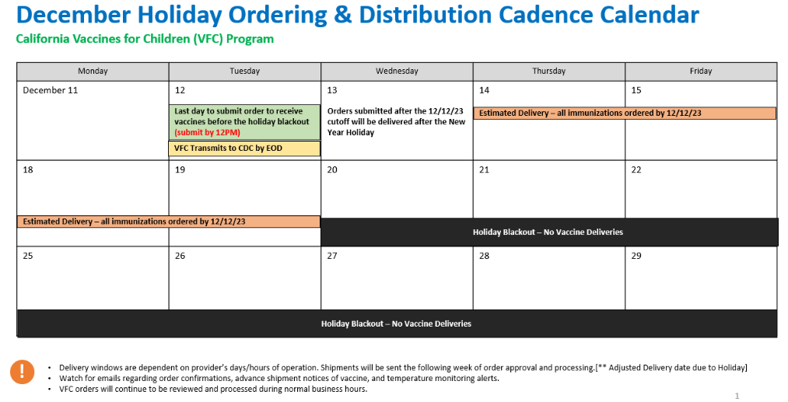
- BeyfortusTM VFC Ordering
  - The VFC Program has opened ordering for nirsevimab (BeyfortusTM) in MyVFCvaccines for all VFC Providers.
  - Requests will be reviewed and approved based on a provider’s historical ordering of sentinel vaccines (monthly order averages of hepatitis B doses for hospitals, and Pneumococcal Conjugate Vaccine (PCV) for outpatient providers).
  - Multiple reminders are being shared with VFC providers urging them to place orders, given increase in RSV activity, and the holiday shipping blackout.
- Optimizing RSV Protection for Infants with Limited Supply of Nirsevimab
  - SEE JOB AID PDF HERE
- COVID-19 Vaccine Fact Sheets
  - SEE FACT SHEETS HERE
- Upcoming VFC Vaccines
  - RSV Vaccines
    - VFC:
      - Abrysvo (Pfizer) – maternal RSV vaccine during weeks 32-36 of pregnancy, added to the VFC Program
      - Expected to be on the CDC contracts soon. “coming soon with ordering controls”
      - Estimated availability timeline: January 2024
    - Mpox VACCINE
      - On 10/25/23, ACIP recommended vaccination with the 2-dose JYNNEOS vaccine series for persons aged 18 years and older at risk for mpox, and added to VFC through a VFC resolution
      - This product will be available through VFC once the vaccine transitions to the commercial market
    - MenABCWY Vaccine
      - PENBRAYA (Pfizer)
      - Also voted on 10/25/23 for inclusion in the VFC Program
      - May be used when both MenACWYand MenB are indicated at the same visit
      - No CDC contract yet. Timeframe for availability still TBD
- 2024 Recertification for VFC, 317, VFA
  - Target launch: Mid to late December 2023
  - Due date: Wednesday, January 31, 2024
  - 2024 Recertification is through myVFCvaccines for VFC, 317, and VFA Programs
  - All public and private providers must recertify yearly
    - Even if an LHD clinic is only receiving 317 vaccine for outbreak or SGF vaccine
    - Recertification maintains the PIN’s active status
  - New providers that enrolled prior to December 2023 will also be expected to complete 2024 VFC Recertification.
  - Who can access the 2024 VFC Recertification site?
    - All active providers, including providers on hold, and providers that are suspended for all reasons except for mandatory corrective actions.
  - Who cannot access the 2024 Recertification site?
    - Providers suspended for mandatory corrective actions
_____________________________________________________________________________________
Holiday Shipping Cadence
- BAP PROGRAM
  - December BAP Holiday Shipping Cadence
    - For the week of December 11, 2023, LHD order approval will be shifted a day earlier to submit orders for fulfillment ahead of the shipping blackout.
    - LHD need to approve orders by 12:00 PM PT on Tuesday, December 12, 2023. CDPH transmits them by EOD to ensure arrival before Wednesday, December 20, 2023.
- BAP Holiday Shipping Calendar for December and January: https://eziz.org/assets/docs/COVID19/IMM-1360-Holiday.pdf
- SGF Holiday Ordering and Shipping Calendar for December and January: https://eziz.org/assets/docs/317forLHD/IMM-1475-Holiday.pdf
_____________________________________________________________________________________
Upcoming Webinars
An Ounce of Prevention: The Importance of Maternal Vaccinations in the Prevention of Newborn Disease
Overview: Learn about the RSV vaccine indicated for maternal use, including benefits, potential adverse effects and the strengths and weaknesses of the California Immunization Registry. Concerns about access, office practice reimbursement and patient assistance support will be discussed.
When: Wednesday, December 13th at 12:15 pm.
Link to Register: Click here to register for the session.

Upcoming Crucial Conversations Webinar
When: Wednesday, December 13th from 12PM - 1PM, PT
Link to Register: Please register here.

Respiratory Viruses in Older Californians
When: Wednesday, December 13th at 12:00 pm.
Link to Register: Click here to register for the session.

Maternal Vaccinations
Overview: The maternal RSV vaccine, Abrysvo, is a new recommendation for prenatal care in 2023 and the window for intervention is short and rapidly closing for this year. Join the District IX Public Health Committee, Section 5 and the Los Angeles County Department of Public Health as we discuss the roll-out of this intervention and learn interview techniques that encourage your patients to evaluate the science and make informed decisions.
When: Wednesday, December 13th at 12:15 pm.
Link to Register: Click here to register for the session.

_____________________________________________________________________________________
LACDPH & CDPH Provider Office Hours Link
LA County Department of Public Health Provider Immunization Office Hours Information
- Every other Wednesday from 9am-10am - Next meeting: 12/20/2023
  - NOTE: Effective 2/01/23 the Office Hours will be held on a biweekly basis
- This has been meeting amended to discuss COVID, Mpox, Flu and RSV vaccines. The meeting link will remain the same.
- MS Teams meeting link below; please create a recurring calendar invite with this link.
- To request meeting slides, please email covidvaccinereq@ph.lacounty.gov
Microsoft Teams meeting
Join on your computer or mobile app
Click here to join the meeting
Or call in (audio only)
+1 323-776-6996,,350547595# United States, Los Angeles
Phone Conference ID: 350 547 595#

California Department of Public Health Provider Office Hours Registration Link
- Every Friday from 9am-10:30am.
- Complete one-time registration here.
- Meeting recordings and slides can be found here.
Providers should add staff names to the Provider Listserv to receive weekly emails and updates. To be added, please email blanca.corona@cdph.ca.gov

