Weekly Vaccine Digest 12/1/23
Los Angeles County Department of Public Health
Dear Colleagues and Partners,
Below are the LACDPH weekly vaccine administration and order updates, upcoming webinars, and newsworthy events. Attached to this email you will find a pdf version of this digest and the links shared during the CDPH Office Hours. To view the CDPH recording and slides please visit https://eziz.org/. We have received additional doses for the Bridge Access Program (BAP). Please submit your vaccine order by Monday at 5:00 pm to receive your vaccine order the following week. Orders submitted after Monday at 5:00 pm may take an additional week to deliver. Please order a 1–2-week supply of COVID-19 vaccine through myCAvax and re-order as necessary as you assess patient demand.

If you received this email and would like to be added to our listserv, please contact our COVID-19 Provider Vaccine Call Center at covidvaccinereq@ph.lacounty.gov
Table of Contents
- Page 1-2: Order and Administration Reminders
- Page -3: CDPH Information and Education
- Page 3-5: COVID-19 Vaccine Administration Data
- Page 5-6: Respiratory Syncytial Virus (RSV) Immunization Uptake in California
- Page 6: Pharmacy Medi-Cal Rx Update
- Page 6-7: Vaccine Management
- Page 7-8: Upcoming Webinars, LACDPH & CDPH Provider Office Hours Link

Order and Administration Reminders
- Vaccine delivered from the DPH warehouse will be delivered 3-7 business days after the order is place in myCAvax. Please present a photo ID (work badge, school ID, driver’s license, etc.) and sign for the delivery when received.
- UPDATE: Attached to this email is the updated JYNNEOS Screening & Vaccination Consent Form PDF for Mpox providers.
  - The PDF form should only be used when offline. All entries in the PDF form MUST be eventually entered electronically into REDCap or MyTurn!
- REMINDER: If a Shipment Incident results in a Temperature Excursion, providers should always report the Shipment Incident first. CDPH will determine if the vaccine should be reported as waste and then they will inform the provider
  - VFC providers should report temperature excursions and waste events in myVFCvaccines
  - BAP and SGF providers should report temperature excursions and waste events in myCAvax
  - Outbreak (mpox/Jynneos) providers should NOT report temperature excursions in myCAvax, but all waste events should be recorded in myCAvax in vials NOT doses.
    - Note: Expired or spoiled Jynneos vaccine does NOT need to be returned to LAC DPH or the manufacturer. Ignore the “Return Shipping Method” section when reporting a waste event and leave it as the default. That section is only for other programs.
- REMINDER: Pfizer, Moderna, and Novavax are all available for ordering through myCAvax for Bridge Access Program (BAP) providers and through myVFCvaccines for Vaccines for Children (VFC) providers VFC providers may only report through myVFCvaccines.
  - VFC providers that report in the wrong system (myCAvax) should contact the Provider Call Center at ProviderCallCenter@cdph.ca.gov or call (833) 502-1245 for guidance on removing or updating the incorrect report BAP providers may only report through myCAvax.
  - BAP providers that report in the wrong system (myVFCvaccines) should contact the VFC Call Center at myVFCvaccines@cdph.ca.gov or call (877) 243-8832 for guidance on removing or updating the incorrect report
- REMINDER: Job aid for Vaccine and Clinic Eligibility by Funding Source can be found here.
- UPDATED: Bap Eligibility Resource can be found here
- CA BAP Program Requirements can be found here.
- Additional BAP Resources can be found here.
- NOTE: CAIR/RIDE Registry ID's - Under AB 1797, vaccine providers are required to enter immunization information into the California Immunization Registry (CAIR) OR Healthy Futures/RIDE.
  - 119 VFC Providers have no IIS Org Code.
  - Reminder to Providers: Please join CAIR/RIDE.
  - CAIR webinar slides and recordings will be available after next week at http://publichealth.lacounty.gov/ip/trainingsconferences.htm
- NOTE: V-safe for RSV Vaccines in Older Adults Now Available
  - V-safe now available for adults 60 years and older who received RSV vaccine
    - Will be available soon to pregnant people who received RSV vaccine
  - V-safe is a safety monitoring system that lets you share with CDC how you, or your dependent, feel after getting an RSV vaccine.
  - Using V-safe after RSV vaccination requires a new registration.
  - Please encourage your patients to participate.
  - CDC V-safe
  - V-safe print materials
- Covid-19 Vaccine Fact Sheets can be found here.
- Novavax COVID-19 Vaccine Resources:
  - Novavax at a Glance (CDC, 10/31/23)
  - Storage & BUD Tracking Labels (CDC, 10/18/23)
  - Standing Orders (CDC, 10/31/23)
  - Expiry Checker (Novavax)
  - Temperature Excursion Checker (Novavax)
  - CDC Resources by Product
______________________________________________________________________________
CDPH Information and Education
- National Influenza Vaccine Week
- Late Season Flu Vaccination Campaign
- Communication Toolkit: (see here)
  - Social Media Messages
  - Template Matte Release
  - Sample Newsletter Blurb
  - Patient Reminder Messages
- December 4-8, 2023, we will observe National Influenza Vaccination Week, a reminder for everyone 6 months and older that there’s still time to get a flu vaccine this season
- Samples: Social Media Toolkit
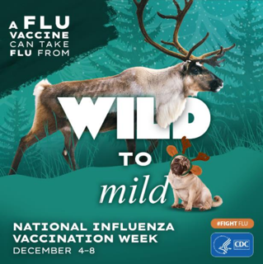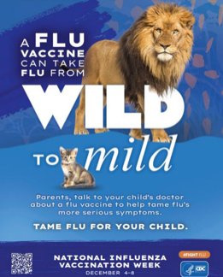
COVID-19 Treatments – Public Communication
- Awareness Campaign Resumed!
- Radio, social media, and digital media to increase awareness of COVID-19 treatments resumed on November 13, 2023. Running in English and Spanish until January 15, 2024!
- All targeted to older than 50 population
- See associated Facebook video here
- Helpful Messaging Practices:
  - "COVID-19 Medications" or "COVID-19 Prescription Medications" rather than "COVID-19 Treatments"
  - Free?: While government-purchased supplies last, the medications are free whether or not you have insurance or citizenship status
  - Emphasize: Must be taken within the first 5 days of symptoms (don't wait until symptoms get worse!) • Remind: Recommended for most adults (and some teens). Many don't know that they have eligible conditions.
  - Clarify: For both vaccinated and unvaccinated
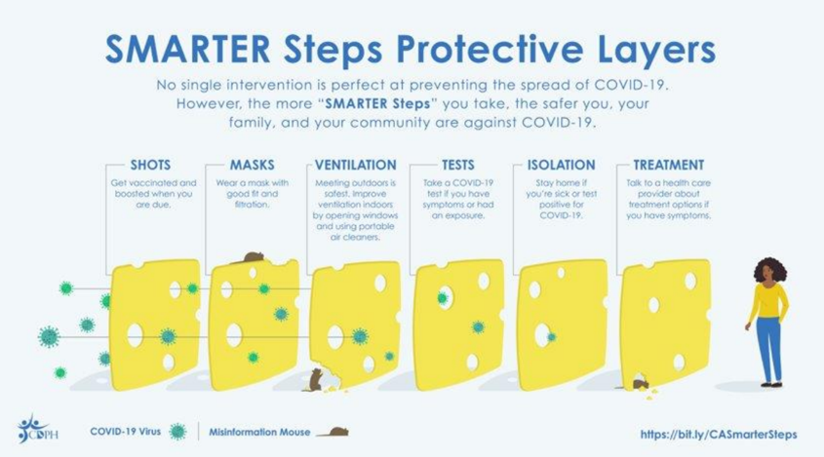
- Toolkit: Handouts, Graphics, Videos, Wallet Cards (see here)
- Toolkit for Providers (see here)
  - Readiness Checklists, Best Practices Toolkits, and More
- Respiratory Virus Prevention Communications Tools (see here)
- Toolkits for Care Providers Contact Information:
  - Email: COVIDRxProviders@cdph.ca.gov
_____________________________________________________________________________
COVID-19 Vaccine Administration Data
- COVID-19 Vaccine Administration Summary (as of Nov. 27, 2023)
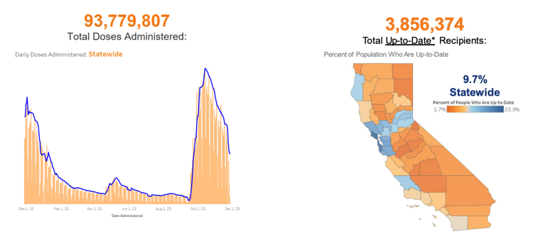
- State-wide Vaccine Data (see here)
- COVID-19 Vaccine: Bivalent vs. Up-to-Date Uptake
  - Over time:
  - In 76 days since EUA, Bivalent Booster uptake was 12.5% vs 9.7% with Updated 2023-2024 doses
  - Divide in Bivalent Booster vs. Updated 2023-2024 dose increasing over time
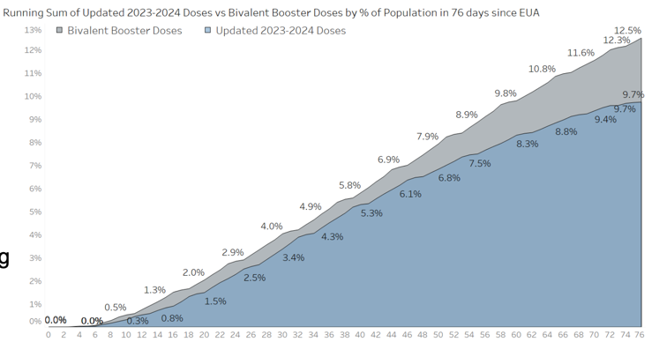
- Trends in COVID-19 Vaccine Administration
- Most Recent Eligibility Groups
  - Updated 2023-2024 vaccine for 6 months and older
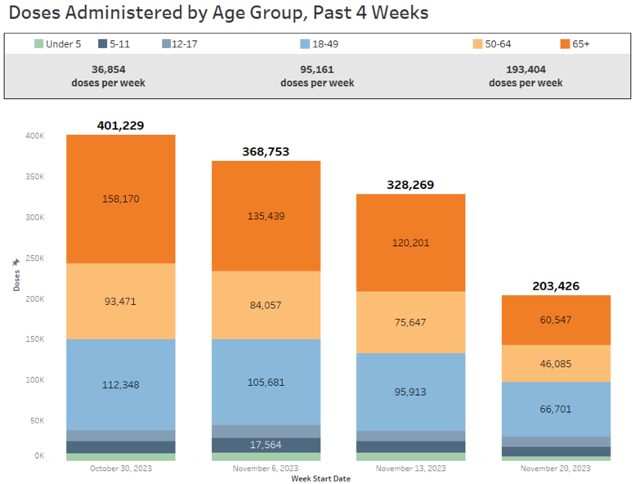
- Up-to-Date COVID-19 Vaccination Status by Race* and Age
  - By race and age: Highest uptake among NHPI, White, and Asian
  - Uptake above state average in all 65+ race/ethnicity groups
  - * - Vaccination rate estimates for some groups, such as NHPI, may be affected by differences in how demographic data is collected by the Census and at the time of vaccination
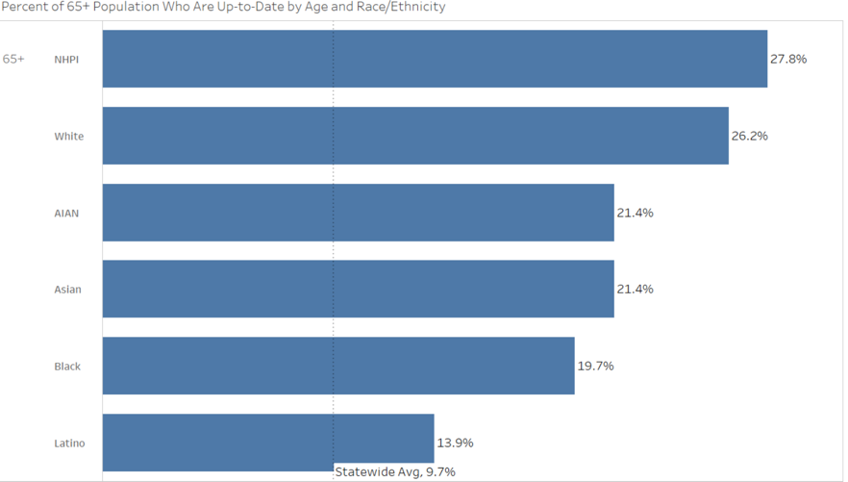
- Providers Administering Updated 2023-2024 COVID-19 Vaccine
  - 4,861 Total Updated 2023-2024 Vaccine Providers Reported
  - 72% of previous Bivalent vaccine Providers
  - +2% pt increase from last week
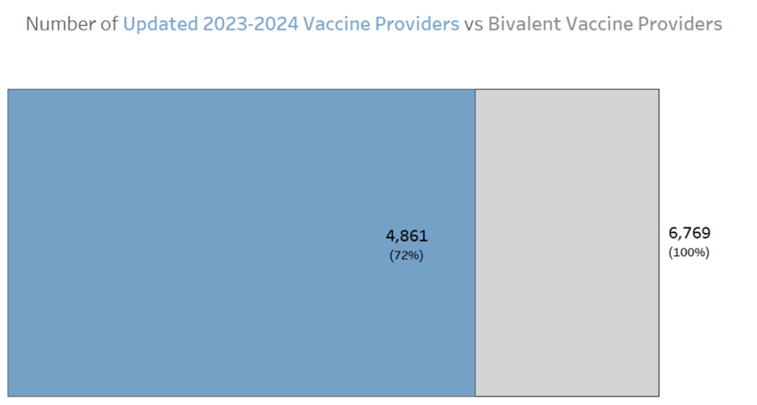
- COVID-19 Vaccine Data Summary
  - Key Metrics
93.8 million doses administered | +203K doses administered
9.7% Statewide who are Up-to-Date | 3.9 million Up-to-Date recipients
25.8% 65+ who are Up-to-Date | 1.7 million 65+ Up-to-date recipients
  - System Notes
    - Public dashboard Up-to-Date status now includes the Updated 2023-2024 guidelines
    - Email cdphvaccinedatateam@cdph.ca.gov for questions and comments
_____________________________________________________________________________________
Respiratory Syncytial Virus (RSV) Immunization Uptake in California
- RSV Immunizations in CA Immunization Registry (CAIR)
  - Tracking doses administered for three RSV immunizations:
    - 1. Abrysvo (adult vaccine)
      - Pregnant individuals 32-36 gestational age
      - Adults > 60 years of age
    - 2. Arexvy (adult vaccine)
      - Adults > 60 years of age
    - 3. Nirsevimab (tradename Beyfortus™; pediatric monoclonal antibody product)
      - Children 0-19 months
  - Data are from CAIR2 and include immunizations from 08/01/2023-11/22/2023. Data are preliminary and subject to change.
  - For electronic reporting of doses to CAIR, HL7 codes can be found here.
- Total Weekly Doses by Vaccine, Adults 60+ Years of Age
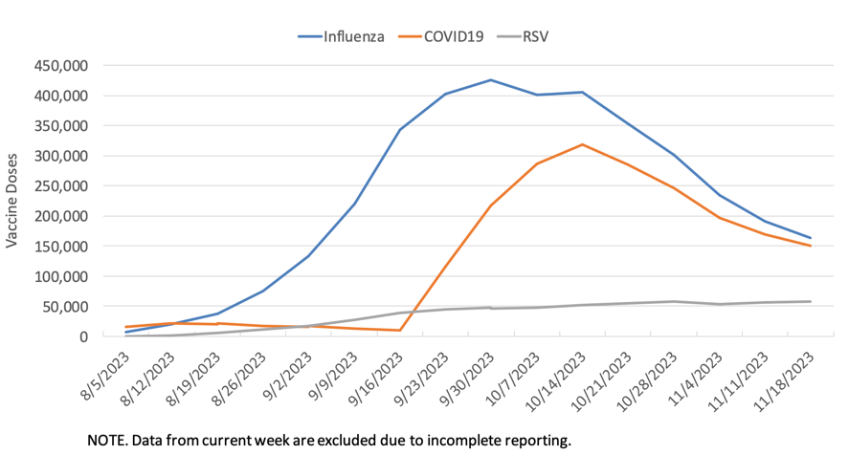
- Nirsevimab Total Weekly Doses, Children 0 - 24 Months
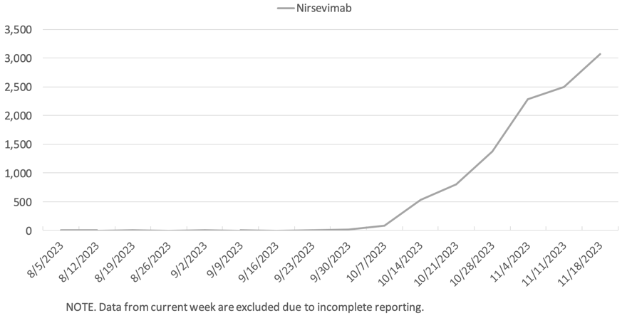
_____________________________________________________________________________________
Pharmacy Medi-Cal Rx Update
- Commercial COVID-19 Vaccine Coverage for Children
  - Medi-Cal beneficiaries, children 3 years and older may now receive their COVID-19 vaccine at pharmacies as a pharmacy benefit.
  - For members 6 months of age up to 3 years of age, COVID-19 vaccine will be available at a VFC provider.
  - Pharmacies that service Medi-Cal patients must use commercial supply.
_____________________________________________________________________________________
Vaccine Management
- My Turn Roadmap
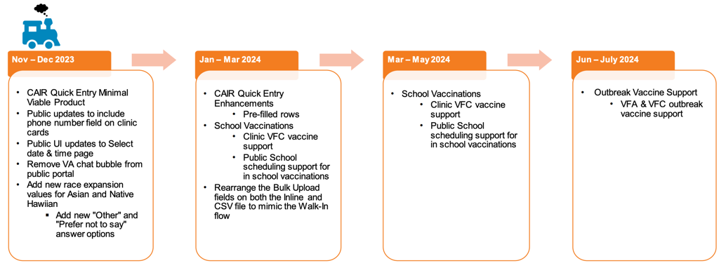
- Bridge Access Program (BAP): Vaccine Allocations Cadence Update
  - As of October 25, 2023, allocations of BAP COVID-19 vaccine products will be refreshed on a biweekly cadence. CDPH anticipates allocations being received mid-week and will distribute inventory to the LHDs by the following business day.
  - The most recent allocation refresh was on Tuesday, November 21, 2023.
- Returning Expired or Spoiled Vaccine
  - Vaccine received from the SGF or BAP programs should be returned to McKesson or Pfizer. Wasted vaccine does NOT need to be returned, but it still needs to be reported in myCAvax.
  - Report doses as expired or spoiled in myCAvax. CDPH processes your report into CDC’s VTrckS system, and then a return shipping label is emailed. SGF Flu Returns are processed Tuesdays and Fridays, and COVID returns are processed on Wednesdays.
  - Mail the vaccine back to McKesson or Pfizer with the return shipping label. Clearly label the outside of the shipping container "Non-viable Vaccine enclosed". You must provider your own shipping container/box.
  - If you not receive your return label, please contact the CDPH Provider Call Center (ProviderCallCenter@cdph.ca.gov or 833-502-1245).
- Refresher: BAP Vaccines– Expired Vaccine Product
  - Doses are considered as expired when they are past either the expiration or the beyond use date, whichever is earlier. Providers should remove any expired vaccine from the storage unit immediately to prevent administration errors.
  - Providers should report expired COVID-19 vaccine doses by clicking the ‘New Waste Event’ button on the ‘COVID-19 - Waste Events’ page and return them to McKesson following CDPH guidance.
_____________________________________________________________________________________
Upcoming Webinars
Vaccines for Children (VFC) Afternoon TEAch Webinar
Description: This Afternoon TEAch webinar will cover what's new with Winter Respiratory Viruses, specifically as related to the Vaccines for Children (VFC) program.
When: Thursday, December 7, 2023; Time: 12PM – 1PM, PT. Please register here.

Upcoming Crucial Conversations Webinar
Description: Discover the current landscape of respiratory viruses for older adults and learn key messages for addressing common vaccine concerns among older adults in BIPOC communities.
When: Wednesday, December 13, 2023; Time: 12PM - 1PM, PT. Please register here.

California Immunization Coalition (CIC) Webinar
Overview: The California Immunization Coalition, in partnership with the American Academy of Pediatrics (AAP) - California Chapters, invites you to attend a webinar to discuss Maternal RSV Immunization, especially during the nationwide Nirsevimab shortage.
When: Tuesday, December 5, 2023; Time: 12PM, PST. Please register here.

American Academy of Pediatrics (AAP)
Nirsevimab Supply and Prioritization Updates Webinar Recording (November 8, 2023) can be found here.

_____________________________________________________________________________________
LACDPH & CDPH Provider Office Hours Link
LA County Department of Public Health Provider Immunization Office Hours Information
- Every other Wednesday from 9am-10am - Next meeting: 12/06/2023
  - NOTE: Effective 2/01/23 the Office Hours will be held on a biweekly basis
- This has been meeting amended to discuss COVID, Mpox, Flu and RSV vaccines. The meeting link will remain the same.
- MS Teams meeting link below; please create a recurring calendar invite with this link.
- To request meeting slides, please email covidvaccinereq@ph.lacounty.gov
Microsoft Teams meeting
Join on your computer or mobile app
Click here to join the meeting
Or call in (audio only)
+1 323-776-6996,,350547595# United States, Los Angeles
Phone Conference ID: 350 547 595#

California Department of Public Health Provider Office Hours Registration Link
- Every Friday from 9am-10:30am.
- Complete one-time registration here.
- Meeting recordings and slides can be found here.
Providers should add staff names to the Provider Listserv to receive weekly emails and updates. To be added, please email blanca.corona@cdph.ca.gov

