Weekly Vaccine Digest 9/08
Los Angeles County Department of Public Health
Dear Colleagues and Partners,
Below are the LACDPH weekly vaccine administration and order updates, upcoming webinars, and newsworthy events. Attached to this email you will find a pdf version of this digest and the links/slides shared during this week’s CDPH Office Hours. To view the CDPH recording and slides please visit eziz.org/covid/education.

If you received this email and would like to be added to our listserv, please contact our COVID-19 Provider Vaccine Call Center at covidvaccinereq@ph.lacounty.gov
Table of Contents
- Page 1: Welcome, Order and Administration Reminders
- Page 2: Upcoming Calls/Webinars
- Page 3: Bridge Access Program and Pharmacy
- Page 4: COVID-19 Vaccine Commercialization BAP and VFC, Commercial Purchase Information
- Page 5: Commercial Vaccines
- Page 6: Frequently Asked Questions
- Page 6-7: LACDPH & CDPH Provider Office Hours Link
Order and Administration Reminders
- UPDATE: In anticipation of ACIP's meeting the week of September 12th, and the authorization of new products, CDPH has moved up timelines for the closeout of the current COVID-19 program.
  - NOTE: If you urgently need bivalent vaccine before the deauthorization, you can reach out to the call center via email at: covidvaccinereq@ph.lacounty.gov
  - REMINDER: Jynneos and Flu orders will be unaffected by the closure of COVID-19 vaccine orders in myCAvax.
  - NOTE: All Providers should follow the steps listed in this communication to complete COVID-19 vaccine product closeout activities in myCAvax.
  - Commercialization Resources can be found below:
    - UPDATED (8/31): Commercialization at a glance provider transition guide can be found here.
      - For more details on Provider Transition guide please see pg.6
    - CDPH COVID-19 Commercialization FAQs can be found here.
    - HHS guide on commercialization can be found here.
- REMINDER: COVID-19 Provider Resources can be found here.
- REMINDER: Provider Operations Manual can be found here.
- REMINDER: Please report all COVID-19 doses administered within 24 hours to your medical record system and to CAIR as soon as practicable and no later than 72 hours.
- REMINDER: Record Vaccine Waste in myCAvax. Job aid can be found here.
- Diluent Reminder:
  - Use the normal saline diluent vials for Pfizer vaccines only once.
  - Providers cannot use one vial of diluent to dilute multiple vials of vaccine.
  - Discard the diluent vial immediately after use to prevent errors.
  - Using a vial of diluent to dilute multiple vaccines is dangerous for patients and can lead to infection.
_____________________________________________________________________________________
Upcoming Calls/Webinars/Resources
- Virtual Grand Rounds
  - Description: New Communicable Disease Guidance for Schools
  - Tuesday, September 12, 2023, 12PM – 1PM registration link can be found here.
- Afternoon TEAch Webinar
  - Description: This Afternoon TEAch webinar will cover what's new with RSV and Flu, updates on the COVID-19 vaccine formulation, and the transition of COVID-19 vaccines to the Vaccines for Children (VFC) program.
  - Thursday September 14, 2023, 12PM – 1PM, PST, registration link can be found here.
- CDC COCA Call: Preparing for the Upcoming Respiratory Virus Season: Recommendations for Influenza, COVID-19, and RSV Vaccines for Older Adults
  - Tuesday September 19, 2023, 11AM-12PM, PST, zoom link to join the call can be found here.
- CDC Advisory Committee on Immunization Practices (ACIP) Topic (Anticipated): Fall 2023 COVID-19 Vaccine When: Tuesday, September 12, 2023 Time: 7AM, PST, webcast link can be found here.
- CDC Clinical Guidance for Use of Products to Prevent RSV Disease in Infants
  - Wednesday September 27th, 2023, webinar information can be found here.
- Addressing vaccine anxiety resources can be found here.
- Sign up for the CDPH Office of Communications Newsletter here.
- CDPH archived communications can be found here.
- CDC COVID-19 Vaccination Requirements and Support can be found here.
_____________________________________________________________________________________
Bridge Access Program (BAP) and Pharmacy
- CDC will establish contracts with pharmacies to enable them to continue offering COVID-19 vaccines and with no out-of-pocket costs to uninsured individuals ◦
  - Walgreens – Still in contract negotiations. More information to come.
  - CVS – Still in contract negotiations. More information to come. ▪
    - Requested all California locations to be included (locations subject to CDC approval).
  - eTrueNorth – Still in contract negotiations but has released an interest form for providers to complete.
    - Pharmacies will identify themselves as BAP participants through vaccines.gov (required)
    - Pharmacies will utilize the reimbursement model.
    - No separate supply
    - Reimbursed with each dose given
    - Allows pharmacy component to launch as soon as they will receive commercial product
    - Pharmacy Interest Flyer with QR Code
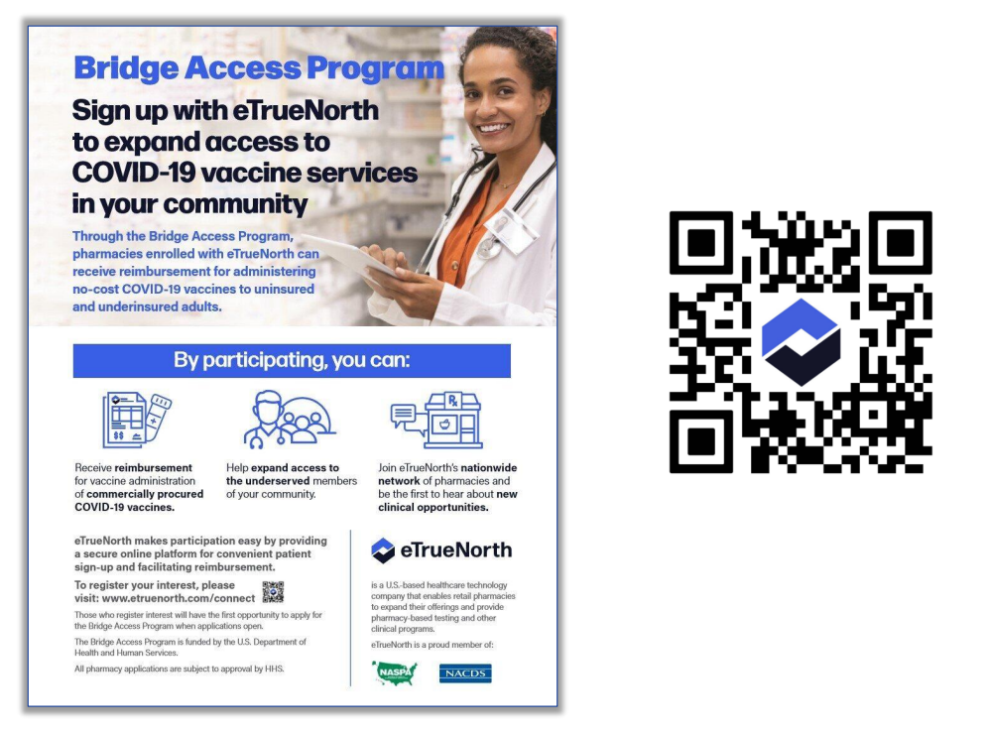
    - Complete this form for general inquiries or to indicate interest in the Bridge Access Program for pharmacies. Pharmacy Interest Contact Page
- UPDATE: Contracts between CDC and pharmacies finalized and ready to launch at the same time with the public health component in September. CDC is accelerating their timeline from a previously stated date of mid-October.
Frequently Asked Questions:
QUESTION: When do we expect the contract negotiations to be finalized for pharmacy?
ANSWER: CDC's goal - contracts between CDC and pharmacies finalized and ready to launch at the same time with the public health component in September. CDC is accelerating their timeline from a previously stated date of mid-October.
QUESTION: Will pharmacies need separate storage for BAP doses?
ANSWER: No. Bridge Access Program pharmacy component will have the reimbursement model. No separate storage will be necessary.
_____________________________________________________________________________________
COVID-19 Vaccine Commercialization BAP and VFC
- Providers selected to participate in the Bridge Access Program received enrollment instructions this week. NOTE: Providers that are not selected will not receive instructions.
- Providers participating in the VFC Program will receive a communication next week with information regarding product availability and ordering of pediatric COVID-19 vaccine doses through VFC. All 3 brands of COVID-19 vaccines will be made available through VFC's routine vaccine order form. No prebooking will be required.
- Bridge Access Program (BAP) on EZIZ Homepage can be found here.
- BAP Resources can be found here.
- CA Bridge Access Program Provider Operations Manual can be found here.
- BAP Requirements at a glance can be found here.
Frequently Asked Questions:
QUESTION: We have multiple locations that have been approved for the Bridge Access Program, do we need to complete the BAP Agreement and enrollment information for each location, or can we combine the population estimates and complete enrollment for just one location?
ANSWER: You will need to complete this for each location that is approved for BAP. Redistribution will not be allowed so each location will have to order for themselves, the same as how VFC and VFA operate. You can have your Medical Director sign one form as CEO and CMO and then send that to each location for the Vaccine Coordinator to sign and upload when they complete the BAP enrollment.
QUESTION: If personnel changes have occurred at our provider location since we enrolled in myCAvax, do we need to update that before completing the BAP provider agreement?
ANSWER: Yes, the Organization Coordinator and/or the primary Vaccine Coordinator would get the pop-up, so if those have changed, send an email to ProviderCallCenter@cdph.ca.gov
QUESTION: Can I place an order for vaccine for one of my clinics/locations, and then redistribute that order to the other clinics/locations?
ANSWER: No, redistribution will not be allowed so each individual clinic/location will have to order ONLY for their individual location. BAP will operate the same as how VFC and VFA operate.
QUESTION: We are an FQHC and some of our sites were not selected for the BAP program. How can we proceed?
ANSWER: Please reach out to your local health department to discuss further. If it is an FQHC site that only serves children, they would not be added. If they serve adults, then reach out because they may have been missed. If the provider is determined to be appropriate for BAP, they can easily be added.
_____________________________________________________________________________________
Commercial Purchase Information
It is the provider’s responsibility to order private vaccines for their insured patients.
- Moderna:
  - Customers can order through their distributors or directly with Moderna
    - Moderna has signed with the major group purchasing organizations (GPOs) and with all major distributers, such as McKesson, Cardinal, AmeriSource-Bergen, etc.
    - Customers may order directly with Moderna at www.modernadirect.com.
    - The Moderna Care Team may be reached at: 1-866-MODERNA / 1-866-663-3762
  - Pre-booking is not necessary but helps with the management of demand and production on the manufacturer side. On the provider side, it may prioritize shipping, and access to limited supply of packaging not available on the CDC Contract (pre-filled syringes)
- Pfizer:
  - Providers may work with their wholesalers prior to and post launch of approved products
  - May order directly with Pfizer for minimum quantity after commercial availability
  - Customers may order directly at https://primecontracts.pfizer.com/
  - The Pfizer Customer Service team may be reached at 1-800-666-7248.
  - Product will ship direct from Pfizer at ultra-low temperature (ULT). Upon receipt, may storage at ULT or at 2-8 °C (shelf life of the product anticipated to be 10 weeks when stored at 2-8 °C)
- Novavax:
  - Currently working on a Commercialization Information packet for providers.
  - Novavax will work with major distributors for providers to order as needed. Novavax will not ship directly.
  - Providers can order through their preferred group purchasing organizations or distributors.
  - Product purchasing information may be directed to Novavax CA Regional Business Director Nidal Naser at nnaser@novavax.com
_____________________________________________________________________________________
Commercial Vaccines
Moderna:
- Three presentations: 6 months - 11 years & 12 years plus
  - 6 months – 11 years, single dose vials
- 12 years plus, single dose vials and prefilled syringes.
- Shipped as frozen product.
- Minimum order – 10 doses.
- Will offer returns of vaccines
Novavax:
- Shipped as refrigerated product
- 5-dose vials
- Will offer 100% returns for opened and unopened vaccine
- Standard refrigerated storage
- Minimum order – 10 doses
- Prefilled syringes seem unlikely for this season
Pfizer:
- Three presentations:
  - 6 months - 4 years (requires diluent), 3 dose vial, yellow cap, 3 x 0.3mL doses after 1.1mL saline dilution
  - 5 years - 11 years, (no diluent) single dose vial, blue cap, 0.3 mL dose
  - 12 years +, single dose vial gray cap, 0.3 mL dose
- Ships at ultra-low temperatures (ULT) but…
  - Expect a shift for commercial Comirnaty. Wholesalers may ship it at 2° to 8° C. Applies to both vials and prefilled syringes.
- Prefilled syringes, limited quantities for large commercial customers
- Will offer return of vaccines
_____________________________________________________________________________________
Frequently Asked Questions
Question: If we are not VFC or BAP providers, do we have any need for myCAvax once vaccine is commercialized?
Answer: You will not need to use myCAvax if you do not receive publicly funded vaccine.
Question: If our site has been disenrolled in myCAvax, what are our current reporting responsibilities?
Answer: If your location is no longer active due to program close out, CDPH will not require you to report waste or complete any other close out activities in myCAvax (closing Marketplace posts, transfers, etc.). If you did want to get your reports in, you may contact the provider call center (ProviderCallCenter@cdph.ca.gov) and provide details about the report(s). Please still make sure to contact the manufacturer or shipper (if TPR or local health department) for a resolution on the vaccine stability if there was an excursion. Dispose of the vaccine per usual protocols if they are deemed non-viable.
Question: When and where can we find information on how insurances will cover the new Covid formulation after commercialization? Is that covered under medical or pharmacy benefit? Will insurances reimburse administration fees to pharmacies like before?
Answer: We do know that COVID-19 vaccines will be covered under Medi-Cal. It is on the contracted drug list so it should be covered both medical and pharmacy. For pharmacy it should also be considered under pharmacist services, so those admin fees should apply. It’s less clear for other insurances. Plans subject to DMHC oversight will cover vaccines and treatments through November. After that the rules change a bit and we will have to wait and see what that looks like.
Question: Is it known yet whether BAP doses given will be reimbursed a vaccine administration fee to providers? If so, has the reimbursement rate been determined? and to what entity would the billing be submitted?
Answer: There is currently no source of funding for vaccine administration fees for the uninsured patients receiving BAP doses.
Question: We were attempting to close out Marketplace posts. Is there a way to search for our listings, without having to go through all postings?
Answer: Under the 'Vaccine Marketplace' tab on your account you'll need to select the drop-down list on the left (usually defaults to recently viewed) and select the "My Marketplace Posts" lists.
_____________________________________________________________________________________
LACDPH & CDPH Provider Office Hours Link
LA County Department of Public Health Provider Office Hours Information
- Every other Wednesday from 9am-10am - Next meeting: 09/13/23
  - NOTE: Effective 2/01/23 the Office Hours will be held on a biweekly basis
- This meeting has been combined with the Mpox Office Hours call. Part one of the meeting will focus on COVID-19 issues while the second part will address Mpox vaccine issues.
- MS Teams meeting link below; please create a recurring calendar invite with this link.
- To request meeting slides, please email covidvaccinereq@ph.lacounty.gov
Microsoft Teams meeting
Join on your computer or mobile app
Click here to join the meeting
Or call in (audio only)
+1 323-776-6996,,350547595# United States, Los Angeles
Phone Conference ID: 350 547 595#

California Department of Public Health Provider Office Hours Registration Link
- Every Friday from 9am-10:30am.
- Complete one-time registration here.
- Meeting recordings and slides can be found here.
Providers should add staff names to the Provider Listserv to receive weekly emails and updates. To be added, please email blanca.corona@cdph.ca.gov

