Presenting:
Twin Pines Park Belmont Creek Restoration Project & Twin Pines Park Storm Water Detention Basin Project
Exciting news, as project team members will make a presentation on the highly anticipated Twin Pines Park Belmont Creek Restoration Project and Twin Pines Park Storm Water Detention Basin Project at the Park and Recreation Commission on Wednesday, June 1st.
The projects include creek restoration through Twin Pines Park, and installation of a new stormwater detention basin below the parking lot of Twin Pines Park.
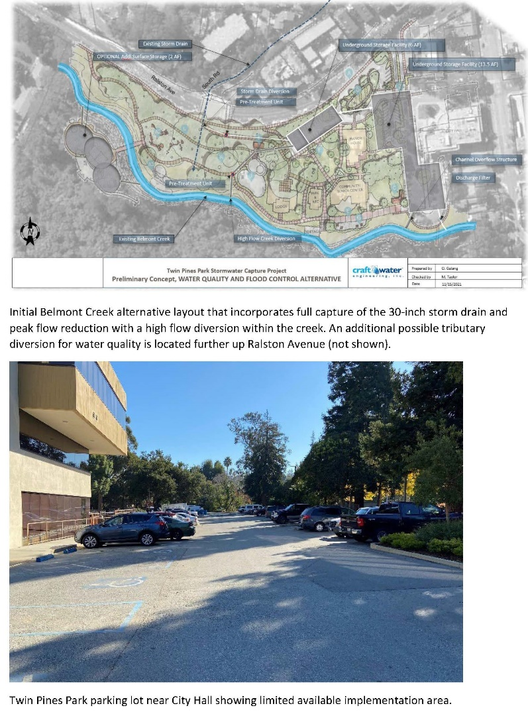
Creek restoration improves the environmental health of the water way. It minimizes stream bed erosion, protects adjacent properties, reduces downstream sedimentation, and restoration of aquatic ecosystems.
The stormwater detention basin will assist in a hold pattern as it collects stormwater and releases in a lesser amount to help mitigate flooding downstream.
Join the community to learn more about these environmental milestone projects by attending the Public Meeting below:
Parks and Recreation Commission Meeting
Wednesday, June 1, 2022 7:00 pm
Meeting Agenda
Belmont Creek Restoration Page
Storm Water Detention Basin Project Page

