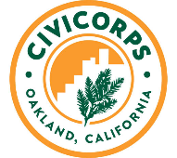
Civicorps Academy
Ongoing enrollment.
Civicorps Academy's new enrollment structure:
  - create a flexible class schedule
  - get into paid job training sooner
  - earn a high school diploma at your own pace
Each student can design a schedule that meets their portfolio and academic needs, and aligns with their commitments outside of Civicorps. Now students will be allowed to move into paid Job Training upon completion of a baseline of onboarding activities. Each student can now select from:
- Part-time or full-time academic options
- Distance Learning - morning, afternoon options
- See our website for class descriptions www.cvcorps.org – click the tab for “distance learning plan”
Civicorps continues to work to re-engage young adults, ages 18-26, to earn high school diplomas, gain job skills, prepare for college, and embark on family-sustaining careers. Please join us in spreading the word about our new enrollment process and flexible academy model.

Distance Learning Resources
Crisis Support
Attendance, Engagement and Academic Stipend
Meals and Food
Case Counseling Services
Students with IEP/504
Technology
Resources for English language learners

We also have internship opportunities for young adults with a High School Diploma.

Contact Bethany at (510) 915-5459.

