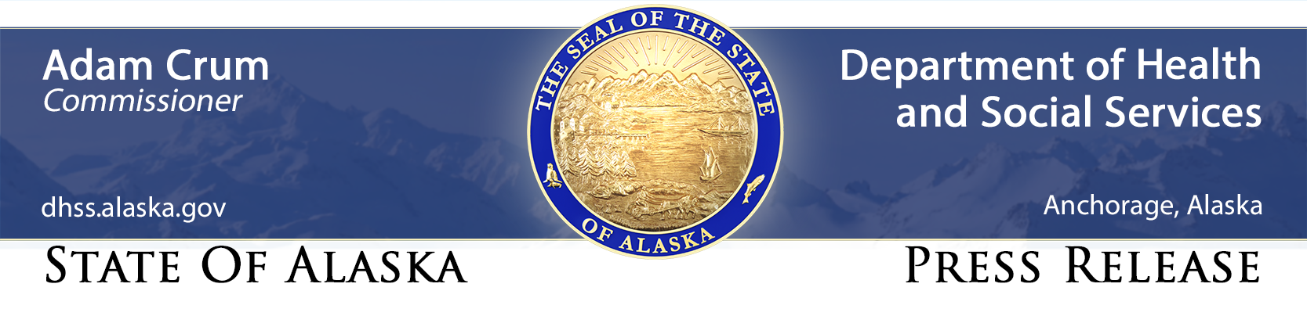
FOR IMMEDIATE RELEASE
Contact: Clinton Bennett, DHSS, (907) 269-4996, clinton.bennett@alaska.gov

Four new cases of COVID-19 reported in three Alaska communities; one new nonresident case reported in a seafood worker in the Valdez-Cordova Census Area

May 23, 2020 ANCHORAGE — The Alaska Department of Health and Social Services (DHSS) today announced four new cases of COVID-19 in: Wasilla (2), Nome (1) and Northwest Arctic Borough (1). This brings the total Alaska case count to 408.
This report reflects data from 12:00 a.m. until 11:59 p.m. on May 22 that posted at noon today on the Alaska Coronavirus Response Hub.
This is the third case for Nome; with a case each reported in the past 2 days. Both are still under investigation and do not appear to be connected. This is the second case for the Northwest Arctic Borough; the two borough cases have residences in different villages.
Nonresident cases are not part of the Alaska case counts; they are listed separately. Another nonresident case in Alaska was identified yesterday in the Valdez-Cordova Census Area in a seafood industry worker. This case was reported by the Valdez Unified Command by press release and on Facebook. The patient was asymptomatic and identified through employer testing put into place to protect workers and the community. The case investigation found that the individual has remained on the Peter Pan Seafoods campus since arriving in Valdez; several individuals identified as close contacts of the patient have been moved into quarantine. Risk to the community is considered to be low. This is the first case in Valdez; it brings the nonresident case count to 13.
Of the new Alaska cases, two are male and two are female. One each is aged 40-49, 50-59, 60-69 and 70-79 years. There have been a total of 45 hospitalizations and 10 deaths with one new hospitalization and no new deaths reported yesterday. Recovered cases now total 358, with two new recovered cases recorded yesterday. A total of 42,351 tests have been conducted.
Stay informed
- Alaska’s response
- United States response
- Global response
Questions about COVID-19?
- For general questions and assistance, please call 2-1-1.
- For the general public, questions regarding DHSS COVID response, including mandates and alerts, can be sent to covidquestions@alaska.gov.
- For data questions, please contact data.coronavirus@alaska.gov.
- For DHSS media inquiries, please contact clinton.bennett@alaska.gov.
###

