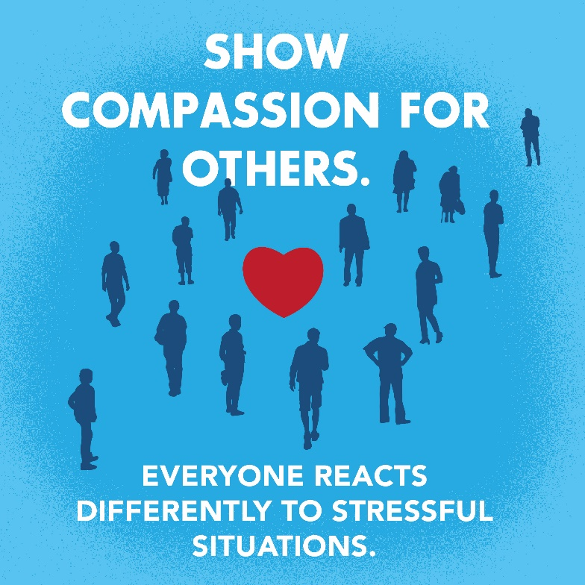 | Don’t forget to show compassion and respect for others. Everyone reacts differently to stressful situations.
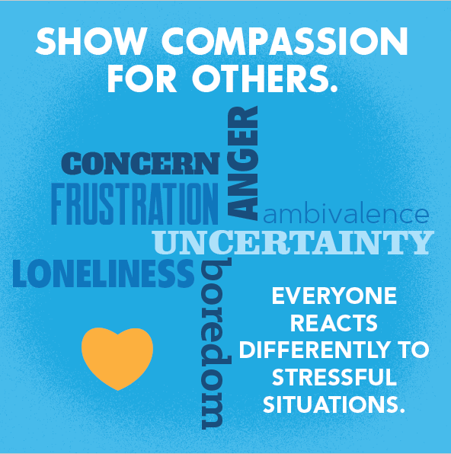 | People will respond to stress differently depending on their background, their risks related to COVID-19 and the risk of people in their household.
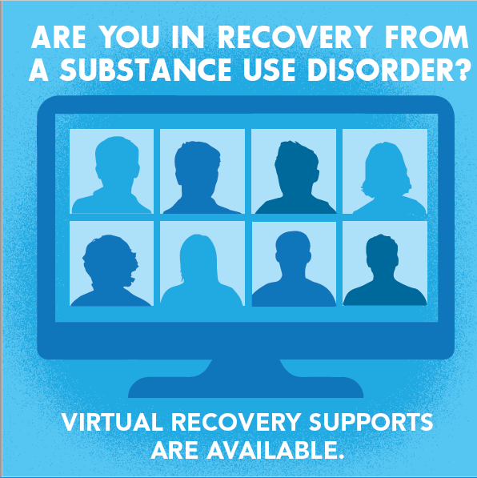 | Many recovery supports are available virtually. Learn about resources you can use during this time. http://dhss.alaska.gov/osmap/Pages/covid-19_considerations.aspx
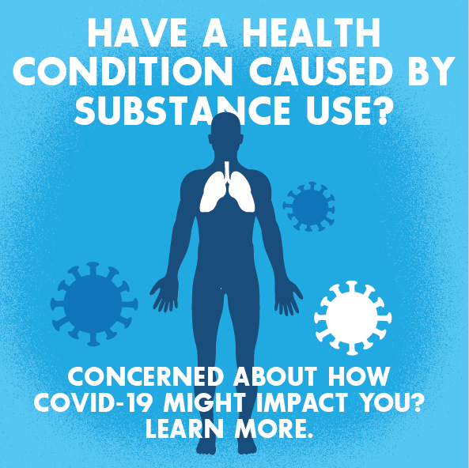 | COVID-19 is a newly recognized virus, so there’s a lot health professionals don’t know yet. This means we’re still learning how it impacts people, like those with existing health conditions related to substance use. http://dhss.alaska.gov/osmap/Pages/covid-19_considerations.aspx
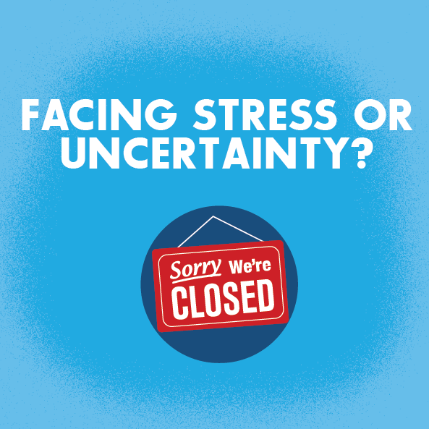 | People having concerns about money, changes in routine or experiencing loneliness can be more likely to have difficulty with substances or alcohol. Find tips for wellness at the Office of Substance Misuse and Addiction’s page. http://dhss.alaska.gov/osmap/Pages/covid-19_considerations.aspx
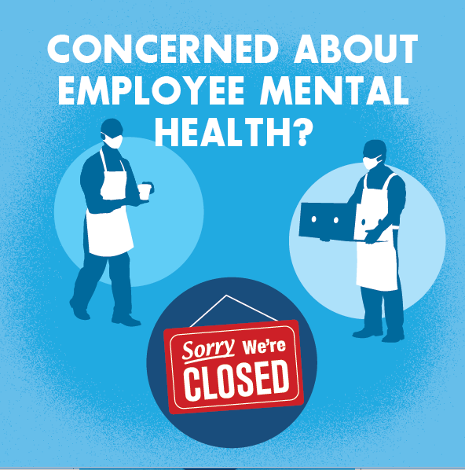 | Build confidence in supporting your employees and preventing substance/alcohol harms for your workforce. With uncertainty and stress, substance and alcohol challenges may affect people who haven’t experienced these issues before. Learn more with this toolkit for Alaska employers. http://www.dhss.alaska.gov/osmap/Pages/workplace.aspx

