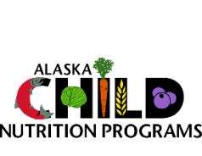

  - Alaska Department of Education and Early Development

Child Nutrition Program
Civil Rights in Child Nutrition Programs and the Bostock Rescission
  - rev 20250711

On July 7, 2025, James C. Miller, Administrator of the U.S. Department of Agriculture (USDA) Food and Nutrition Service, issued a memo rescinding previous guidance based on the 2020 Bostock v. Clayton County Supreme Court decision.
This notice applies to all child nutrition programs including the National School Lunch Program, School Breakfast Program, Child and Adult Care Food Program, Summer Food Service Program, and Fresh Fruits and Vegetable Program, as well as Farm to School/Farm to Child Nutrition Grants that are awarded by the Alaska Department of Education and Early Development (DEED).

Summary of the Bostock Rescission
The Bostock Rescission reverses prior guidance that extended civil rights protections on the basis of sex to include sexual orientation and gender identity. Effective with the recission memo, the definition of “sex” only means biological sex for the purposes of applying civil rights requirements. This rescission has the force of law, since it is based upon an Executive Order (EO).
In 2022, the USDA expanded the definition of “sex” as it pertains to civil rights in Child Nutrition Programs. The expanded definition of sex included sexual orientation and gender identity. This expanded definition followed the 2020 Bostock v. Clayton County Supreme Court verdict and Executive Order (EO) 13988 Preventing and Combating Discrimination on the Basis of Gender Identity or Sexual Orientation.
In 2025, EO 14168 Defending Women from Gender Ideology Extremism and Restoring Biological Truth to the Federal Government, reversed the previous administration’s EO, specifically regarding is application to USDA Civil Rights requirements.

And Justice For All Poster (AJFA)
Sponsors should replace their existing “And Justice For All” posters with the updated poster as soon as possible. Child Nutrition Program Sponsors must use the current version of AD-475-A (released March 2025) that is published at https://www.usda.gov/about-usda/general-information/staff-offices/office-assistant-secretary-civil-rights/and-justice-all.
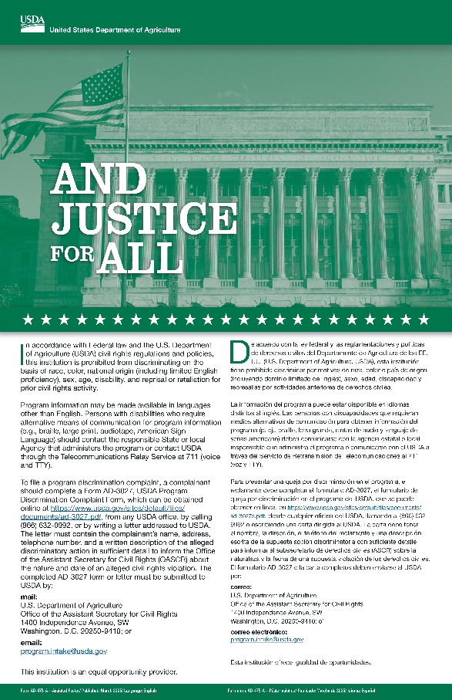
Acceptable versions of the AJFA poster include (in preferred order):
- The 11 × 17 in. full color (NOTE: Not available from USDA at the time of publishing this notice)
- A full color facsimile of the original poster, printed on 8 ½ × 11 in. paper
- A grayscale or monochrome facsimile of the original poster, printed on 8 ½ × 11 in. paper
Sponsors may not modify the text of the AJFA; even if they intend to continue to extend civil rights assurances to classes beyond those protected by USDA Civil Rights.

Old Versions of the AJFA
The December 2022 AJFA poster is now rescinded and should be replaced as soon as possible. Although the March 2025 poster contains substantially similar text as the version that was available prior to December 2022, the older versions should not be posted in lieu of the March 2025 poster.
If sponsors or providers are unable to obtain the new poster (not yet available at the time this notice was published), then the sponsor should display the highest quality facsimile of the poster they can reasonably produce (see above list, “Acceptable versions”.

The USDA Nondiscrimination Statement
Only use the updated Nondiscrimination Statement that was published around March 2025. The version published circa December 2022 is now rescinded; prior versions of the statement may be substantially similar to the March 2025 statement but must also be replaced with the most current version. The most current version is printed on the AJFA poster.

Full vs. Abbreviated Nondiscrimination Statement
Sponsors should use the full USDA Nondiscrimination Statement on all vital documents. The abbreviated statement, “This institution is an equal opportunity provider”, may be substituted on all non-vital documents.
A vital document is a document which contains program access or eligibility information; page length is not a determining factor as to whether a document is vital.

Examples of Vital and Non-Vital Documents
Vital | Non-Vital
- Application form  - Determination letter (notification of eligibility or ineligibility)  - Notice of adverse action  - Program home page (or link)  - Program information / literature | - Menus  - Program flyers  - Social Media Posts  - Posters

Contracting with Small, Minority-owned, Women-owned, Veteran-owned, and Labor Surplus Area Businesses
Neither the current nor previous changes to Civil Rights regulations have altered the fundamental requirements of 2 CFR §200.321.
This regulation requires federal award recipients and subrecipients to consider small and disadvantaged businesses and set standards for doing so. These standards generally include that such businesses should be included in solicitation lists, solicited whenever deemed eligible, that procurements be fractionalized when possible to increase competition, that delivery schedules be created that encourage such businesses to participate, that agencies utilize the Small Business Administration (SBA) or Minority Business Development Agency, and that the provisions of 2 CFR §200.321 be included in subrecipient and subcontract terms.

DEED Compliance Schedule
Beginning on the following dates, DEED will cite noncompliance during routine Administrative Reviews and Civil Rights or Program Investigations:
- 15 August 2025 for the National School Lunch Program (excluding Seamless Summer Option), School Breakfast Program, and Fresh Fruit and Vegetable Program
- 1 October for the Child and Adult Care Food Program, Summer Food Service Program, and Seamless Summer Option
The Bostock rescission is effective immediately; therefore, DEED will not investigate civil rights complaints related to the expanded definition of “sex” effective immediately.

Extending Civil Rights Protections Beyond Federal Requirements
Sponsors may issue supplemental statements, provided they are clearly distinguished from USDA’s AJFA poster and Nondiscrimination Statement. Sponsors receiving other federal funding are cautioned to review the terms and conditions of such funding to ensure that their policies are consistent with requirements of all sources of funding.

Nondiscrimination Statement
In accordance with Federal law and the U.S. Department of Agriculture (USDA) civil rights regulations and policies, this institution is prohibited from discriminating on the basis of race, color, national origin (including limited English proficiency), sex, age, disability, and reprisal or retaliation for prior civil rights activity.
Program information may be made available in languages other than English. Persons with disabilities who require alternative means of communication for program information (e.g., braille, large print, audiotape, American Sign Language) should contact the responsible State or local Agency that administers the program or contact USDA through the Telecommunications Relay Service at 711 (voice and TTY).
To file a program discrimination complaint, a complainant should complete a Form AD-3027, USDA Program Discrimination Complaint Form, which can be obtained online at https://www.usda.gov/sites/default/files/documents/ad-3027.pdf, any USDA office, by calling (866) 632-9992, or by writing a letter addressed to USDA. The letter must contain the complainant’s name, address, telephone number, and a written description of the alleged discriminatory action in sufficient detail to inform the Office of the Assistant Secretary for Civil Rights (OASCR) about the nature and date of an alleged civil rights violation. The completed AD-3027 form or letter must be submitted to USDA by:
mail: U.S. Department of Agriculture
Office of the Assistant Secretary for Civil Rights
1400 Independence Avenue, SW
Washington, D.C. 20250-9410; or
email: Program.Intake@usda.gov

This institution is an equal opportunity provider.

