How to Submit Claims
In order to submit a Claim, the Program Year Checklist must be in Approved status. The Sponsor has the option of A) Entering Claim Data for each Site, or B) or Uploading a Site Claim Data File. Those Sponsors with a lot of sites may wish to use the Uploading process. Both methods will be described here.
Submit your NPFS Report before submitting your October claim

Option A – for most of the Sponsors and Centers in Alaska:

Entering Claim Data for each Site
Select the Claims tab, click the Expansion button of the Claim Month to see Sites. Click the Add button on the right side of the screen to add that Site Claim.
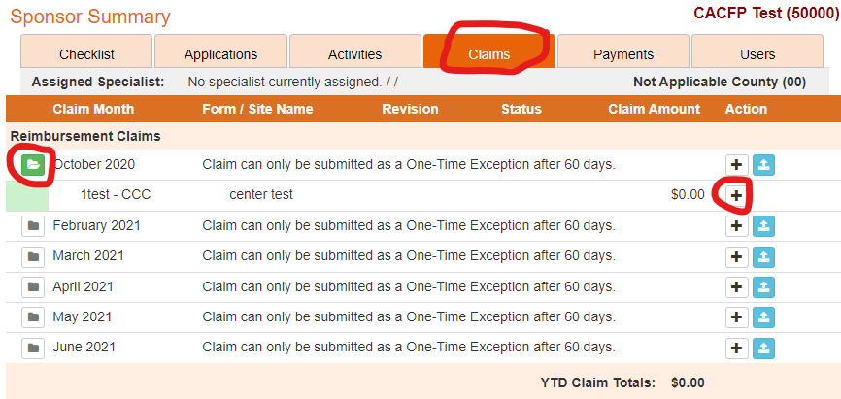
Figure 38: Add site claim

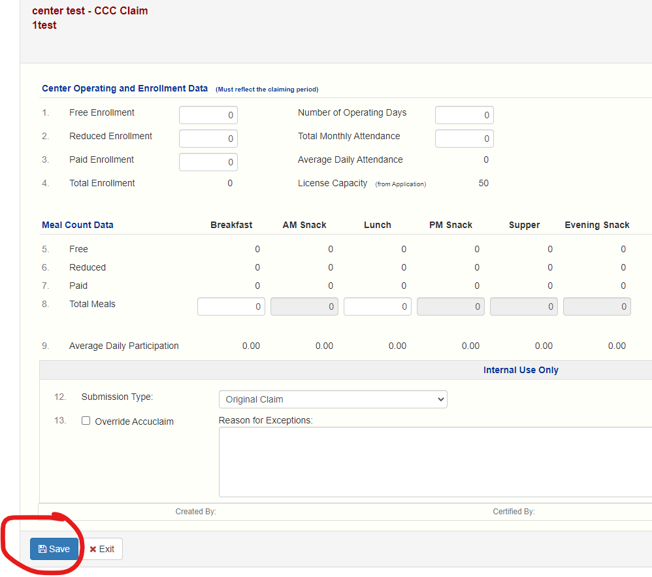
Figure 39: Enter site claim data
- Enter the Free/reduced/over income enrollment numbers on the first claim of the fiscal year. The numbers must match what has been entered on the center information sheet (See figure 40 below). These numbers should match what you submitted on the One Month Enrollment Report (OMER).

- Enter the Total Monthly Attendance. This is the number of participants in attendance each day of the month. If you are using the Child Care Grant roster to collect the number in attendance remember that half day children equal 1 (not a ½) so you’ll need to add all those extra ½ days back in to your total to get the accurate Total Monthly Attendance. 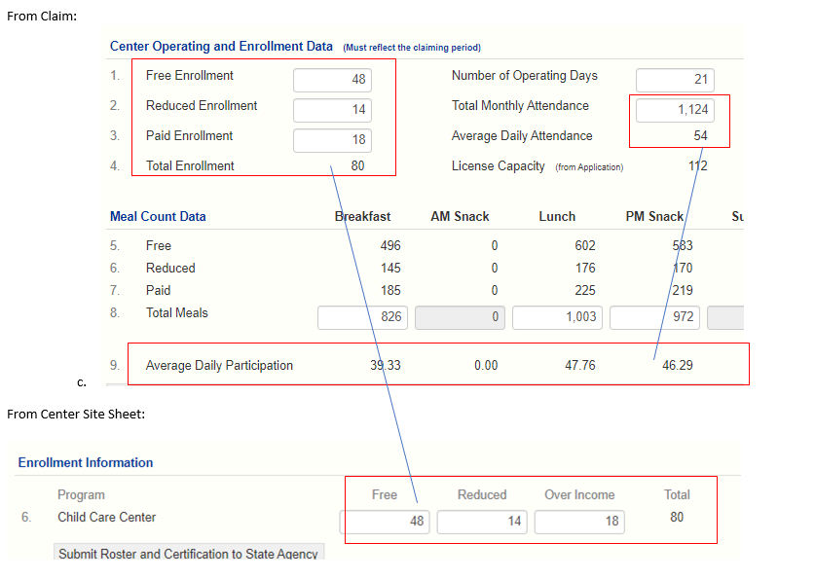

You will notice that your average daily participation (ADP) is less than or equal to the average daily attendance (ADA) since many times not all attendees eat all meals during the month.

If your enrollment increases in future operating months you may get an error if the ADA is larger than the Total Enrollment. If this happens please e-mail DEED to explain why it is higher. It may be advantageous to your agency to submit a revised OMER to capture the increased participants if they are in the free or reduced category. Consult with DEED.

- For-profit Centers:
  - Enter the number of children that are either:
- Receiving Child Care Grant funds for that month in the Total Title XX/XIX Beneficiaries cell or
- That are free or reduced using the Enrollment/CIS forms in the F/RP Eligibles cell

  - Enter the number of children enrolled during the month in the Current Total Enrollment cell (this will change each month if your enrollment goes up or down.The database will calculate the % using either Total Enrollment or your Licensed Capacity, whichever is less.

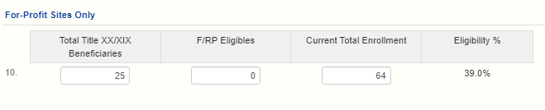
  - Mark whether you do meet the Eligibility requirement or you do not. If you do not meet the 25 % requirement for that month you will not receive reimbursement, but perhaps your enrollment will change, and you will meet it in future months.

DO NOT MANIPULATE YOUR F/R NUMBERS OR YOUR TOTAL ENROLLMENT IN ORDER TO REACH 25% … YOU MUST ONLY REPORT CORRECT INFORMATION.
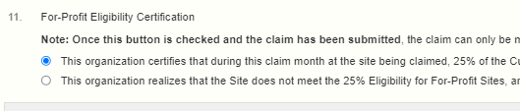

Once you’ve entered all the information in the Site Claim data and then click the Save button. Correct any errors until the Site Claim is in a Complete status. Repeat these steps for each Site Claim. Once all of the Site Claims are in a status of Complete, the Sponsor Claim must be edited (enter expenses) , certified and saved. The Sponsor and Site Claims will then be in Pending Approval status. DEED will review and approve them. When a Sponsor Claim is in an Approved status, it will be processed in the next payment batch.

Option B for large sponsoring organizations of centers:

Uploading Site Claim Data File
First, select the Claims tab and then click the Upload Site Claim Data file button (see Figure 35 below, button circled in blue).
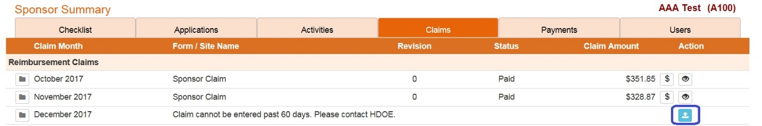
Figure 35: Upload claims file button on the Claims Tab
You will received the Upload Claims page (see Figure 36 below).
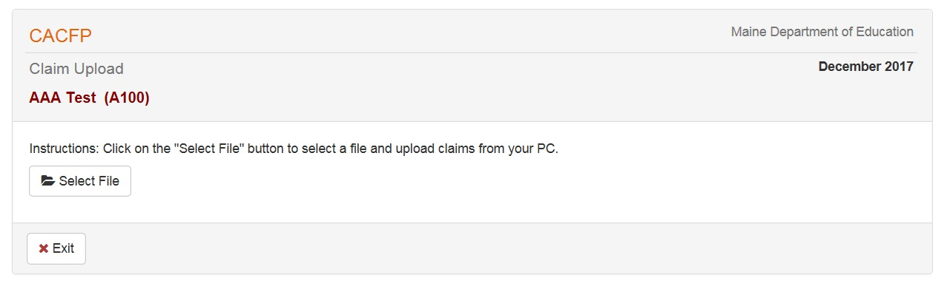
Figure 36: Upload Claims File page
The select a file dialog window will open (see Figure 37 below). Double click on the file you want to upload or click the file once and click the Open button. CnpWeb will try to analyze the file you have selected and if there are errors it will notify you. If the file is acceptable, then it will tell you that as well. Note: the file must be in a very particular format as an Excel spreadsheet or a comma delimited file. See the Help page for examples of an acceptable upload claim data file.
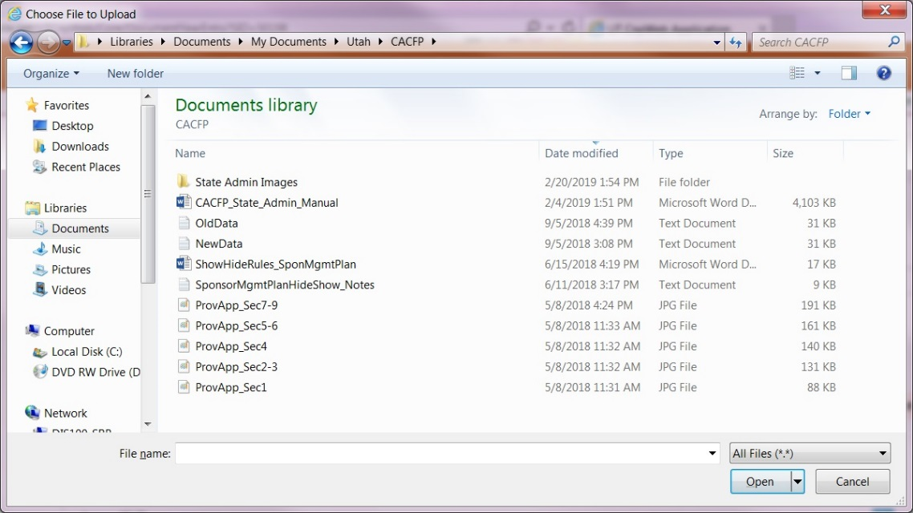
Figure 37: Choose a File Upload dialog window
Once all the site data has been uploaded, if there were no errors then all of the Site Claims will be in “Complete” status. The Sponsor claim will also have been automatically created, but it is not yet complete. Edit the Sponsor Claim by clicking the Edit button in the far right hand side of the screen. Review the information on it, enter the expenses, check the sponsor certification checkbox and click the Save button. This will submit both the Sponsor and Site Claims, which will then be in Pending Approval status. DEED will review and approve them. When a Sponsor Claim is in an Approved status, it will be processed in the next payment batch.

