 | Consolidated Waiver Application  Agreement to Waive Regulatory Requirements of CNP Services due to COVID-19 | Child Nutrition Programs  Finance and Support Services  P.O. Box 110500  Juneau, Alaska 99811-0500

Alaska Child Nutrition Programs has been authorized to provide the following waivers for SFSP, SSO and NSLP/SBP/FFVP sponsors in good standing approved to operate July 1, 2022 – May 30, 2023; and CACFP sponsors approved to operate July 1, 2022 thru September 30, 2023.
In order to be eligible for the waiver, a program site will have to be in the “high” category using the CDC’s Community Level Databank, and checking for your community using the COVID-19 County Check search feature. A waiver would only be approved while a community is in the high category or if enrolled programs face building closures or limited attendance for social distancing regardless of the CDC levels (including school sites). Sponsor must submit a separate Waiver application for each program selected.

Sponsor Name
Click or tap here to enter sponsor name.
Sites that will participate in selected COVID-19 Waiver (attach additional page for additional sites):
Site Name (s)
Click or tap here to enter site name.
Click or tap here to enter site name.
Click or tap here to enter site name.

Select each waiver you wish to utilize during a COVID-19 related safety mitigation.

Summer Food Service Program (SFSP) and Seamless Summer Option (SSO):
The waivers in this section apply to SFSP and SSO for summer 2022. However, FNS expects that flexibilities under the waivers in this section will only be implemented by Program operators when congregate meal service is limited by the COVID-19 pandemic. CDC Community Level Databank
◻ Waiver 1: Non-Congregate Meal Service during Summer 2022 [42 U.S.C. 1753(b)(1)(A), 42 U.S.C. 1761(a)(1)(D), and 7 CFR 225.6(e)(15)] (May 1, 2022-September 30, 2022)
◻ Waiver 2: Parent/Guardian Meal Pickup during Summer 2022 [42 U.S.C. 1761(f)(3), 7 CFR 210.10(a), 7 CFR 220.2, 7 CFR 220.8(a), 7 CFR 225.2, and 7 CFR 225.9(d)(7)] (May 1, 2022-September 30, 2022)

National School Lunch Program (NSLP) and School Breakfast Program (SBP):
The following waivers are intended to provide needed flexibility to support school food authorities (SFAs). FNS expects that flexibilities under the waivers in this section will only be implemented by Program operators when congregate meal service is limited by the COVID-19 pandemic. CDC Community Level Databank
◻ Waiver 3: Non-Congregate Meal Service [42 U.S.C. 1753(b)(1)(A) and 42 U.S.C. 1773(b)(1)(A)] (July 1, 2022 – June 30, 2023)
◻ Waiver 4: Parent/Guardian Meal Pickup [7 CFR 210.10(a), 220.2 (Breakfast), and 220.8(a)]
(July 1, 2022 – June 30, 2023)
◻ Waiver 5: Meal Service Times [7 CFR 210.10(l) and 220.8(l)] (July 1, 2022 – June 30, 2023)
◻ Waiver 6: Offer Versus Serve [42 U.S.C. 1758(a)(3) and 7 CFR 210.10(e)] (July 1, 2022 – June 30, 2023)

School Year Administration (NSLP/SBP/SFSP):
The following waivers allow State and local Program operators to overcome administrative challenges resulting from COVID-19 and to appropriately allocate their limited staffing resources to ensure safe service of meals to children as they respond to and recover from the COVID-19 pandemic. FNS expects Program operators will only use these flexibilities for the duration and extent that they are needed. CDC Community Level Databank

◻ Waiver 9: Administrative Review Onsite Requirements [7 CFR 210.18] (End of PHE** – June 30, 2023)
  - Onsite Requirement for SFA Onsite Reviews by February 1 [7 CFR 210.8(a)(1) and 220.11(d)(1)] (End of PHE** – June 30, 2023)
  - Onsite Requirement for Afterschool Care Reviews [7 CFR 210.9(c)(7)] (End of PHE** – June 30, 2023)
  - Onsite Requirement for Periodic On-site Visits when Utilizing an FSMC [7 CFR 210.16(a)(3) and 220.7(d)(1)(iii)] (End of PHE** – June 30, 2023)

Fresh Fruit and Vegetable Program (FFVP):
The following waivers are intended to provide needed flexibility to support schools in continuing to participate in the FFVP. FNS expects that flexibilities under the waivers in this section will only be implemented by Program operators when the FFVP elementary school is closed for in- person instruction and congregate meal service is limited by the COVID-19 pandemic. CDC Community Level Databank
- Waiver 14: Parent/Guardian FFVP Pickup [42 U.S.C. 1769a] (July 1, 2022 – June 30, 2023)
- Waiver 15: Alternate Site [42 U.S.C. 1769a(a)] (July 1, 2022 – June 30, 2023)

Unanticipated School Closures:
The waivers in this section apply to SFSP and SSO during unanticipated school closures. FNS expects that flexibilities under these waivers will only be implemented by Program operators when congregate meal service is limited by the COVID-19 pandemic. CDC Community Level Databank
◻ Waiver 16: Non-Congregate Meal Service during Unanticipated School Closures in SY 2022-23 [42 U.S.C. 1753(b)(1)(A), 42 U.S.C. 1761(a)(1)(D), and 7 CFR 225.6(e)(15)] (October 1, 2022 – April 30, 2023)
◻ Waiver 17: Parent and Guardian Meal Pick-Up during Unanticipated School Closures (SFSP/SSO) [42 U.S.C. 1761(f)(3) and 7 CFR 210.10(a), 220.2 (Breakfast), 220.8(a), 225.2, and 225.9(d)(7)] (October 1, 2022 – April 30, 2023)
- Waiver 18: Meal Service Times for Unanticipated School Closures in SY 2022-23 [7 CFR 225.16(c)(1) and 225.16(c)(2)] (October 1, 2022 – April 30, 2023)
- Waiver 19: Meals at School Sites for Unanticipated School Closures in SY 2022-23 [42 U.S.C. 1761(c)(1) and 7 CFR 225.6(d)(1)(iv)] (October 1, 2022 – April 30, 2023)

Child and Adult Care Food Program (CACFP):
The waivers in this section apply to CACFP. FNS expects that operational flexibilities under these waivers will only be implemented by Program operators when congregation is limited by the COVID-19 pandemic. FNS expects that monitoring flexibilities will only be implemented when pandemic conditions interfere with the ability of State agencies and sponsoring organizations to conduct reviews onsite. CDC Community Level Databank
- Waiver 20: Non-Congregate Meal Service [42 U.S.C 1753(b)(1)(A) and 7 CFR 226.19(b)(6)(iii)] (July 1, 2022 – June 30, 2023)
- Waiver 21: Parent/Guardian Meal Pick-Up [7 CFR 226.2] (July 1, 2022 – June 30, 2023)
- Waiver 22: Meal Service Times [7 CFR 226.20(k)] (July 1, 2022 – June 30, 2023)
- Waiver 23: State Agency Onsite Monitoring Visits [7 CFR 226.6(b)(1) and 226.6(m)(6)]
(End of PHE** – June 30, 2023)
- Waiver 24: Sponsoring Organization Onsite Monitoring Visits [7 CFR 226.16(d)(4)(iii)]
(End of PHE** – June 30, 2023)
** Current nationwide waivers of onsite monitoring for NSLP, SBP, and CACFP remain in effect until 30 days after the end of the Public Health Emergency (PHE). The end of the PHE will be declared by the U.S. Department of Health and Human Services.

Please describe services affected by the approved Waiver for your program.

Meals to be offered: (Breakfast, Lunch, Snack, FFVP, At-Risk Meals)
Meal Service Time Flexibility (including parent/guardian pick-up and meal delivery):
Meal Delivery Methods (Curbside pick-up, Mobile sites, Home Delivery):
Meal Options (Full week of meals at one time, 2-3 days at one time, Weekend meals, Bulk Food, Shelf-stable meals):
Meal Counting Method (Standard POS, Mobile technology, Paper roster, clicker):
Parent or Guardian Pick-Up (Describe processes in place to ensure that meals are distributed only to parents or guardians of enrolled children, and that duplicate meals are not distributed or attach written procedures):
Procedure for notifying parents and guardians regarding program services while utilizing Wavier flexibilities:
The sponsor agrees to provide DEED Child Nutrition Programs with reporting requirements to be sent with waiver approval by DEED and the following as applicable:
- A summary of the use of the non-congregate feeding flexibilities by local program operators,
- A summary of the use of the parent or guardian pick-up flexibilities by local program operators,
- A summary of the use of the meal-time flexibilities by local program operators,
- A summary of the use of the SSO option by local program operators,
- A summary of the use of the offer versus serve flexibilities by local program operators,
- A summary of the use of the Administrative Reviews, Monitoring and Reporting flexibilities,
- A summary of the use of Alternative Site flexibility (FFVP),
- A summary of the use of the Meals at School Sites for Unanticipated School Closures flexibilities,
- A description of how each waiver resulted in improved services to program participants.
- A description of how the waiver impacted meal service operations, children’s access to nutritious meals, and participation in SFSP.
- A description of how the waiver impacted the quantity of paperwork necessary to administer the program.
Failure to comply with reporting requirements may result in the State Agency denying future waiver requests. Please contact the appropriate program DEED representative for additional information.

Signature of Authorized Representative and Date
Sign and Date here:

Approval Signature of DEED Child Nutrition Programs and Date
Sign and Date here:

Waiver Application instructions
The CDC database is updated each Thursday. Sponsors will check the CDC database each Friday for the latest update on your community status. If the CDC database site shows a community as high, and the sponsor wants to employ the waiver, the sponsor will take a screen shot of the High status, including the current date, and submit the screen shot with waiver application to the appropriate CNP contact on list below.
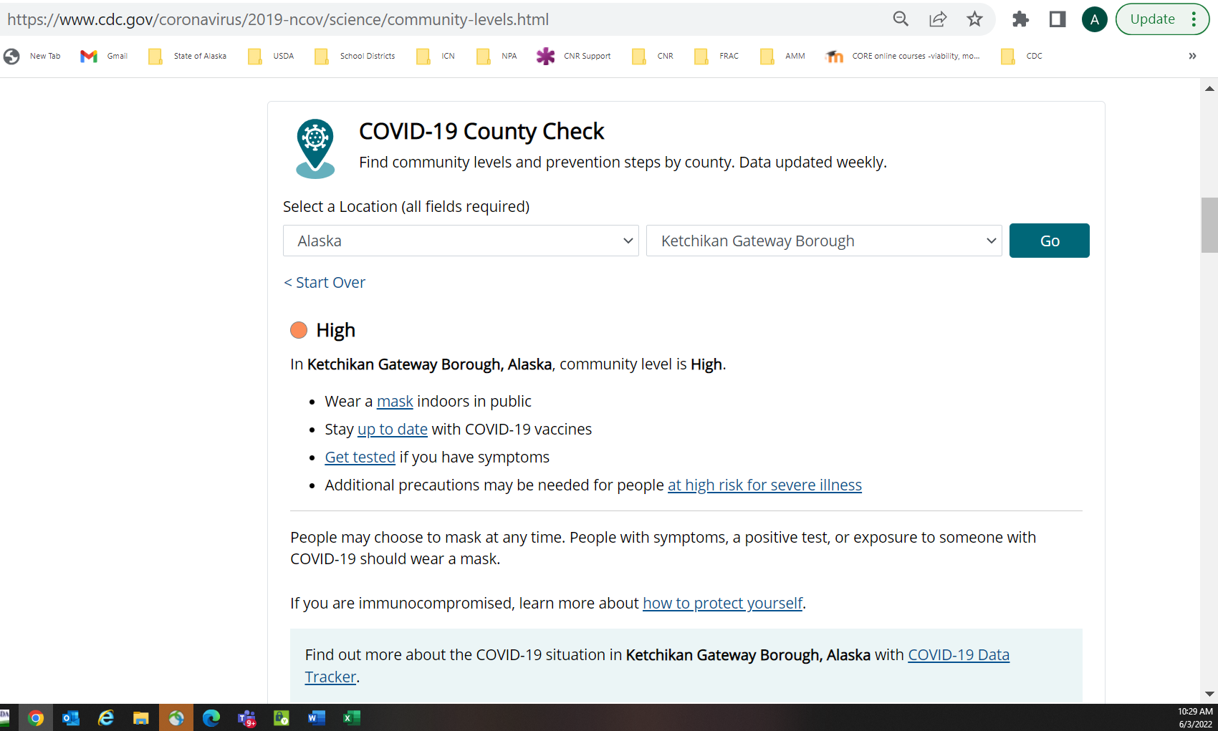

If the CDC database shows that a community has dropped from a High to a Medium or Low status, they will transition back to normal practices during the next week – resuming normal meal service the following Monday. For example, Juneau moves from a High status to a medium or low status on Friday July 22nd; a sponsor would then transition back to normal meal served no later than August 1st.

If a sponsor has multiple child nutrition programs they wish to apply for, a separate Waiver Application for each program (SFSP and SSO, NSLP and SBP, School Year Administration NSLP/SBP/SFSP, FFVP, Unanticipated School Closure, or CACFP) will be submitted. For example, if a sponsor is requesting a waiver for a SFSP site and a NSLP site, they will submit two separate applications to the appropriate CNP contact on list below.
Upon Waiver application approval you will receive instructions from DEED with reporting guidelines and any additional required information needed to document necessary data regarding USDA requirements.

Current timelines for reporting Waiver usage:
- CACFP – Month end documenting waiver flexibilities used.
- SFSP – Year-end for FY2022 SFSP program
- NSLP/SSO – End of summer session waivers, and prior to beginning of SY2023
- NSLP/SSO – Year-end for SY23 school year.
- FFVP – Year-end for SY2023 school year

DEED CNP Program Contact Information:
- Program Coordinator (USDA Foods, TEFAP, FFVP)
  - Sue Lampert: (907) 465-8710
- Program Coordinator (NSLP)
  - Beth Seitz: (907) 465-8709
- Program Coordinator (CACFP)
  - Ann-Marie Martin: (907) 465-8711
- Program Specialist (SFSP)
  - Val Cummins: (907) 465-4788

Non-Discrimination Statement
In accordance with federal civil rights law and U.S. Department of Agriculture (USDA) civil rights regulations and policies, this institution is prohibited from discriminating on the basis of race, color, national origin, sex (including gender identity and sexual orientation), disability, age, or reprisal or retaliation for prior civil rights activity.
Program information may be made available in languages other than English. Persons with disabilities who require alternative means of communication to obtain program information (e.g., Braille, large print, audiotape, American Sign Language), should contact the responsible state or local agency that administers the program or USDA’s TARGET Center at (202) 720-2600 (voice and TTY) or contact USDA through the Federal Relay Service at (800) 877-8339.
To file a program discrimination complaint, a Complainant should complete a Form AD-3027, USDA Program Discrimination Complaint Form which can be obtained online at: https://www.usda.gov/sites/default/files/documents/USDA-OASCR%20P-Complaint-Form-0508-0002-508-11-28-17Fax2Mail.pdf, from any USDA office, by calling (866) 632-9992, or by writing a letter addressed to USDA. The letter must contain the complainant’s name, address, telephone number, and a written description of the alleged discriminatory action in sufficient detail to inform the Assistant Secretary for Civil Rights (ASCR) about the nature and date of an alleged civil rights violation. The completed AD-3027 form or letter must be submitted to USDA by:
- mail:
U.S. Department of Agriculture
Office of the Assistant Secretary for Civil Rights
1400 Independence Avenue, SW
Washington, D.C. 20250-9410; or
- fax:
(833) 256-1665 or (202) 690-7442; or
- email:
program.intake@usda.gov

This institution is an equal opportunity provider

