Ukraine GPS Navigation Equipment Importer Overcomes Export Hurdles
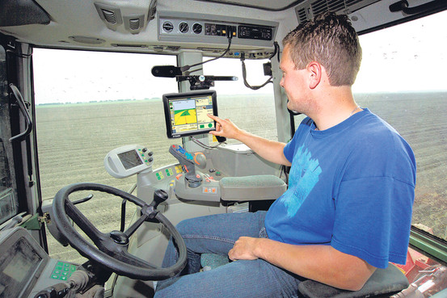
North Dakota native Jim Bueling imports and distributes Trimble navigational equipment into Ukraine and Russia, and has successfully developed this business and managed this network for ten years. Trimble provides GPS solutions all over the world for many industries including agriculture, construction, transportation, natural resources, and more.

Bueling’s Ukraine import shipments came to a sudden standstill in February 2015 when new laws came to restrict exports to certain areas of Ukraine, and his current shipment ended up sitting in a port unable to move. Needing a solution fast, Bueling contacted Heather Ranck at the U.S. Commercial Service in North Dakota by referral from U.S. Senator John Hoeven’s office. Heather Ranck contacted the U.S. Commercial Service Office or Russia, Ukraine, and Eurasia of the U.S. Commercial Service (CS), and within a matter of hours, Bill Thorn, a Commercial Officer for the office, provided detailed information and contacts to help Bueling in the area of sanctions, licensing and export controls. Ranck also provided Bueling with some contacts to help with financing challenges in Ukraine.

As a result of Bueling’s ability to quickly gain knowledge, contacts and insight, he was able to confidently work on the issue and get his shipment released in a matter of days. Bueling was appreciative for the assistance of the U.S. Commercial Service saying, “Thanks so much for all the information you provided. I am still reading! We will definitely use most, if not all, of the contacts you’ve provided us. I will be sure to contact you again. Thanks again!”

For more information on Trimble Navigation Limited, Inc., visit their website at http://www.trimble.com/ (JIM, if you have a website you would prefer we use, we can put it here) and for information on the U.S. Commercial Service, call (701) 239-5080, or visit www.export.gov/northdakota.

###

