U.S. Environmental Protection Agency Sam Nunn Atlanta Federal Center
Region 4: AL, FL, GA, KY, MS, NC, SC, TN 61 Forsyth St. SW
Office of External Affairs Atlanta, GA 30303-3104
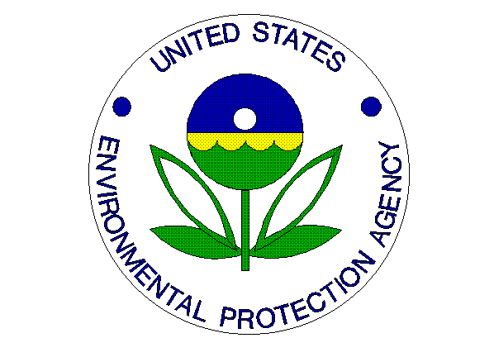
Environmental News
PHONE: (404)562-8327 FAX: (404)562-8335

FOR IMMEDIATE RELEASE
November 24, 2014
EPA Awards Kentucky-based Conference of Radiation Control Directors Grant to Reduce Indoor Pollutant Exposure and Protect Public Health
CONTACT: Jason McDonald, (404)-562-9203, mcdonald.jason@epa.gov
ATLANTA - The U.S. Environmental Protection Agency (EPA) awarded the Conference of Radiation Control Directors in Frankfort, Kentucky funding to protect public health by reducing exposure to indoor pollutants, such as radon, and environmental asthma triggers commonly found in homes, schools, offices and other large buildings. The organization is one of eight from throughout the United States to receive up to $200,000 of the $4.5 million in funds that are being made available. Awards were obtained through a competitive grant process. These EPA-funded projects will ensure Americans, especially in low-income, minority and tribal communities, are able to reduce their exposure to indoor pollutants and safeguard their families’ health.
“Partnering with these leading organizations will increase national awareness on the importance of healthy indoor air quality in our changing climate and will empower communities to implement public health projects locally,” said Janet McCabe, acting assistant administrator for the Office of Air and Radiation.
“With these agreements, EPA advances our commitment to communities by providing financial and technical assistance so they can take action to prevent lung cancer, asthma episodes and other respiratory diseases.”
Americans spend up to 90 percent of their time indoors, making indoor air quality an important public health issue. For example, radon is the second leading cause of lung cancer in the United States and asthma affects more than 25 million Americans, including 7 million children, with poor and minority children suffering a greater burden of the disease.
EPA will collaborate with the recipients of the three-year cooperative agreements to:
- prevent future lung cancer deaths by reducing public exposure to radon by mitigating risks in existing homes and schools and by constructing new homes and schools with radon-reducing features;
- prevent asthma attacks, emergency room visits, and other poor health outcomes by supporting delivery, infrastructure and/or sustainability of environmental asthma interventions at home and school, with a focus on populations disproportionately impacted by asthma; and
- prevent other poor health outcomes through expanded support of state and local efforts to improve indoor air quality by promoting best practices and policies.
The Conference of Radiation Control Program Directors (CRCPD) is a professional organization dedicated to radiation protection. CRCDP will collaborate with EPA to provide nationwide assistance to state, tribal and local government officials to reduce the American public’s exposure to elevated radon in homes and other buildings and will highlight program success. Specifically, the project will assure that technical assistance, tools and information provided by states and tribes are based on the most current science available, and increase collaboration among organizations to raise radon awareness and reduce risks through mitigation of existing buildings and building new structures radon resistant.
Other recipients of the “National Indoor Environments Program: Reducing Public Exposure to Indoor Pollutants” cooperative agreements are:
- · American Lung Association, Washington, DC
- · American Lung Association of the Upper Midwest, Springfield, Ill.
- · America’s Health Insurance Plans, Washington, DC
- · Environmental Law Institute, Washington, DC
- · Kansas State University, Manhattan, Kan.
- · National Center for Healthy Housing, Columbia, Md.
- · Public Health Institute, Oakland, Calif.
For more information on these innovative projects, visit www.epa.gov/iaq.

