U.S. Environmental Protection Agency Sam Nunn Atlanta Federal Center
Region 4: AL, FL, GA, KY, MS, NC, SC, TN 61 Forsyth St. SW
Office of External Affairs Atlanta, GA 30303-3104
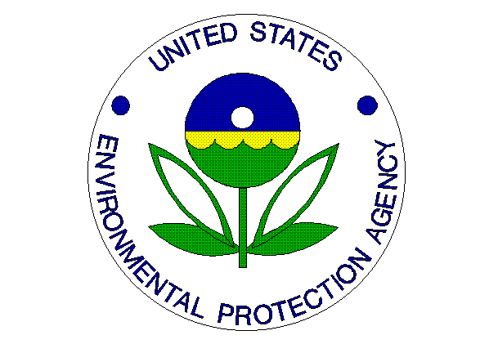
Environmental News
PHONE: (404)562-8327 FAX: (404)562-8335

FOR IMMEDIATE RELEASE
October 10, 2012

EPA Awards $1.2 Million to Improve Indoor Air Quality

CONTACT: Jason McDonald, 404-562-9203, mcdonald.jason@epa.gov

Atlanta – The U.S. Environmental Protection Agency (EPA) announced today it will provide a combined $218,046 in funding to the University of Tulsa and the Mission Healthcare Foundation for indoor air quality projects. The funding will support recipients’ efforts to improve indoor air quality, which will better protect the health of Americans in classrooms, communities and homes across the country.
Education projects, training and outreach efforts supported by the funding will help reduce the environmental health risks of indoor air contaminants such as radon and asthma triggers. From organizing and training speakers on how to educate parents of children with asthma, to providing technical assistance that will help school districts develop indoor air quality management plans, these projects will help protect children and families. Funding for each of the grants awarded will be provided incrementally over a two-year time period. EPA emphasized selecting projects that assist low income and minority families that are disproportionately impacted by poor indoor air quality.
“EPA is proud to be working with our awardees across the nation to improve the air we breathe at school, work and home,” said Gina McCarthy, assistant administrator for EPA’s Office of Air and Radiation. “American communities face serious health and environmental challenges from air pollution. This effort gives us an opportunity to improve indoor air quality by increasing awareness of environmental health risks.”
Indoor air pollutants in homes, buildings, and schools can negatively impact the health of occupants. Some pollutants cause health problems such as sore eyes, burning in the nose and throat, headaches or fatigue. Others can cause worsen allergies, respiratory illnesses (such as asthma) or even cancer (from radon gas).

The projects will help improve indoor air quality and reduce the associated health risks by:
- Increasing effective indoor air quality practices through community level education and outreach
- Promoting positive indoor air quality management practices in schools by working with school districts and teachers
- Increasing the number of homes tested for radon, homes built with radon-resistant features, and existing homes mitigated for radon
- Creating awareness to reduce asthma triggers in the home and encourage the use of asthma management plans through community based asthma programs
.

More information about Indoor Air Assistance Agreements: http://www.epa.gov/iaq/regional_funding.html

