U.S. Environmental Protection Agency Sam Nunn Atlanta Federal Center
Region 4: AL, FL, GA, KY, MS, NC, SC, TN 61 Forsyth St. SW
Office of External Affairs Atlanta, GA 30303-3104
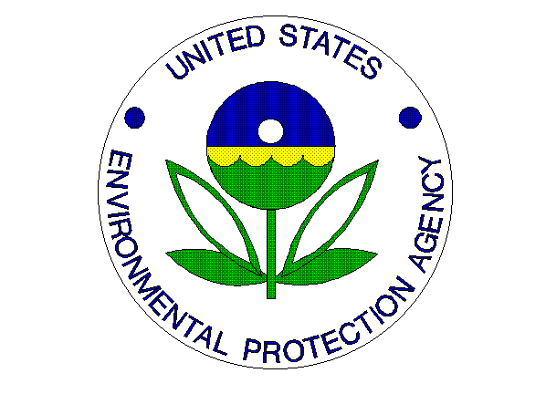
Environmental News
PHONE: (404)562-8327 FAX: (404)562-8335

FOR IMMEDIATE RELEASE
September 24, 2012
EPA Honors Organizations for Supporting Green Power
Contact: Jason McDonald, 404-562-9203, mcdonald.jason@epa.gov
ATLANTA – Today the U.S. Environmental Protection Agency (EPA) presented its 12th annual Green Power Leadership Awards to one Green Power Partner and one supplier for their achievements in advancing the nation’s renewable electricity market. For most municipalities, electricity usage is the single-largest source of greenhouse gas emissions. By using green power, communities and businesses can dramatically reduce greenhouse gas emissions, create local jobs, and improve public health.

“Our 2012 Green Power Leadership Award winners have not only demonstrated commendable civic leadership in their efforts to use renewable energy sources, they’ve also helped to reduce our carbon footprint and cut back on pollution – all while supporting America's growing renewable energy industry,” said EPA Administrator Lisa P. Jackson. "Thanks to their commitment -- and the commitment of all of our Green Power Partners -- our country is one step closer to a cleaner, more sustainable energy future.”

“Green power” is electricity generated from renewable resources, such as solar, wind, geothermal, biogas and low-impact hydro, and produces no net increase of greenhouse gas emissions. From purchasing 100-percent green power to installing large-scale solar panel arrays, the award winners help demonstrate that green power makes sense not only for Americans' health and environment but for business' bottom lines.

The 2012 Green Power Leadership Award winners are listed below in the following categories:

On-site Generation: Coca-Cola Refreshments
Green Power Supplier of the Year: Sterling Planet

The award-winning partners were chosen from more than 1,300 partner organizations. Utilities, renewable energy project developers and other green power suppliers were eligible to apply for the Supplier of the Year and Program of the Year awards.

EPA, through the Green Power Partnership, works with partner organizations, over half of which are small businesses and nonprofit organizations, to reduce the environmental impacts of conventional electricity use. Partners are voluntarily using more than 23 billion kWh of green power annually. Through their use of green power, these organizations are avoiding carbon pollution equal to that created by the electricity use of more than two million average American homes each year.

More on the Green Power Leadership Awards: www.epa.gov/greenpower/awards
More on the Green Power Community Challenge: www.epa.gov/greenpower/communities/gpcchallenge.htm
More on the Green Power Partnership: www.epa.gov/greenpower

