U.S. Environmental Protection Agency Sam Nunn Atlanta Federal Center
Region 4: AL, FL, GA, KY, MS, NC, SC, TN 61 Forsyth St. SW
Office of External Affairs Atlanta, GA 30303-3104
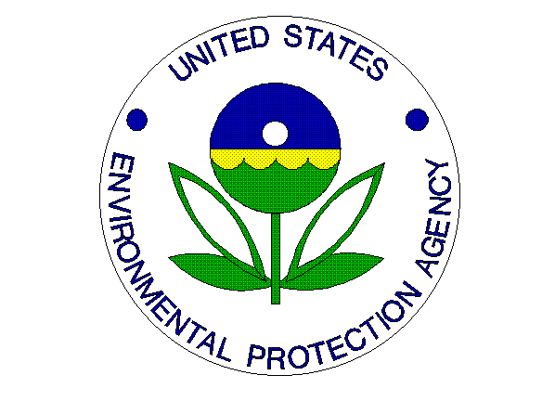
Environmental News
PHONE: (404)562-8327 FAX: (404)562-8335

FOR IMMEDIATE RELEASE
September 19, 2012
EPA Announces 12th Annual Clean Air Excellence Awards

Communities, public health and U.S. economy benefit from winners’ work on clean air initiatives
CONTACT: Jason McDonald, 404-695-0989, mcdonald.jason@epa.gov

ATLANTA – Today, the U.S. Environmental Protection Agency (EPA) is presenting the 12th annual Clean Air Excellence Awards honoring 3 projects and companies from across the Southeast for their work on clean air initiatives. The awards recognize innovative programs that protect Americans' health and the environment, educate the public, serve their communities and stimulate the economy.

“The 42-year history of the Clean Air Act is all about meeting challenges through commitment and innovation,” said Gina McCarthy, EPA Assistant Administrator for the Office of Air and Radiation. “The contributions of this year’s award winners are continuing the Clean Air Act’s progress in benefiting public health, our communities and the economy.”

From providing better access to electric vehicles and charging stations to creating a classroom toolkit promoting strategies to improve air quality to developing a real-time air monitoring notification system, award winners demonstrate a commitment to improving the air that we breathe. This year’s winners include:

Community Action
- Electric Vehicle Ecosystem Pilot Project, City and County of Greenville, S.C.

Education Outreach
- Conservation and Climate Change Challenge, Broward County, Fla.

Transportation Efficiency Innovations
- Leadership in Reducing Ocean-going vessel Emissions, Maersk Line/Maersk Agency USA, Charlotte, N.C.

The awards program, established in 2000 at the recommendation of the Clean Air Act Advisory Committee, annually recognizes entries that help reduce air pollution, provide a model for others to follow and offer innovative, sustainable outcomes. Entries are judged by EPA and the Clean Air Act Advisory committee, and winners are recognized with a certificate at an awards ceremony in Washington D.C.

More on this year’s award winners: http://www.epa.gov/air/cleanairawards/index.html

