U.S. Environmental Protection Agency Sam Nunn Atlanta Federal Center
Region 4: AL, FL, GA, KY, MS, NC, SC, TN 61 Forsyth St. SW
Office of External Affairs Atlanta, GA 30303-3104
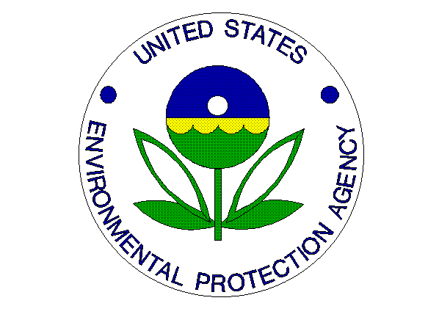
Environmental News
PHONE: (404)562-8327 FAX: (404)562-8335

For Immediate Release
September 10, 2012
EPA, North Carolina A&T State University, Bennett College, and the United Negro College Fund Host Third Symposium on Sustainable Environmental Practices at Colleges and Universities

Contact Information: Jason McDonald, (404) 562-9203, mcdonald.jason@epa.gov

ATLANTA – The U.S. Environmental Protection Agency (EPA) Regional Administrator Gwen Keyes Fleming, North Carolina A&T State University Chancellor Dr. Harold Martin, Bennett College Interim President Dr. Esther M. Terry, and United Negro College Fund Special Programs Corporation President and Chief Executive Officer Michael J. Hester will co-host the 3rd Annual Symposium on Sustainable Environmental Practices at Colleges and Universities on September 13-14, 2012. The event will be held on the campuses of North Carolina A&T State University and Bennett College.

The two-day conference runs through Friday with a full slate of panel discussions and seminars on the greening campuses and curricula at collegiate institutions located primarily in the Southeast. Students, faculty members, higher education administrators, and other environmental and sustainability stakeholders will have an opportunity to develop partnerships, network, and collaborate on sustainable environmental strategies and practices.

EPA Region 4 Regional Administrator Gwen Keyes Fleming will deliver the “Shaping Tomorrow’s Environmental Leaders” key note address on Thursday afternoon in the North Carolina A&T State University Event Center. Later in the day, Mrs. Fleming will meet with students attending the conference as host of the Youth Summit’s “Youth Wrap-Up Session”.

“EPA recognizes the necessity for full participation by citizens of all ages in developing environmental policy, sustainable practices and problem solving,” said Fleming. “We are endeavoring to encourage academic institutions to develop a culturally diverse pool of well qualified graduates interested in environmental careers.”

A Conference Town-Hall Session convening campus representatives with signed Memorandums of Understandings (MOU) is scheduled for Friday afternoon. EPA Region 4 will moderate the session as the members identify and coordinate priorities within the MOUs for the period 2012-2014.

The agenda will include sessions and presentations on greening campuses and curricula at collegiate institutions mostly in the Southeast. The conference will provide opportunities for students, faculty members, administrators, and other environmental and sustainability stakeholders to network, develop partnerships and collaborate on sustainable environmental practices. Students in attendance will have an opportunity to participate in seminars on federal employment as part of the concurrently held Youth Environmental Summit.

Please see symposium agenda for a complete list of experts and presentations.
http://www.ncat.edu/research/documents/events-documents/epa-agenda2012-final.pdf

