U.S. Environmental Protection Agency Sam Nunn Atlanta Federal Center
Region 4: AL, FL, GA, KY, MS, NC, SC, TN 61 Forsyth St. SW
Office of External Affairs Atlanta, GA 30303-3104
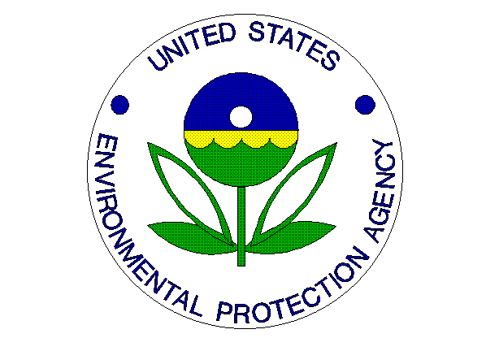
Environmental News
PHONE: (404)562-8327 FAX: (404)562-8335

Media Advisory
September 6, 2012
EPA, North Carolina A&T State University, Bennett College, and the United Negro College Fund Host Third Symposium on Sustainable Environmental Practices at Colleges and Universities

Contact Information: Jason McDonald, (404) 562-9203, mcdonald.jason@epa.gov

ATLANTA – The U.S. Environmental Protection Agency (EPA) Regional Administrator Gwen Keyes Fleming, North Carolina A&T State University Chancellor Dr. Harold Martin, Bennett College Interim President Dr. Esther M. Terry, and United Negro College Fund Special Programs Corporation President and Chief Executive Officer Michael J. Hester will co-host the 3rd Annual Symposium on Sustainable Environmental Practices at Colleges and Universities on September 13-14, 2012. The event will be held on the campuses of North Carolina A&T State University and Bennett College.

Who: Gwen Keyes Fleming, EPA Regional Administrator
Dr. Gilbert Rochon, President, Tuskegee University and Chair, Council of 1890 Universities
Dr. Harold Martin, Chancellor, North Carolina A&T State University
Dr. Esther M. Terry, Interim President- Bennett College
James Colon, Vice President for Product Sales, Toyota Motor Sales, NA

What: Third Annual Symposium on Sustainable Environmental Practices at Colleges and Universities

When: September 13-14, 2012

Where: North Carolina A&T State University
1601 East Market Street
Greensboro, NC 27411

Bennett College
900 East Washington Street
Greensboro, NC 27401

The agenda will include sessions and presentations on greening campuses and curricula at collegiate institutions mostly in the Southeast. The conference will provide opportunities for students, faculty members, administrators, and other environmental and sustainability stakeholders to network, develop partnerships and collaborate on sustainable environmental practices. Students in attendance will have an opportunity to participate in seminars on federal employment as part of the concurrently held Youth Environmental Summit.

Please see symposium agenda for a complete list of experts and presentations.
For more conference information, agenda, hotel, and registration go to:
http://www.ncat.edu/research/events/epa-symposium.html

