U.S. Environmental Protection Agency Sam Nunn Atlanta Federal Center
Region 4: AL, FL, GA, KY, MS, NC, SC, TN 61 Forsyth St. SW
Office of External Affairs Atlanta, GA 30303-3104
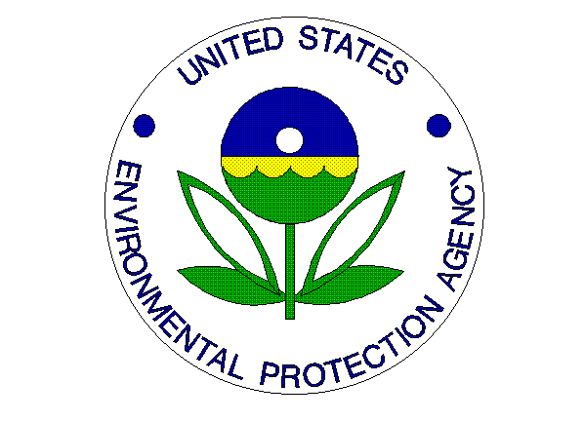
Environmental News
PHONE: (404)562-8327 FAX: (404)562-8335

For Immediate Release:
August 29, 2012

EPA, HUD, DOT and City of Atlanta Celebrate Third Anniversary of Partnership for Sustainable Communities
Contact Information: Dawn Harris-Young, (404) 562-8421, harris-young.dawn@epa.gov or Jason McDonald, (404) 562-9203, mcdonald.jason@epa.gov
ATLANTA – Today, the U.S. Environmental Protection Agency (EPA) Regional Administrator Gwen Keyes Fleming joined Mayor Kasim Reed, U.S. Department of Housing and Urban Development (HUD) Regional Administrator Ed Jennings, Jr. and Federal Transit Administration (FTA) Regional Administrator Dr. Yvette Taylor to celebrate the third anniversary of the Partnership for Sustainable Communities (Partnership). The Partnership is an interagency effort to help communities nationwide improve access to affordable housing, increase transportation options, and lower transportation costs while protecting the environment and people’s health.
“Three years ago, EPA embarked on this innovative partnership to change how we interact with our stakeholders and bring about change in the community,” said EPA Regional Administrator Gwen Keyes Fleming. “The programs and projects that are now in place here in Atlanta and across the Southeast, exemplify what can be accomplished when citizens, states, cities and federal agencies work together. We look forward to continuing this partnership and assisting each of these communities in achieving its long-term economic, environmental and public health goals.

“Atlanta’s Partnership for Sustainable Communities has really allowed us to do the kind of essential projects that invest directly in our communities, reduce transportation costs for our families, improve house affordability, save energy and increase access to work, play and home,” said Mayor Kasim Reed. “I applaud the EPA, HUD, the Department of Transportation and Department of Labor for their tremendous efforts. Through this partnership, we can work as a team to support ongoing initiatives, promote economic development and receive technical assistance on vital projects.”

In celebration of the local accomplishments of this partnership initiated within the city of Atlanta, a program and workshop was held today to share the partnership’s successes and plans for the future. Stakeholders, that included neighborhood, non-profit and elected leaders, shared information on what has worked in southwest Atlanta. Representatives from nearby communities also discussed how Partnership projects are setting trends in their area.

Since announcing the partnership, the agencies have dedicated more than $2.5 billion in assistance nationally to more than 200 communities in 48 states to help meet housing and transportation goals while simultaneously protecting the environment, promoting equitable development, and addressing the challenges of climate change. Of that funding, $238 million was focused on America’s rural communities.
The partnership, which celebrated its third anniversary in June, works to provide communities with faster, more streamlined access to federal programs and resources, and works closely with other federal agencies, states, and local governments to ensure that partnership programs use federal resources as efficiently as possible.

For more information about the Partnership for Sustainable Communities, visit: http://www.sustainablecommunities.gov/.

