COVID-19 Vaccination Programme
Information for people accessing the Vaccination Service at Calderdale and Huddersfield Foundation Trust hospital sites.

- You can get an appointment at Calderdale Royal Hospital (Learning Centre on Godfrey Road) and Huddersfield Royal Infirmary (Acre Mill site opposite the hospital) and you can select the most convenient one when you book. As stated in the covering email the vaccination is being done away from the main hospital.

- You need to book via the electronic booking system, and the link has been shared with you in the email. It is important that you do not share the booking link with anyone else. This is a critical requirement, as it ensures the vaccine is only accessed by those most at risk.

- On the online booking form please tick the box that you are:
- Shielding or clinically extremely vulnerable (CEV).
- An unpaid carer (see instructions on last page for booking in unpaid carers)

- Upon booking, you will receive a confirmation email message (please ensure that you have submitted a correct email address), plus an automated follow up reminder on the day prior to your appointment. If someone has completed the booking form for you, they will receive the reminders.

- The hospital will be using the Pfizer vaccine. Once you have had your vaccination you will be asked to wait in a designated area for 15 minutes, so that staff can make sure you are OK before you leave.

- If you have had a serious allergic reaction (called anaphylaxis) to a food, to a specific (known) medicine, or to a vaccine or insect sting in the past, the advice is it is safe for you to have any Covid-19 vaccine. You will also be asked by the vaccinator about any history of allergy before you are vaccinated to confirm it is safe for you.

- If you have had serious allergic reactions to lots of different medicines, or have had a serious allergic reaction and don’t know what it was caused by, then a different COVID-19 vaccine may be more suitable for you. In that case please decline this invitation and wait for your GP practice to contact you to discuss the best option for you.

- Please ensure you book an appointment as soon as the link is shared - ideally book an appointment within 24-48 hours of receiving the link. The online booking system will show availability for the next three days, including the day you are booked for.

- Please attend as soon as possible and take the earliest available appointment so that vaccine slots and vaccine is not wasted.

Please remember to take the following information to your appointment:
- Your NHS Number
- Photographic ID (For those people who are registered as sight impaired and do not have photo ID, they can present their registration certificate or other relevant documentation)
- A copy of this email as evidence that you have been contacted as you are shielding. (Where applicable your carer can also use this same email as evidence when they attend).

- Your NHS number can be found on:
- Prescriptions
- Hospital/GP or other NHS letters
- Antibody test results and Lateral Flow Test results
- GP online booking system

- Please note that you will be able to book your second dose when you attend for your first vaccination, rather than at the online booking phase.

- Please ensure that you follow current social distancing rules and wear a face covering when attending your vaccination appointment.

- Please note marshalling will be in place on both sites, checking documentation for those who have a booking, and that without appropriate documentation, you will not be able to access the service.

- If for some reason you cannot attend please ensure that you cancel your appointment quickly so that it can be reused.

- Please note the importance of attending for the second dose, which will be booked when you attend for your first dose.

- Information will be shared with Calderdale & Huddersfield NHS Trust, but only for the purposes of making the booking and recording that the person has received a Covid-19 vaccination and any follow-up.

Online Booking System for Adult Carers for a COVD-19 vaccination
When booking an appointment using the online link https://www.cht.nhs.uk/COVIDvaccination-booking.
Once you have selected a venue, date and appointment time the screen below will appear:
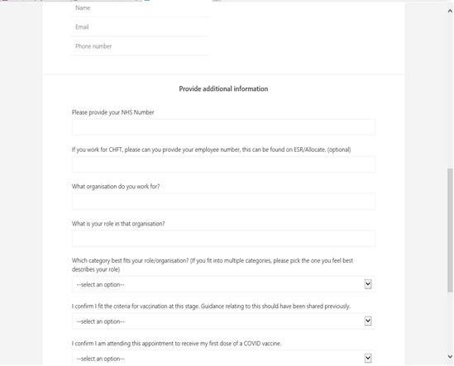
Please enter your name, email (so you can receive confirmation of your appointment and cancel/change the appointment if necessary), phone number and NHS Number.

For unpaid carers: Please input the following answers as an adult carer:
What organisation do you work for? Adult Carer
What is your role in that organisation? Adult Carer
What category best fits your role in that organisation? Social Care

Answer yes to the 2 questions that follow.
End

