Stay Connected to the Department of Motor Vehicles

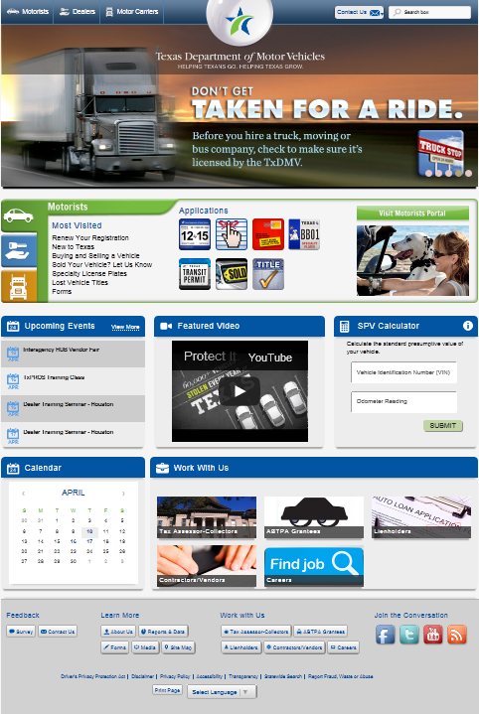
The Texas Department of Motor Vehicles (TxDMV) has a new digital subscription service to keep you informed about agency news. Now you can receive TxDMV updates on the topic of your choice and by your preferred delivery method (email or text message).

To Subscribe

It’s quick and easy to sign up. Just click on the envelope icon at the bottom of the TxDMV website.

Enter your email address or phone number and click “Submit”.
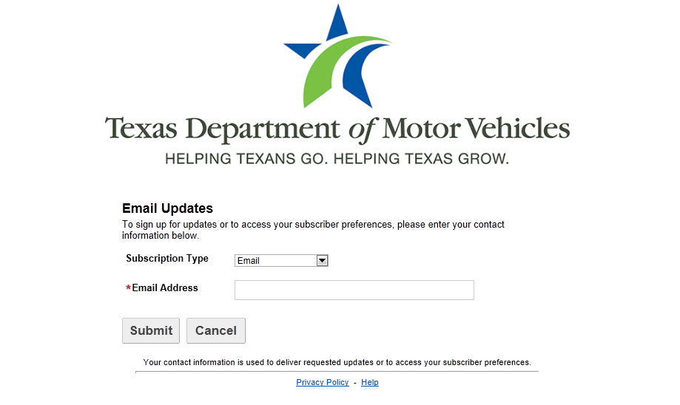

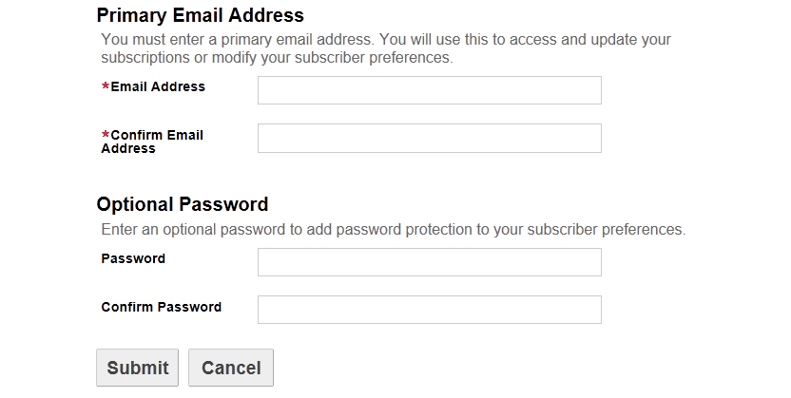

Confirm your information and set a
password (optional).

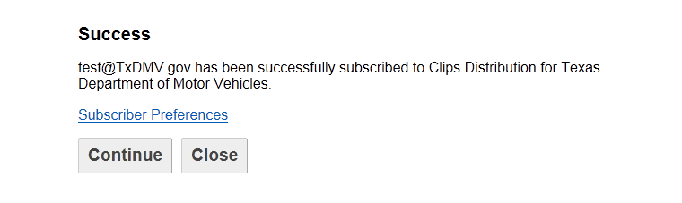

From the Success page, click “Subscriber Preferences” and choose only the topics that interest you. (Note: some topics will ask what region of Texas you live in for location-specific updates.)

Click “Submit” to finalize your selections. You will also have the option to sign up to receive information from other state agencies.

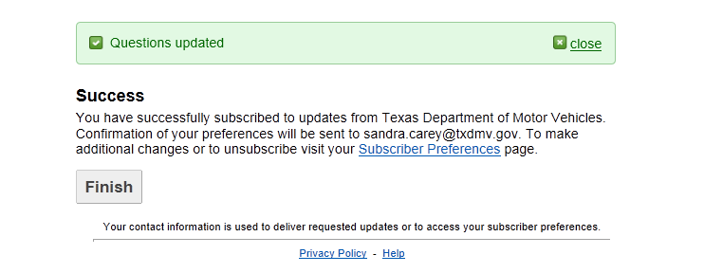
Click “Finish” to leave the page or close the
browser window.

You will receive an email or text message each time a notification concerning your selected topic is distributed. You will also be notified when changes to your subscriptions are made.

Stay Connected to the Department of Motor Vehicles

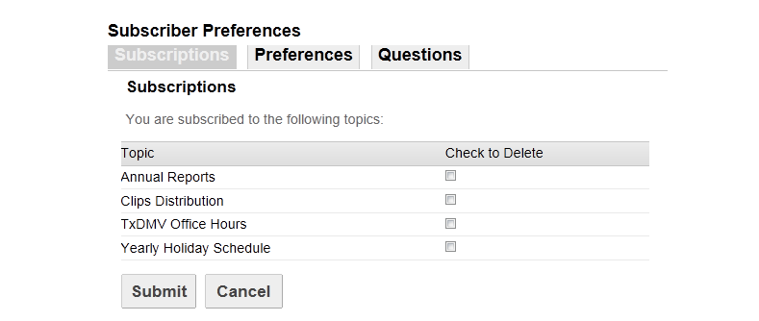
To Make Changes to your Subscriptions

You can manage your subscriptions and make changes anytime by clicking on the envelope icon at the bottom of your email notifications or the TxDMV website. Enter your email address or phone number
and click “Submit” to update your information.

Click “Finish” to leave the page or close the browser window.

