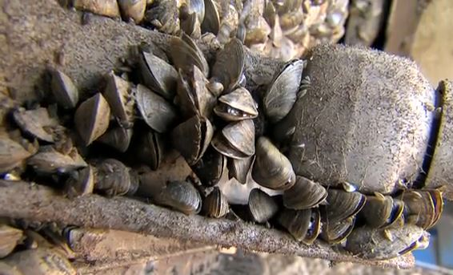
Hello Zebra Mussels, goodbye Texas Lakes.
This Memorial Day Weekend, City of Dallas Water Utilities reminds you to Clean, Drain and Dry your boat!
May 21, 2014
This Memorial Day weekend, City of Dallas Water Utilities reminds you to Clean, Drain and Dry your boat! Our lakes and rivers are under attack by zebra mussels. This destructive invasive species harms aquatic life, damages boats and even affects your water supply. Lake Texoma, Ray Roberts, Lewisville, Bridgeport, Belton and Lavon are already infested, and without your help, zebra mussels could spread throughout the state.
It’s illegal to transport Zebra Mussels
If you’ve boated recently, adult zebra mussels or their microscopic larvae could be hiding in your boat and trailer. By hitching a ride on your boat, zebra mussels can spread and infest new lakes across Texas.
It is illegal to possess or transport zebra mussels knowingly or unknowingly in the state of Texas. In 47 North and Central Texas counties boaters are also required by law to drain all water from their boats when approaching or leaving public waters.
Don’t be a carrier: Clean, Drain, Dry
Prevent the spread of zebra mussels by always following these steps:
CLEAN off any vegetation, mud or foreign objects on the boat, trailer and gear before you leave the lake. Adult zebra mussels attach to hard surfaces such as boat hulls, motors and pipes.
DRAIN all water from the boat. Zebra mussel larvae are invisible to the naked eye and can hide in the water in your motor, bilge, live wells and bait buckets.
DRY the boat and trailer for a week or more before entering another water body. It’s a surefire way to kill any remaining zebra mussels.
Visit TexasInvasives.org/ZebraMussels for more information.
Thank you for doing your part to stop the spread of these destructive invaders in Texas lakes and rivers.
Video Link: https://www.youtube.com/watch?v=h2IIHvWB3A0

