**Theft of Catalytic converters from Trucks and SUVs** **January 9, 2013**

**Facts:** In Northeast Minneapolis 7 vehicles have had the catalytic converters stolen since Decmber 1st, 2012. The majority of the vehicles affected have been Toyota trucks and sport utility vehicles due to easy access and exposure of the converter. A catalytic converter is part of the vehicle exhaust system that is located under a vehicle on the exhaust pipe before the muffler(s). Metals contained in catalytic converters can be taken to metal recyclers where an average of $50 dollars is earned for the precious metals inside.

**General Information:**

Converter theft has become popular because of their value, relative ease to steal (unbolt or cut out), and their lack of identifying markings.

Victims pay an average of $1,000 ( or an average $250/$500 insurance deductible) to get the converter(s) replaced. However, It can cost as much as $4,000.

Any vehicle manufactured after 1974 can be a target. Toyota trucks and SUV models ranging from the 90s to late 2000’s are vulnerable because of the easy access, exposure and additional converters on some models.

[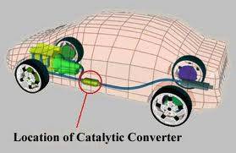](http://www.google.com/imgres?q=catalytic+converter+diagram&um=1&hl=en&tbo=d&biw=1152&bih=667&tbm=isch&tbnid=-Z8kTKSkIedZkM:&imgrefurl=http://www.chem.shef.ac.uk/chm131-2003/cha03ml/Home.html&docid=BV-xqVza8IcZqM&imgurl=http://www.chem.shef.ac.uk/chm131-2003/cha03ml/converter.jpg&w=400&h=259&ei=ft_uUJr2LMaSqgHu8YG4Aw&zoom=1&iact=hc&vpx=238&vpy=268&dur=2860&hovh=181&hovw=279&tx=113&ty=114&sig=117816941160601967490&page=2&tbnh=126&tbnw=228&start=20&ndsp=29&ved=1t:429,r:21,s:0,i:149)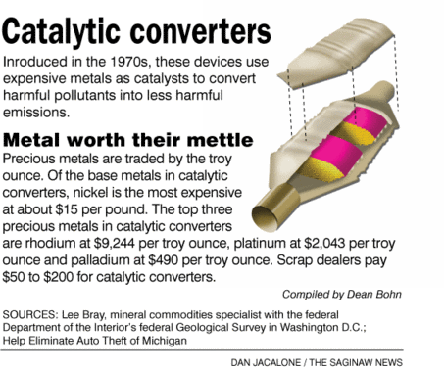

**Suspect Information:**

There is no suspect information publicly available at this time.

**What you can do:**

•Call 911 when you witness suspicious activity and/or people around

your property or block, especially under trucks or sport utility vehicles

•Park your vehicle in a garage if possible

•Educate your friends and neighbors about catalytic converter theft so they can look out too.

•Install a catalytic converter protection device

•Get your catalytic converter etched with your license plate number

•If your catalytic converter is stolen you will know when you start your vehicle. It will sound like you do not have a muffler.