Summer Hours
Starts May 4th, 2015

Drop-in* | Mondays | Tuesdays | Wednesdays* | Thursdays | Fridays*
AM (18-23 year olds) | 9am-1pm | 9am-1pm | 9am-12:30pm | 9am-1pm | 9am-6pm
PM (16-20 year olds) | 3pm-8pm | 3pm-8pm | 3pm-8pm | 3pm-8pm | 9am-6pm

*During Drop-in hours, youth have access to basic needs, onsite Youth Opportunity Center partner services, case management and transportation assistance. A full list of our services can be found at www.youthlinkmn.org

* Hennepin County Eligibility Supports available 10am-6pm. Call 612.252.1200 to make an appointment.

*Fridays the YouthLink building will be open 9am-6pm for 16-23 year olds.

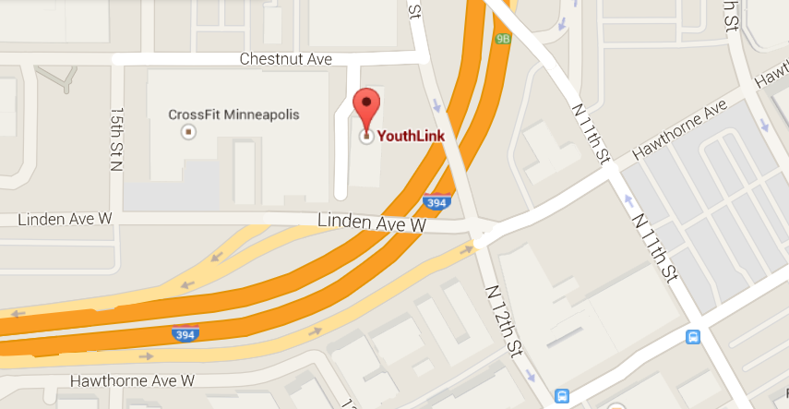

YouthLink is located at 41 N. 12th Street in downtown Minneapolis

