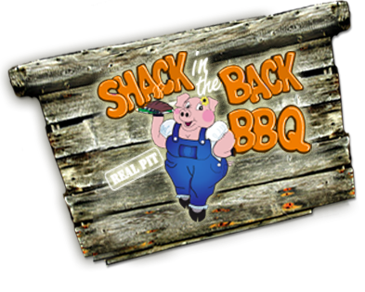
406 Mt. Holly Rd. Fairdale, KY 40118
(502) 363-3227
www.shackinthebackbbq.com

Special Meal Delivery!
On Monday, October 3, 2011 from 11:00 am to 2:00 pm and 4:00 pm to 8:00 pm we are having a Fundraiser at Shack in the Back BBQ for FHS (Fairdale High School Cheerleaders).
Shack in the Back BBQ will donate $2.40 for every meal sold that day!

For only $6.00 you will get a Pulled Pork Sandwich, 2 side dishes, a cookie and your choice of Tea or Lemonade. You can come to the Shack and eat, get your order to go, or have your food delivered directly to you!
If you would like to have your meal(s) delivered to you, please fill out the information below and fax to Shack in the Back BBQ at 363-0106. The deadline is Friday, September 30th. Your order will be delivered to you at the time you indicate below. Thank you so much for your order. We greatly appreciate your support!
NAME # OF ORDERS DELIVER TO WHAT BUSINESS TIME

___________________________ _______________ _________________________________________ _________

___________________________ _______________ ___________________________________ ______ _________

___________________________ _______________ _________________________________________ _________

___________________________ _______________ ___________________________________ ______ _________

___________________________ _______________ _________________________________________ _________

___________________________ _______________ _________________________________________ _________

